**Plot_1_Q00.1.svg**

**Answering on behalf of**

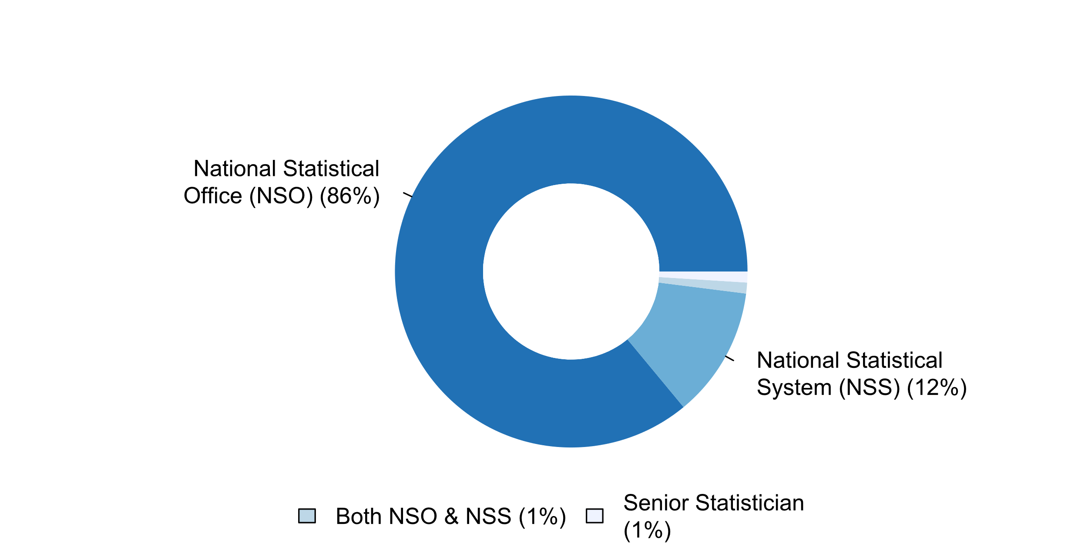

**Plot_2_Q00.2.svg**

**Awareness of existence UNFPOS**

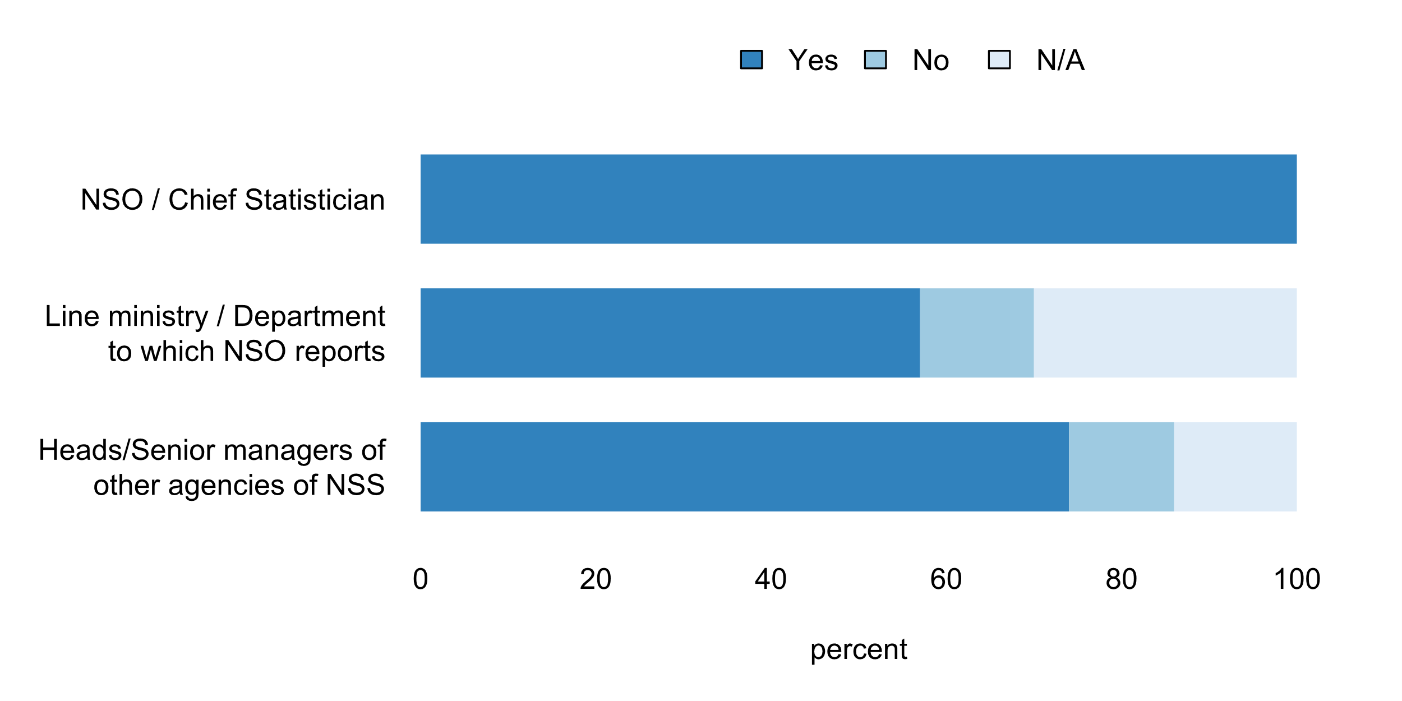

**Plot_3_Q00.3.svg**

**Extent to which UNFPOS are integrated into the NSS institutional framework**

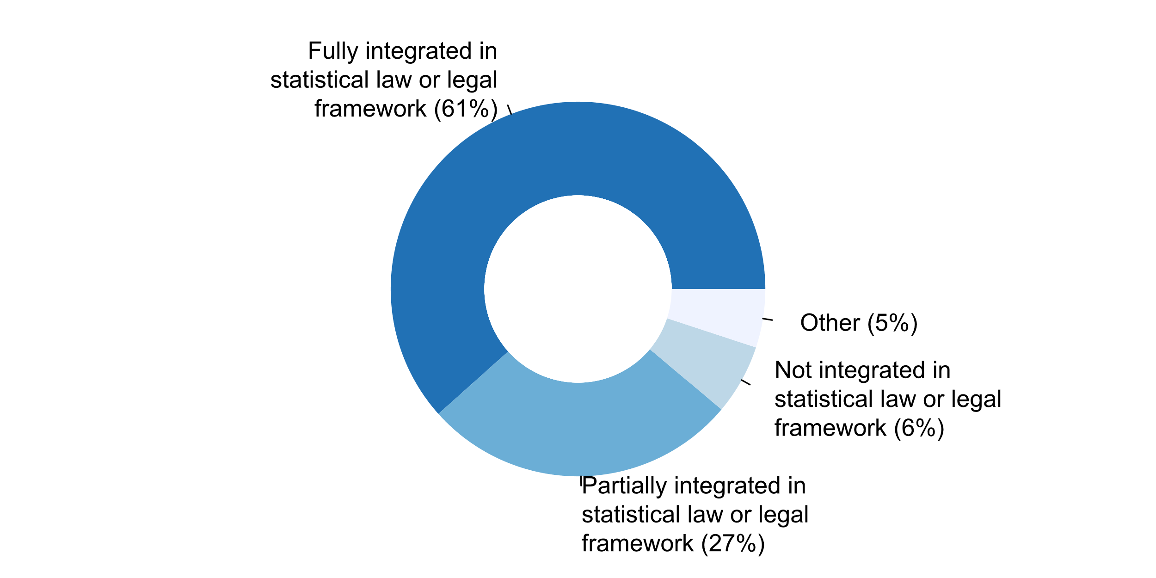

**Plot_4_Q00.4.svg**

**How UNFPOS are communicated to raise awareness at the national level**

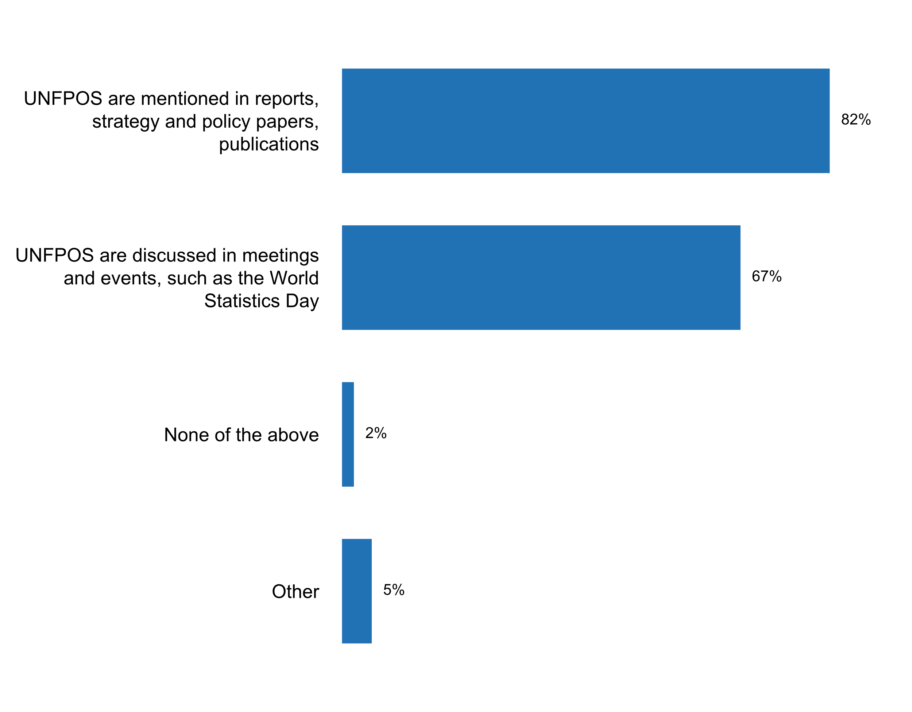

**Plot_5_Q01.1.svg**

**Source of feedback from users on statistical products and services (e.g. needs, satisfaction) sought in the past five years**

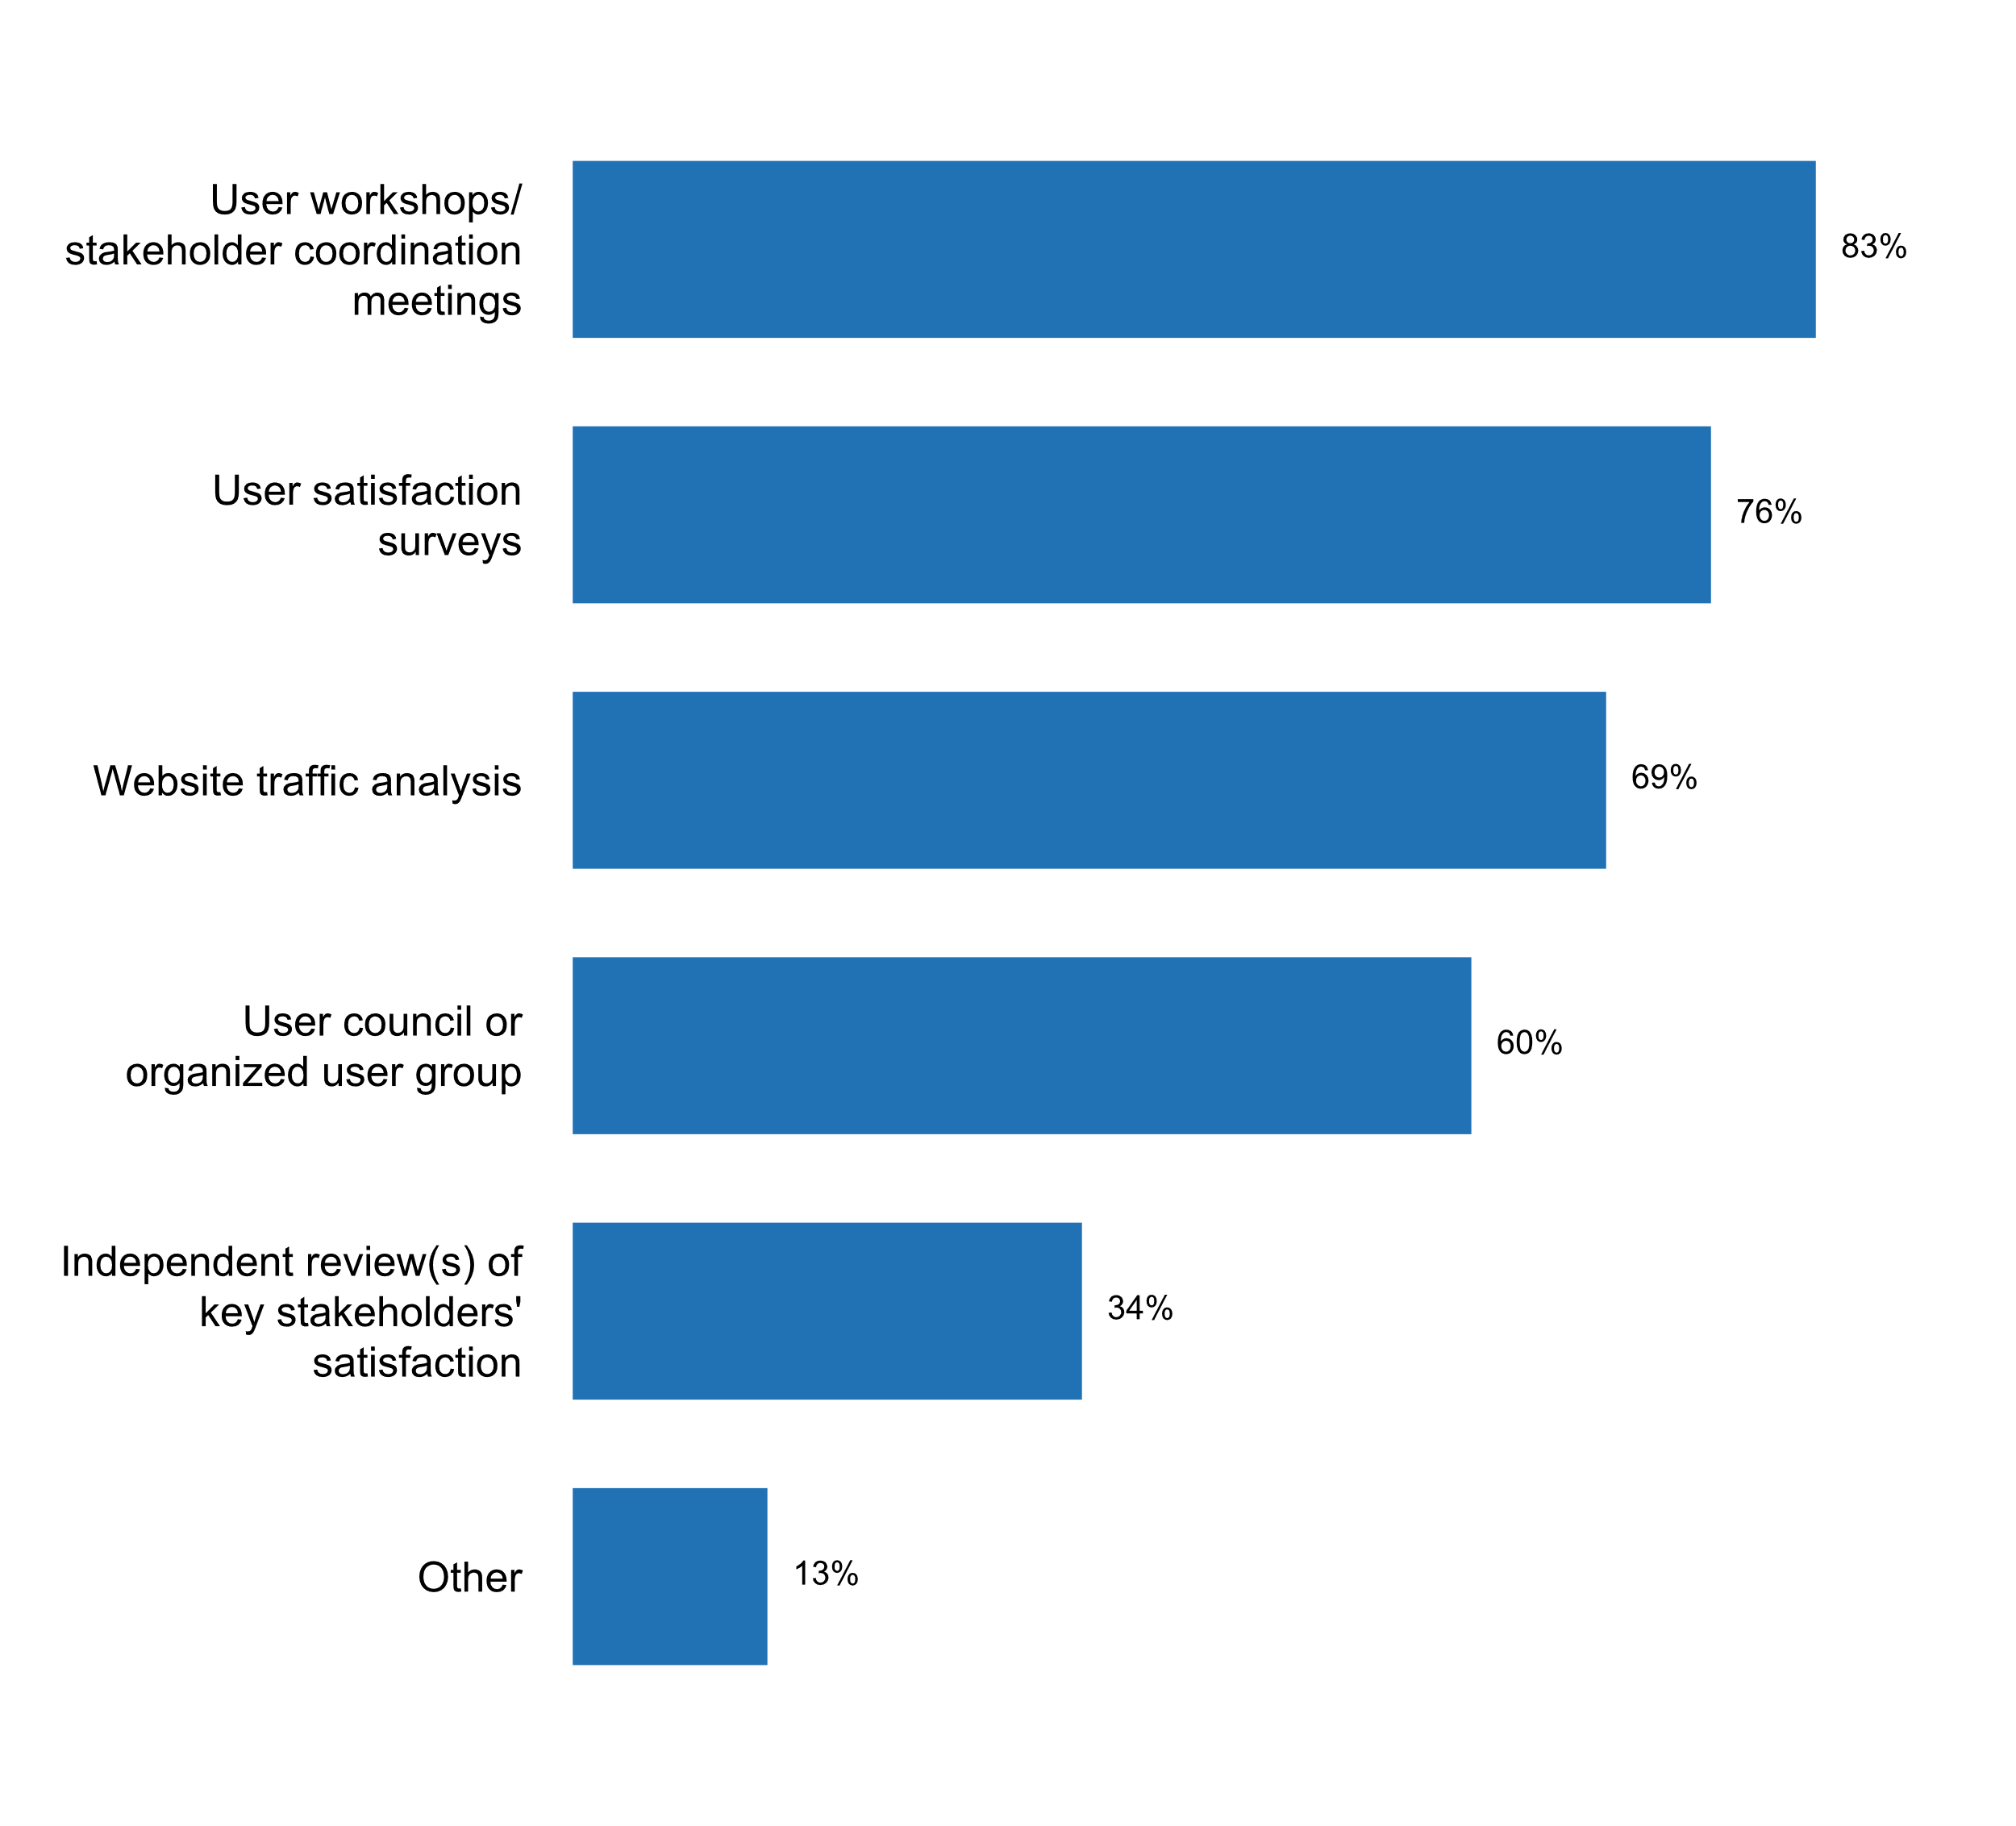

**Plot_6_Q01.1a.svg**

**Mandate of user council or organized user group**

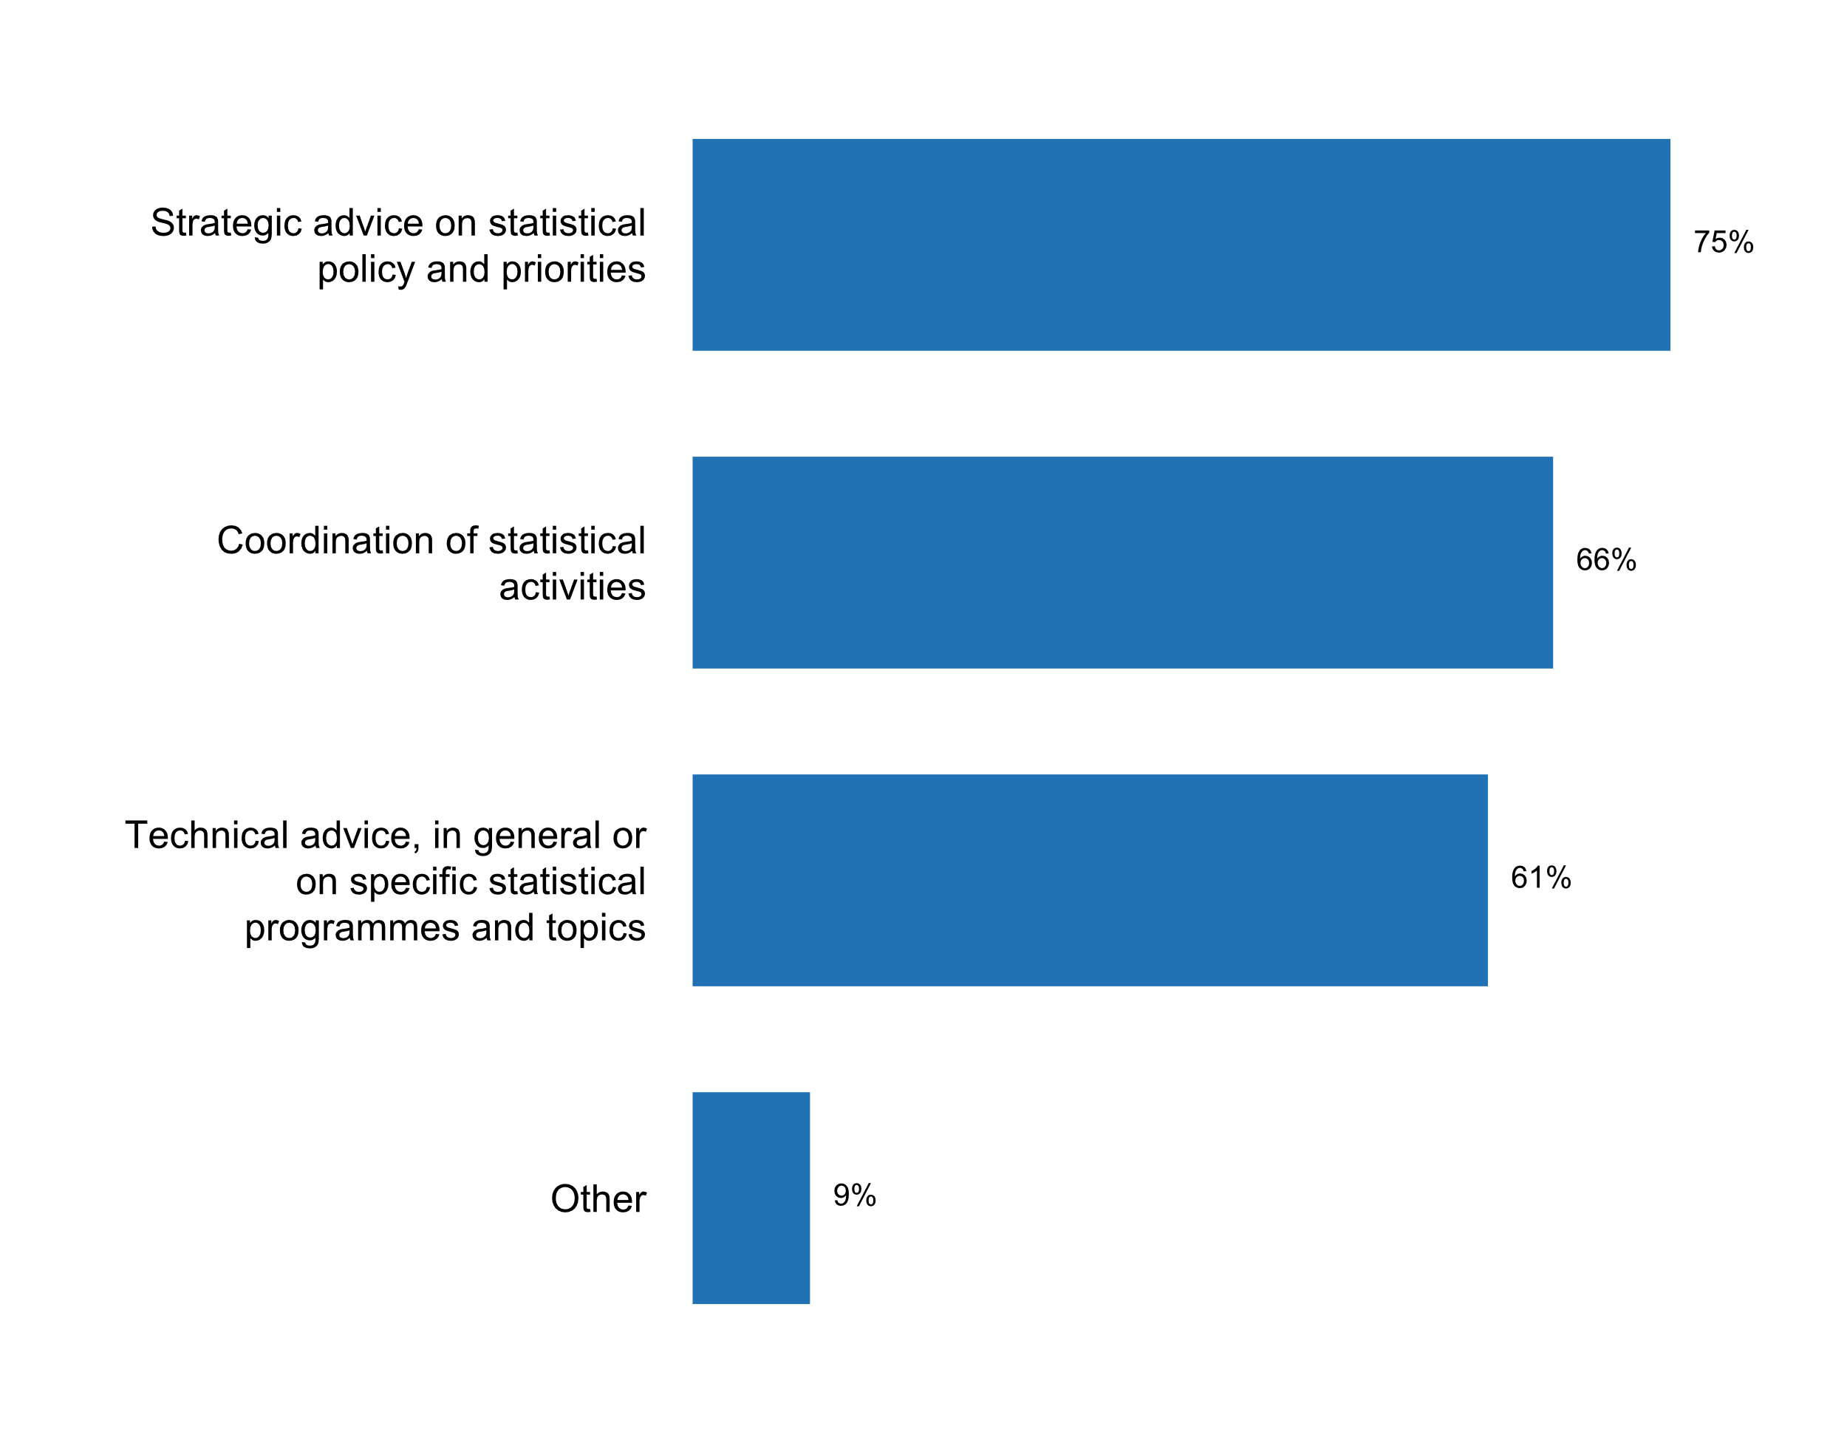**Plot_7_Q01.1b.svg**

**Stakeholders represented in user council or organized user group in the past five years**

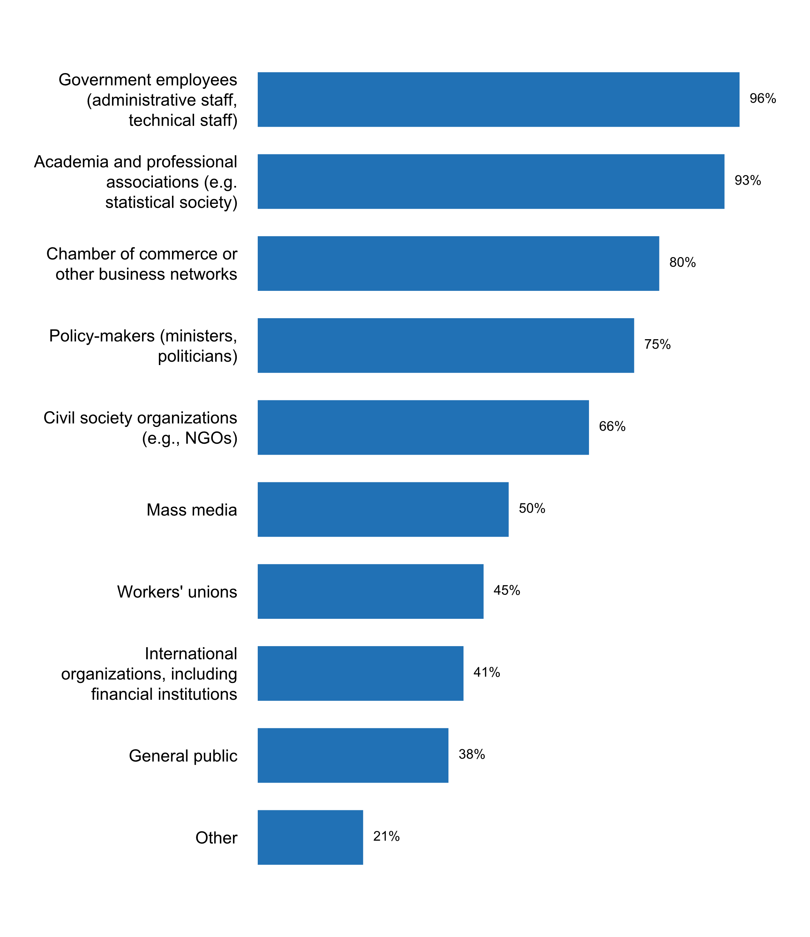

**Plot_8_Q01.2.svg**

**Planning instruments currently being used by the NSS/NSO**

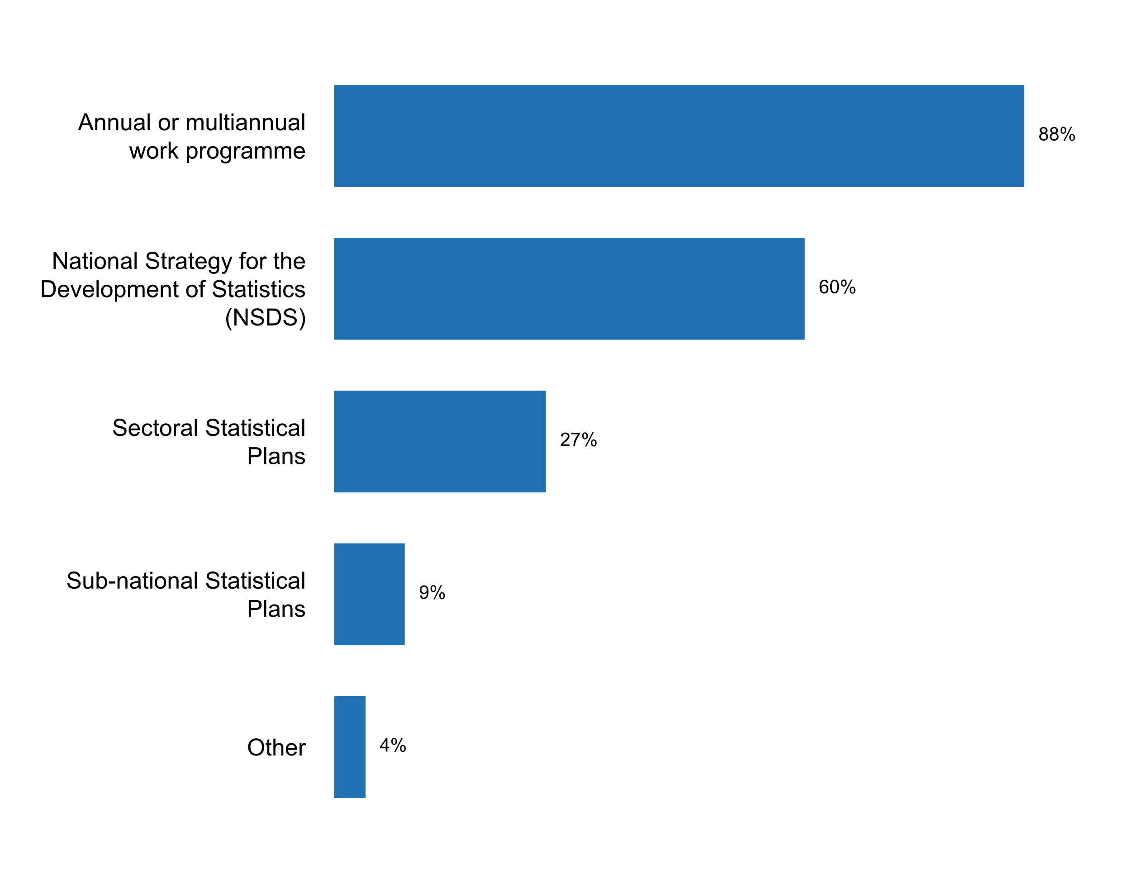

**Plot_9_Q01.2a.svg**

**Time span of current NSDS**

**Plot_10_Q01.4.svg**

**Measures currently in place for disseminating statistics**

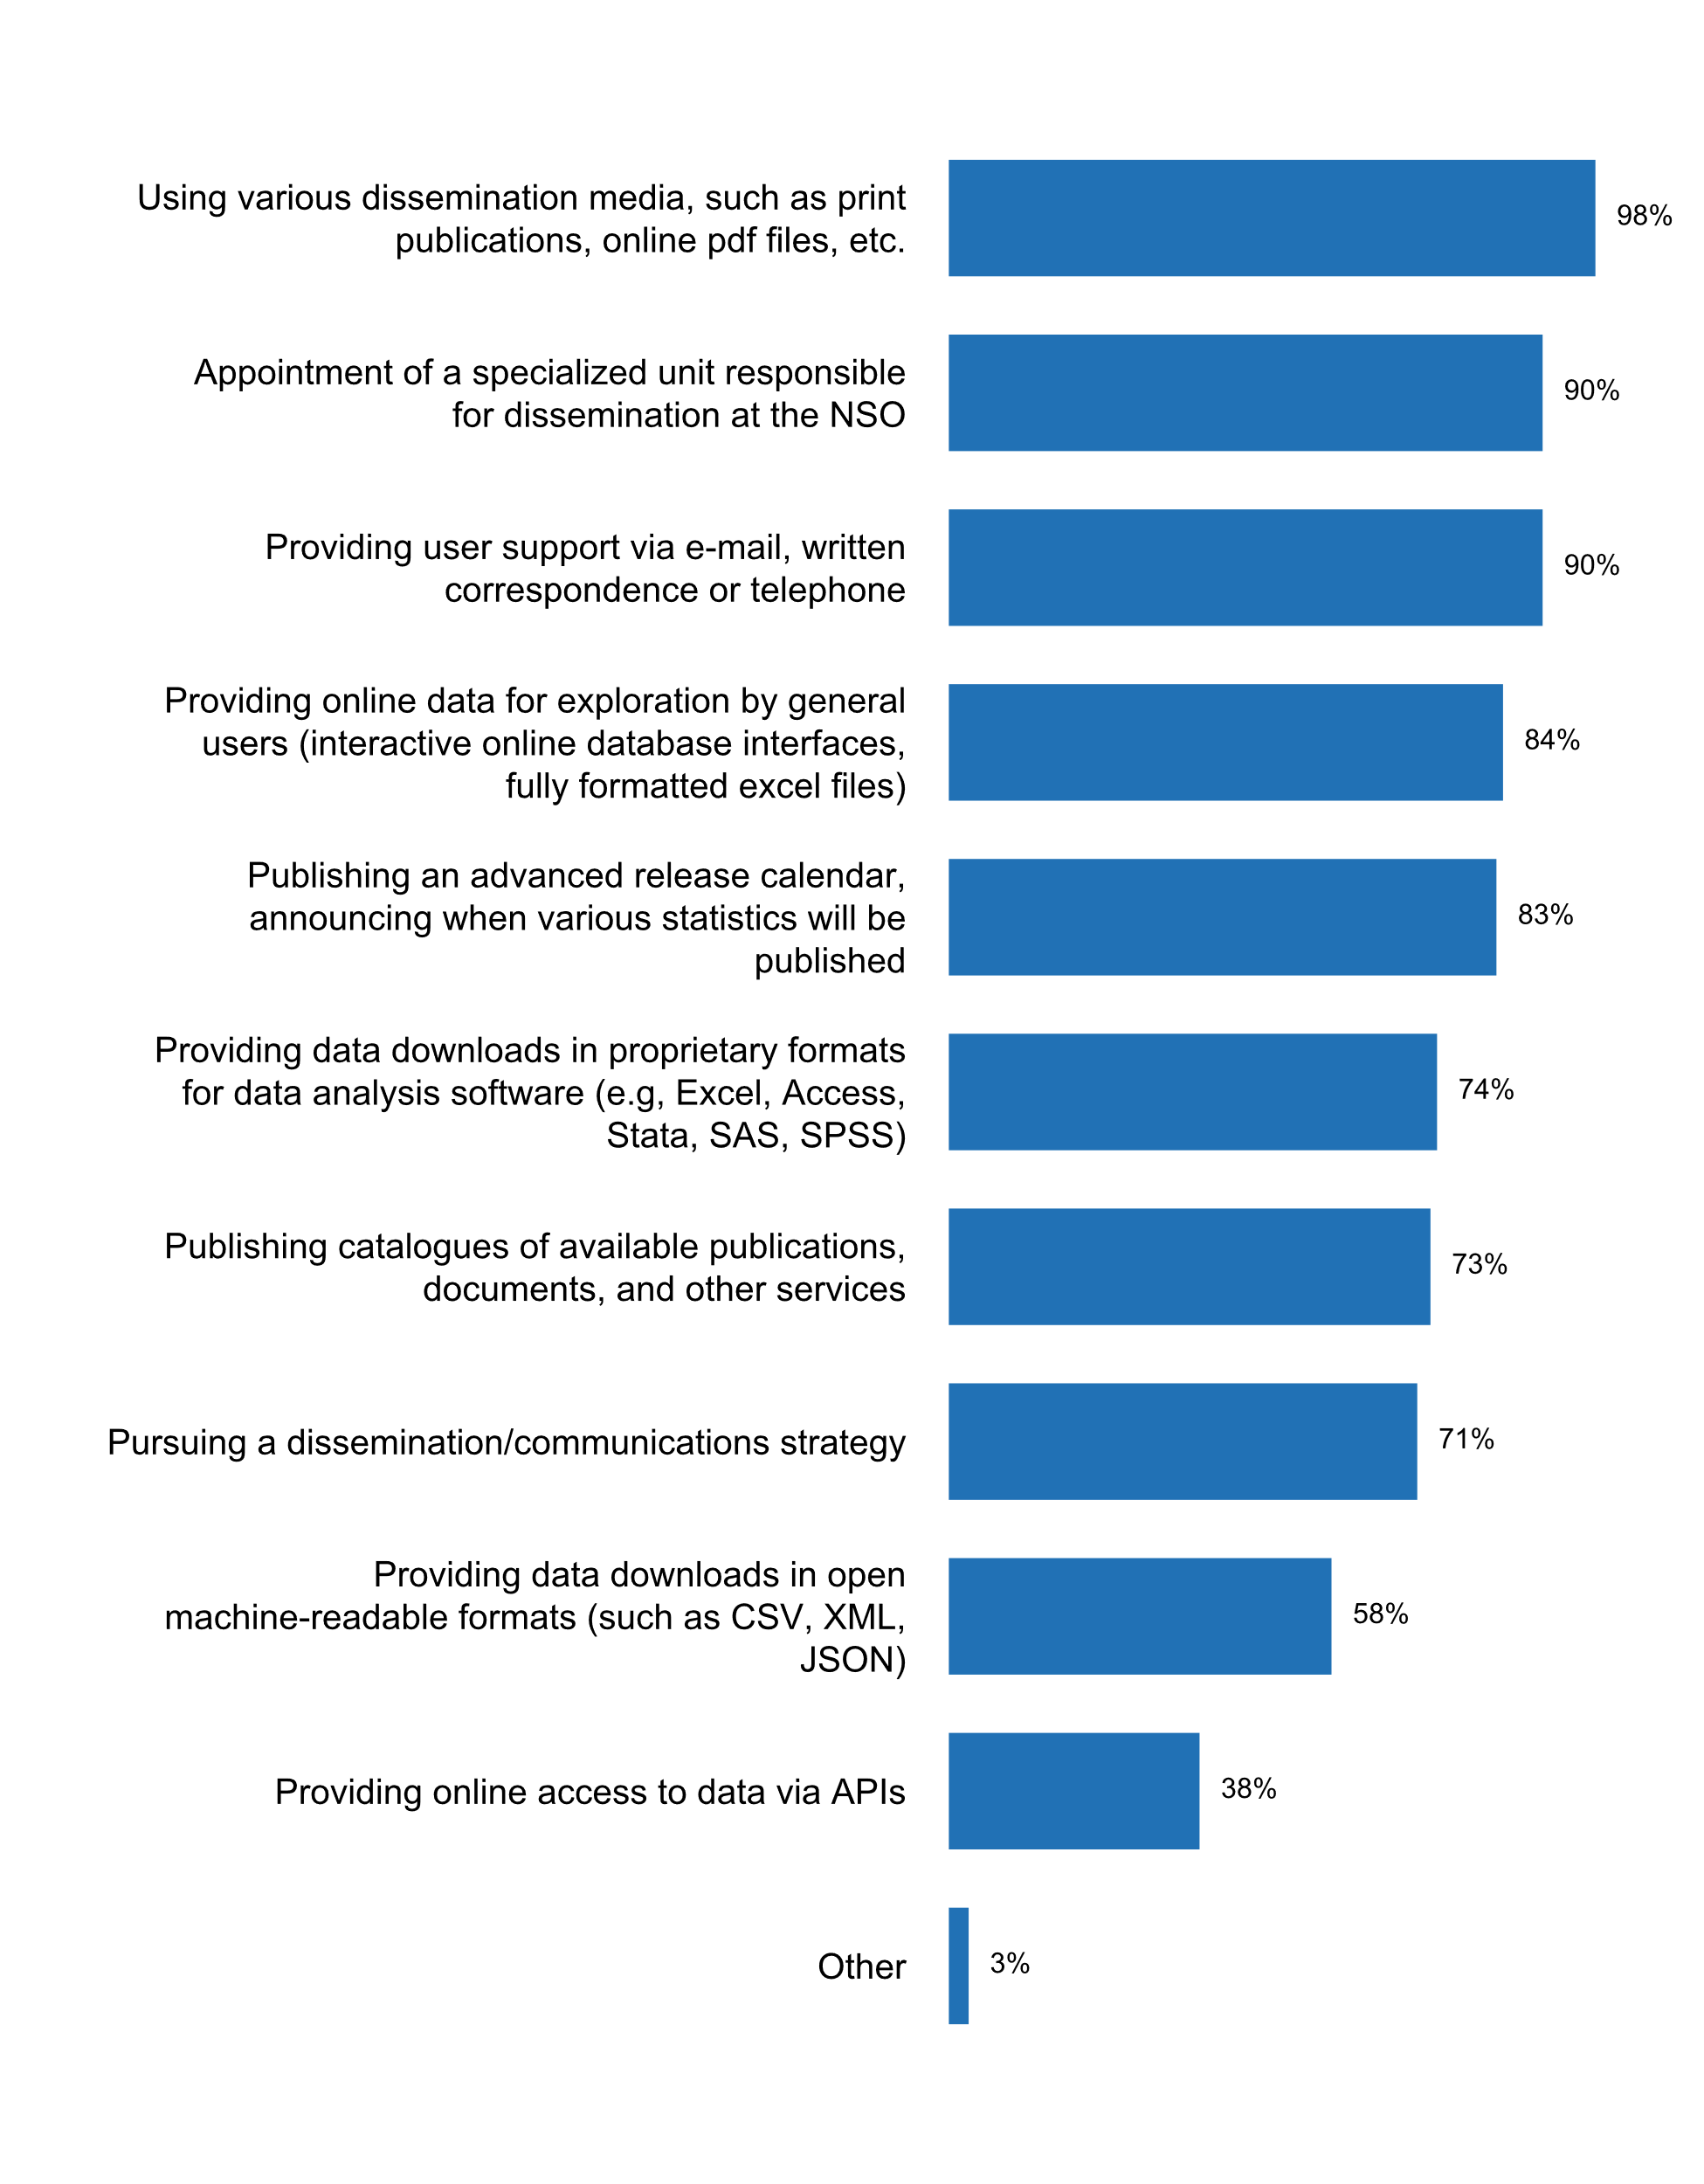

**Plot_11_Q01.4b.svg**

**Time span of the calendar**

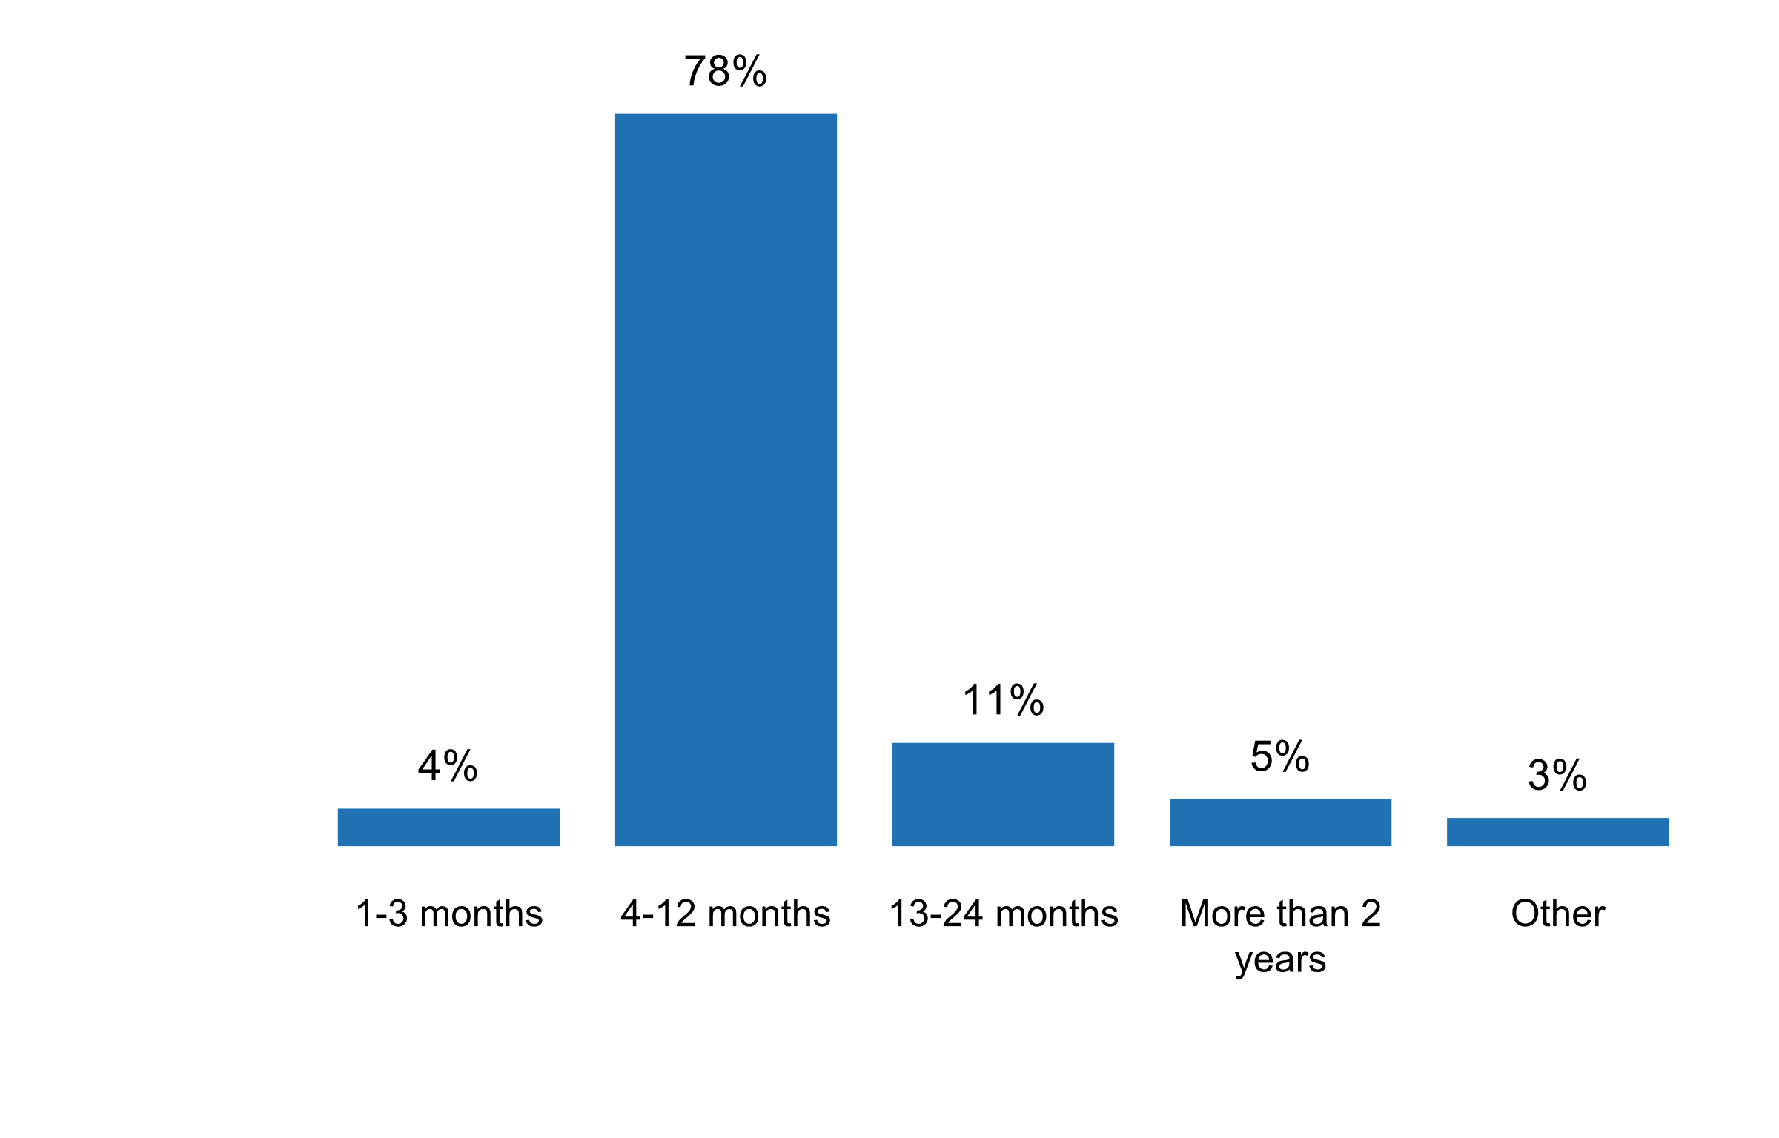**Plot_12_Q01.4c.svg**

**Frequency of adjustments to the release dates specified in the calendar**

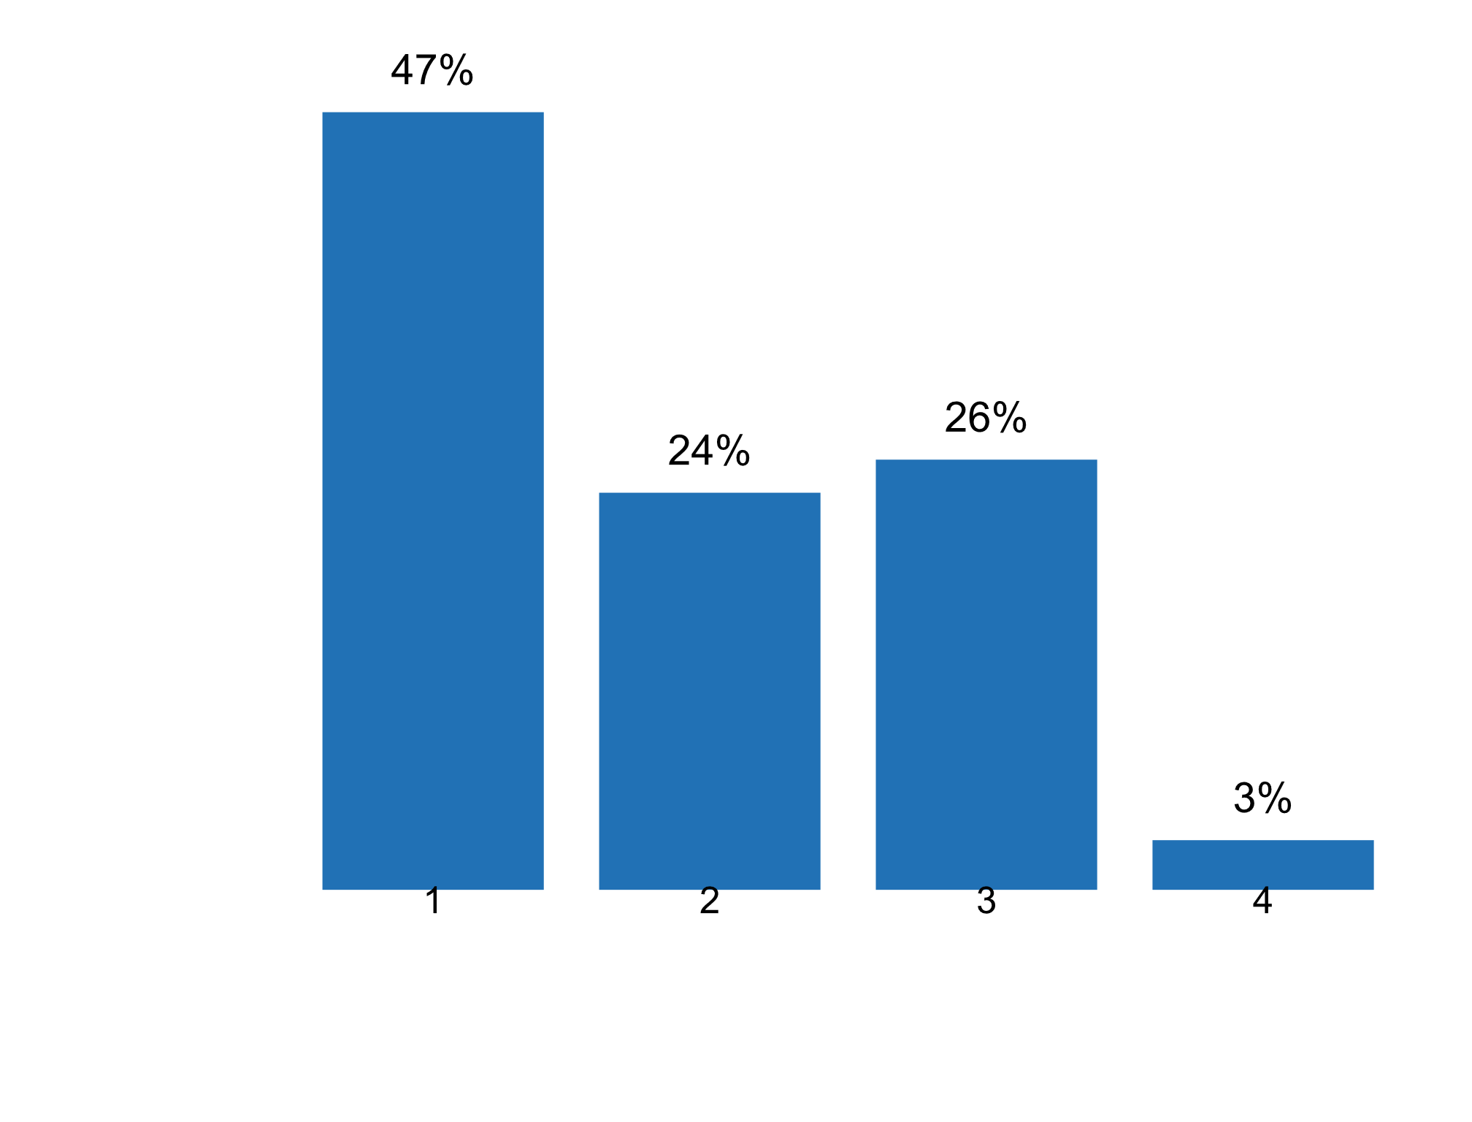

**Plot_13_Q01.6.svg**

**Groups of users given access to statistics prior to their public release in the past five years**

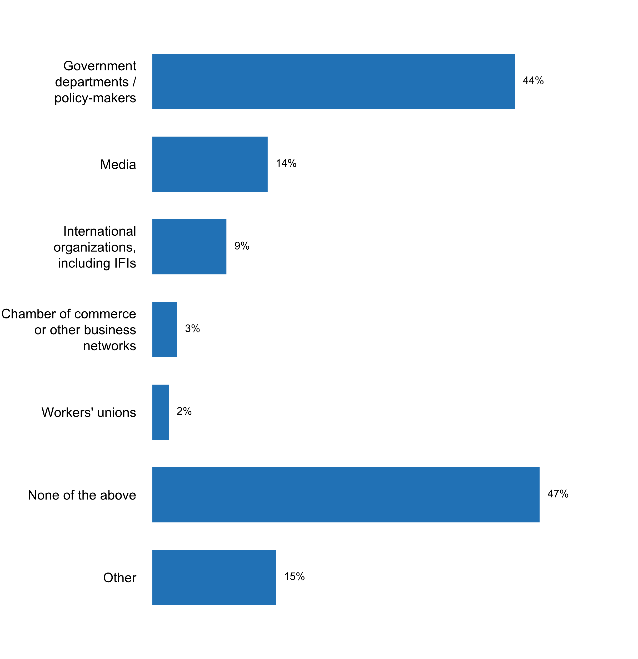

**Plot_14_Q01.6a.svg**

**If any user has access to a pre-release, is this publicly identified?**

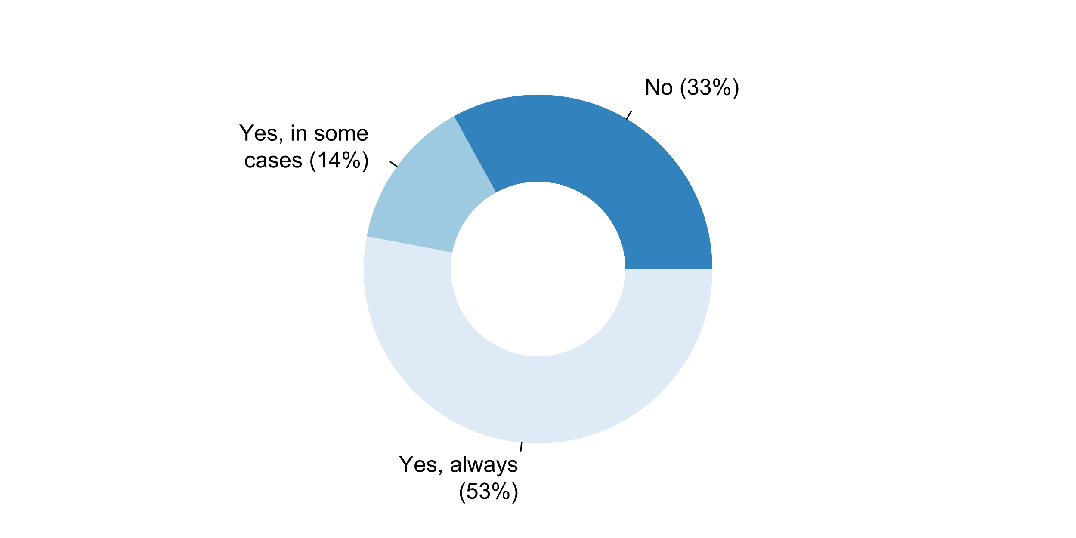**Plot_15_Q01.7a.svg**

**Conditions for online access to aggregates and/or microdata**

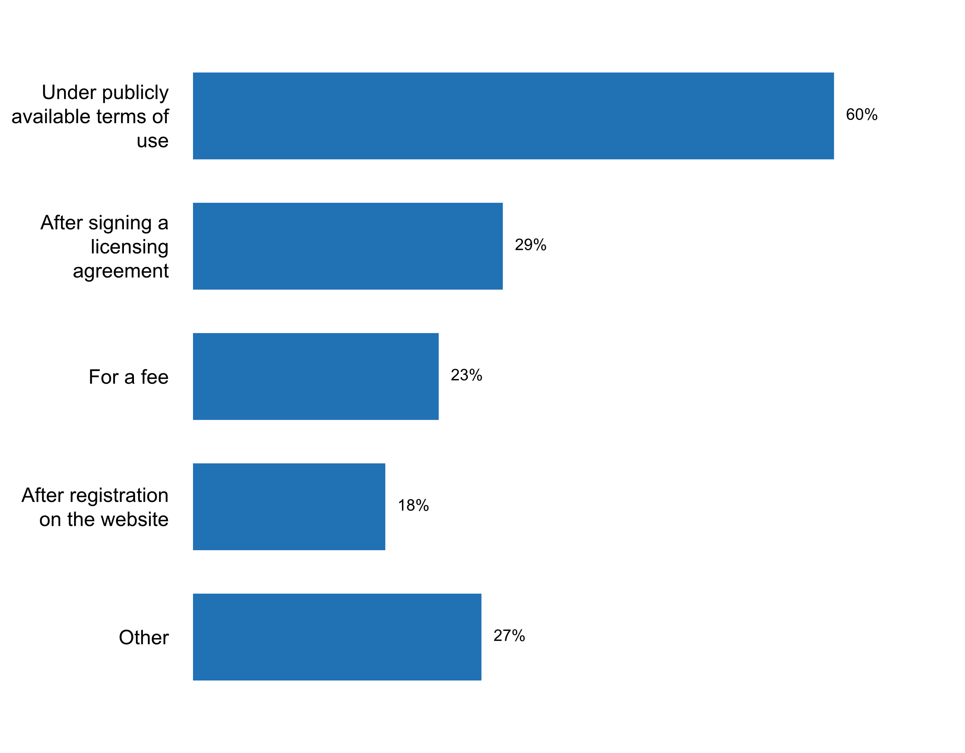

**Plot_16_Q01.7b.svg**

**Conditions for re-distribution of anonymized microdata data and aggregates**

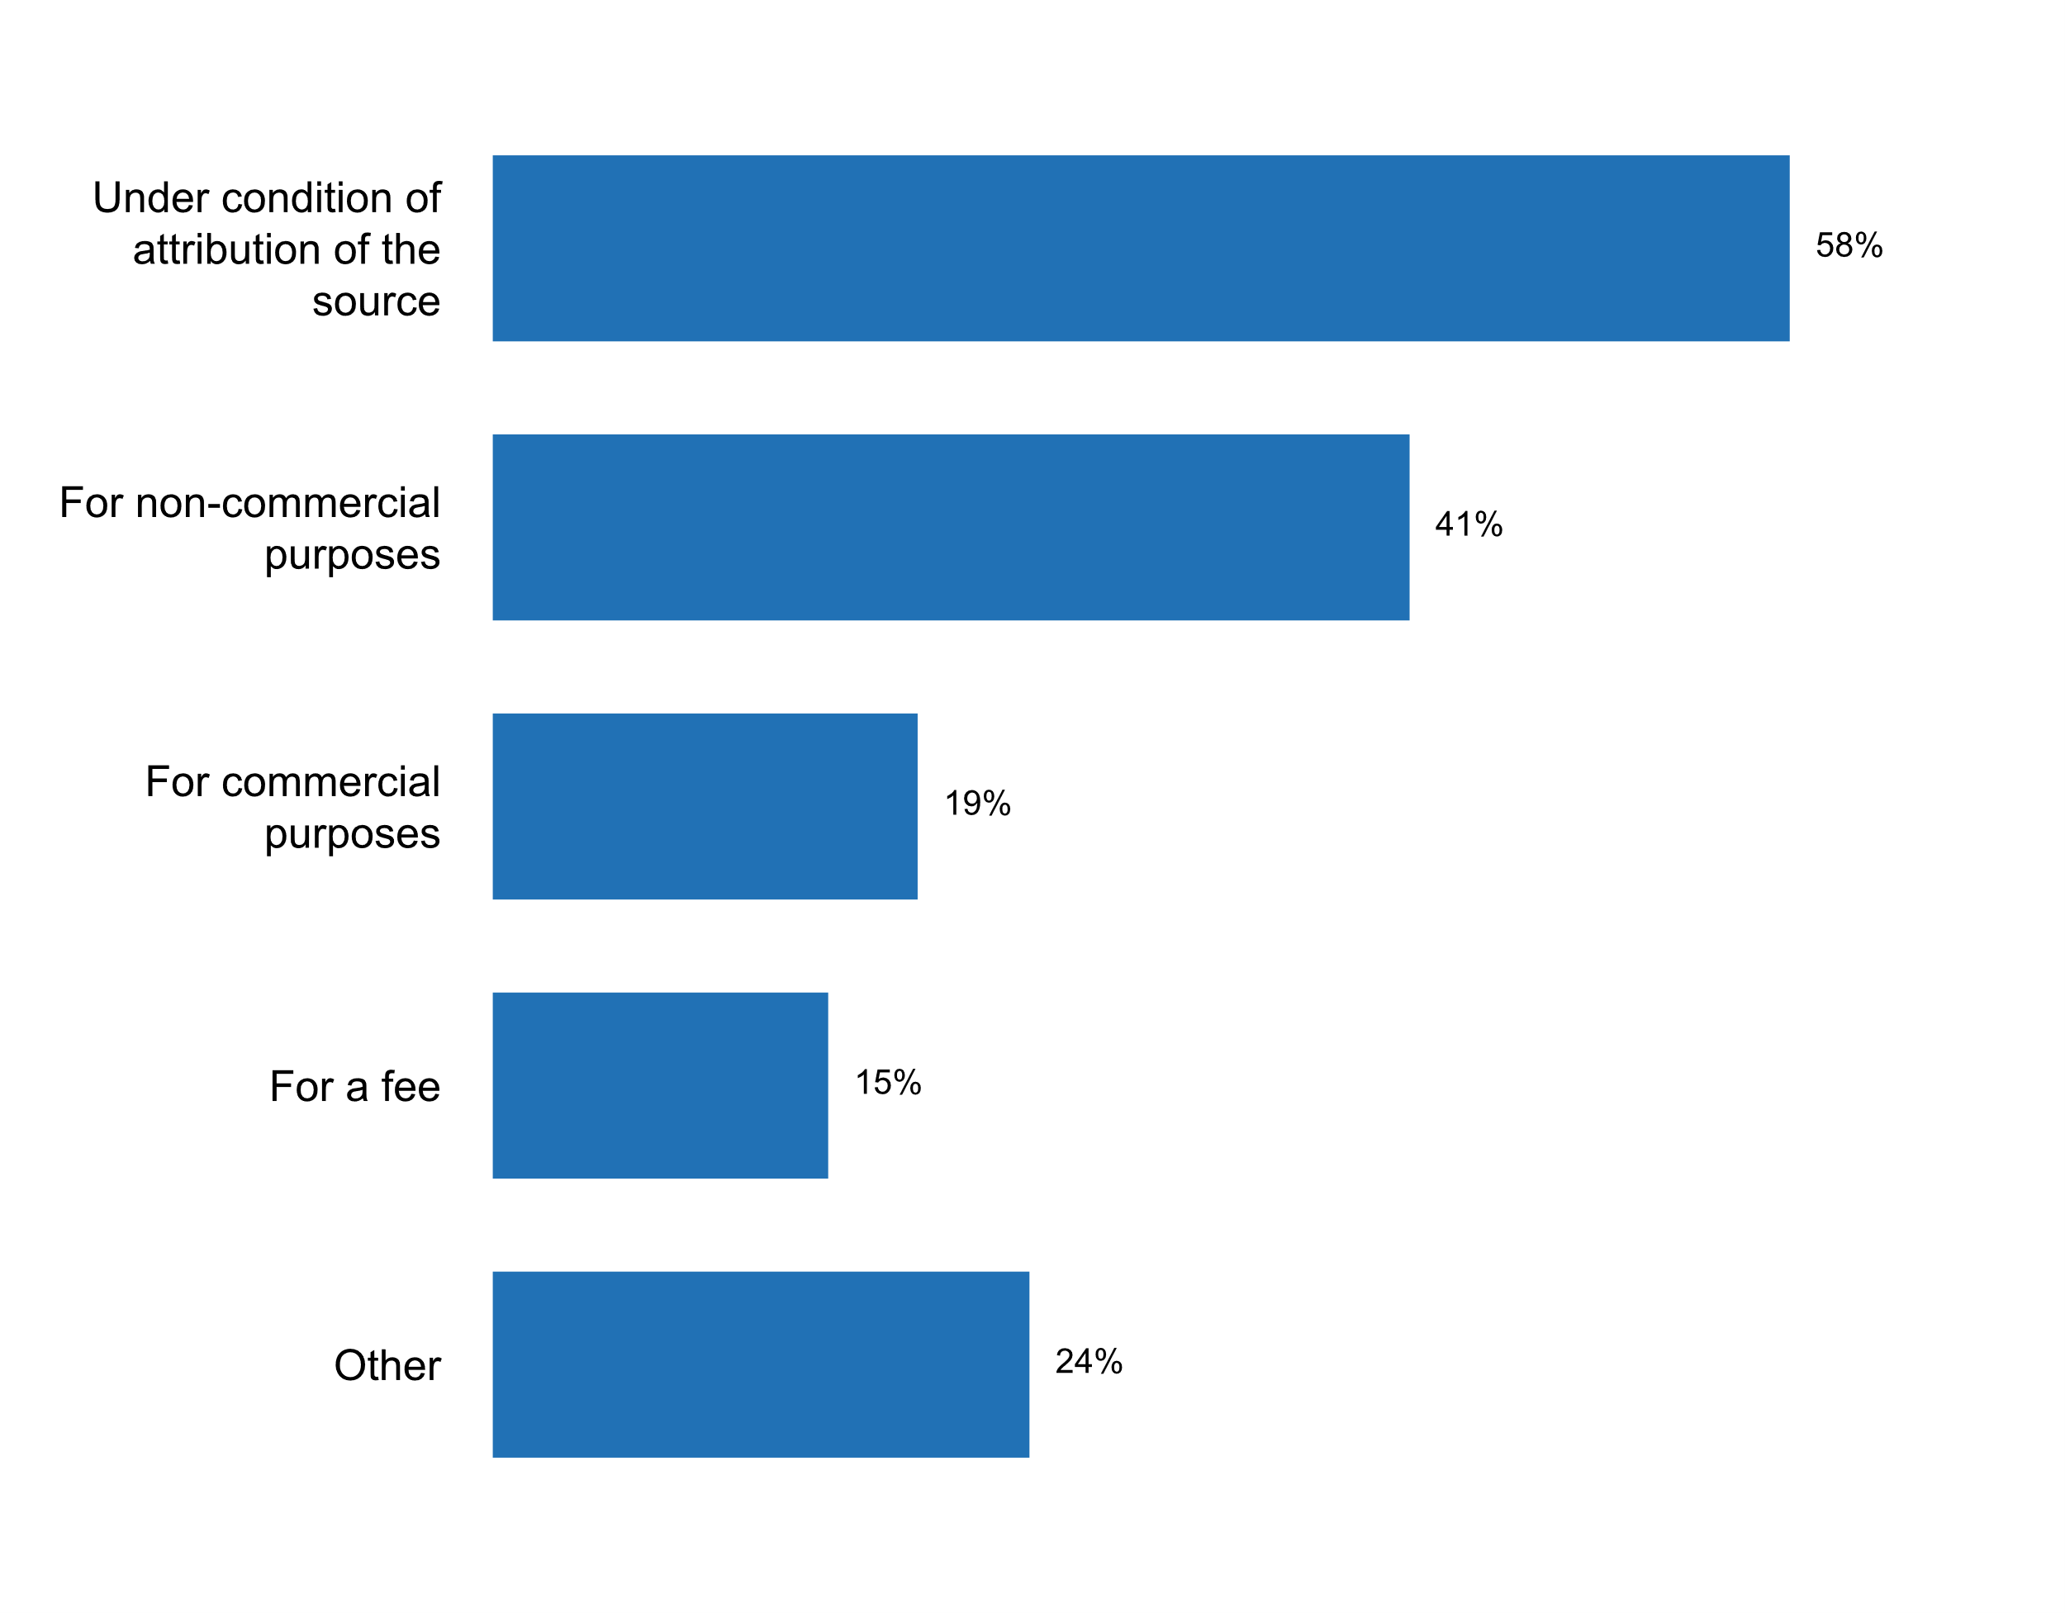

**Plot_17_Q01.7c.svg**

**Conditions for distribution of derivative works based on the aggregates and/or microdata that are available online**

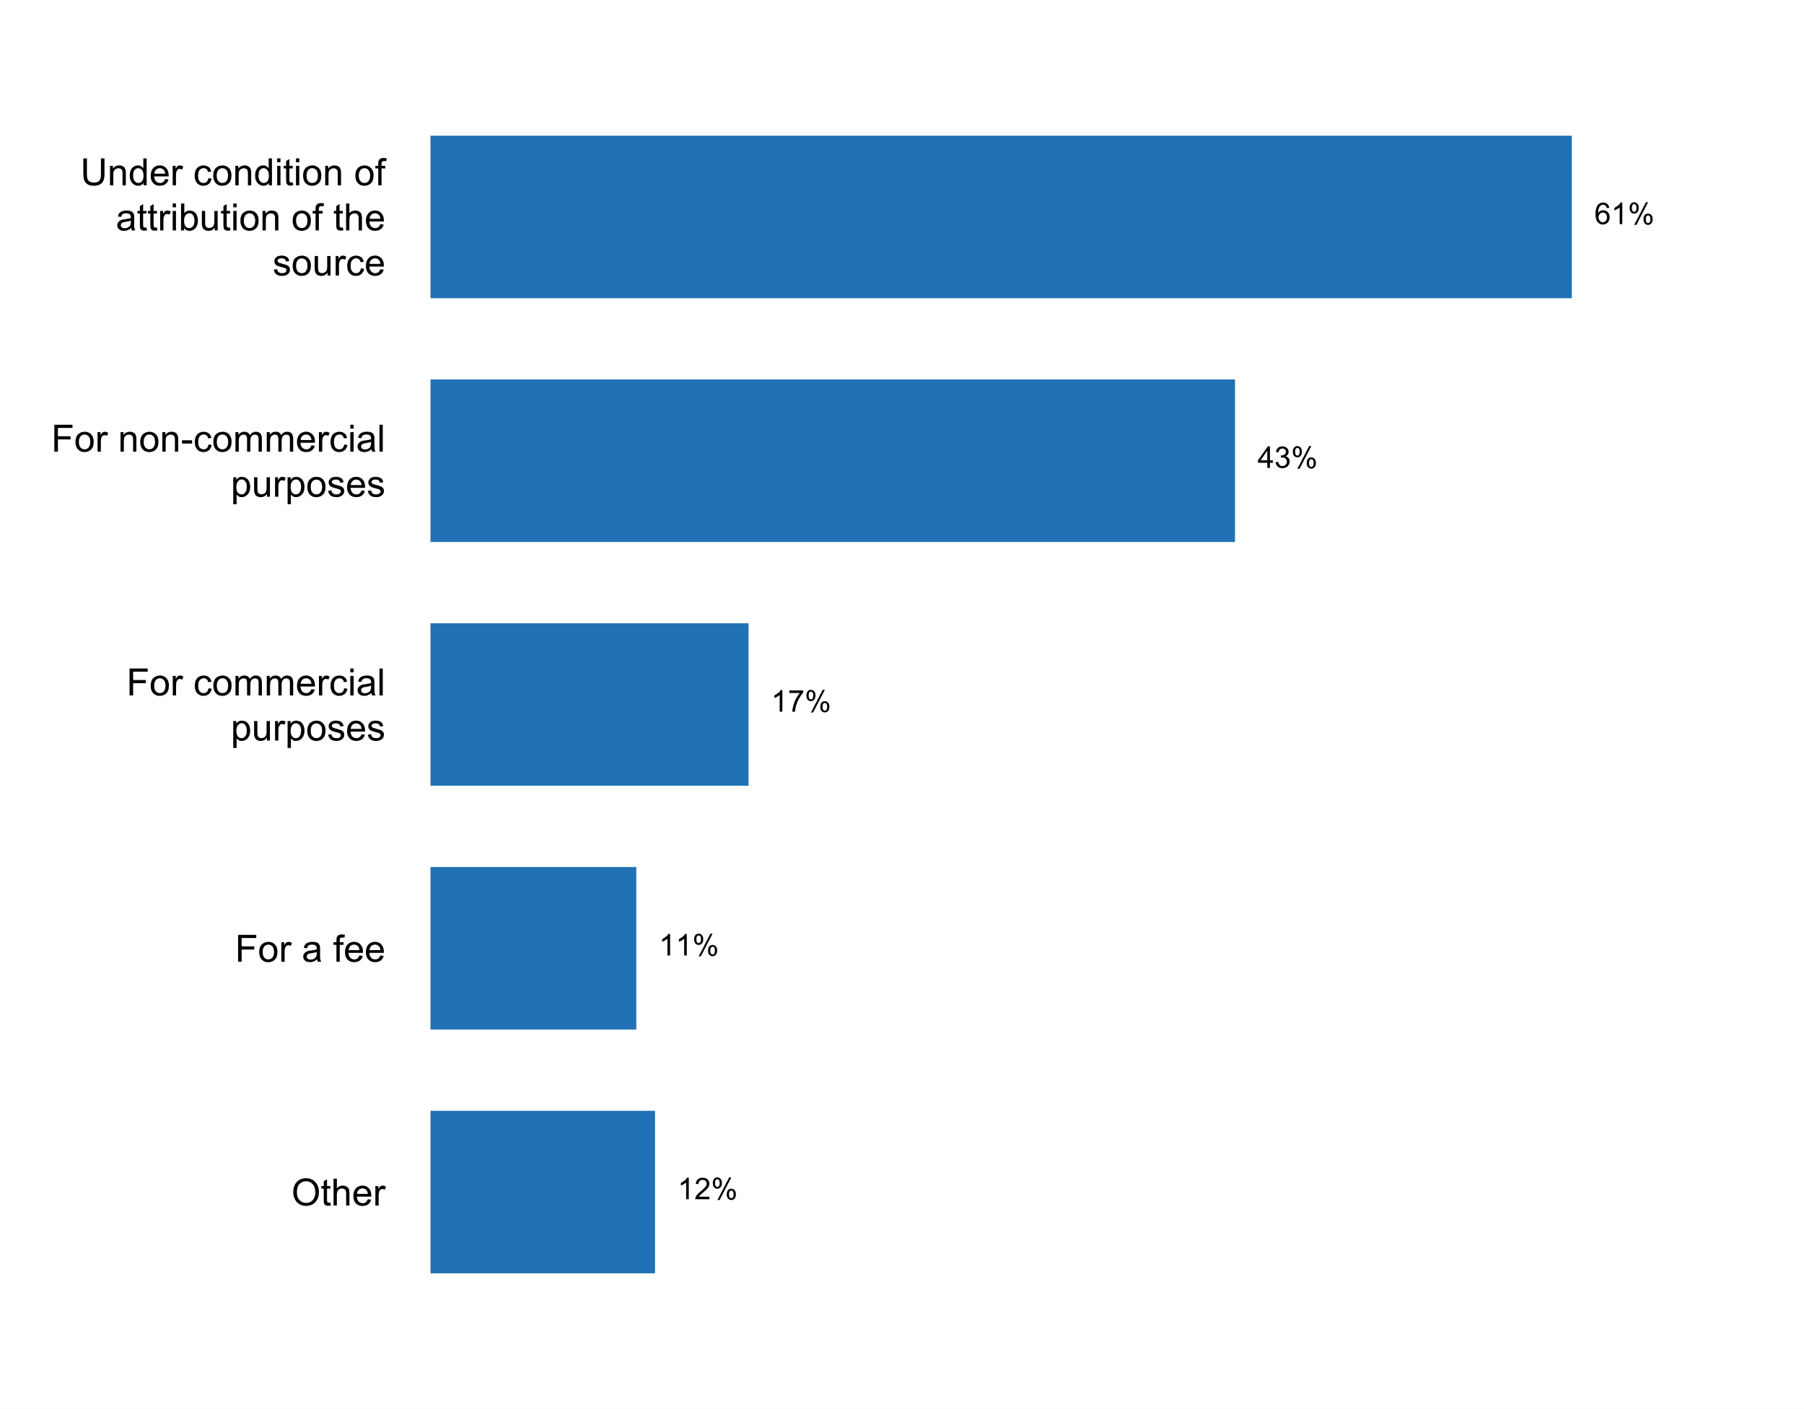

**Plot_18_Q02.1a.svg**

**Modalities of communication between chief statistician and policy-making authorities**

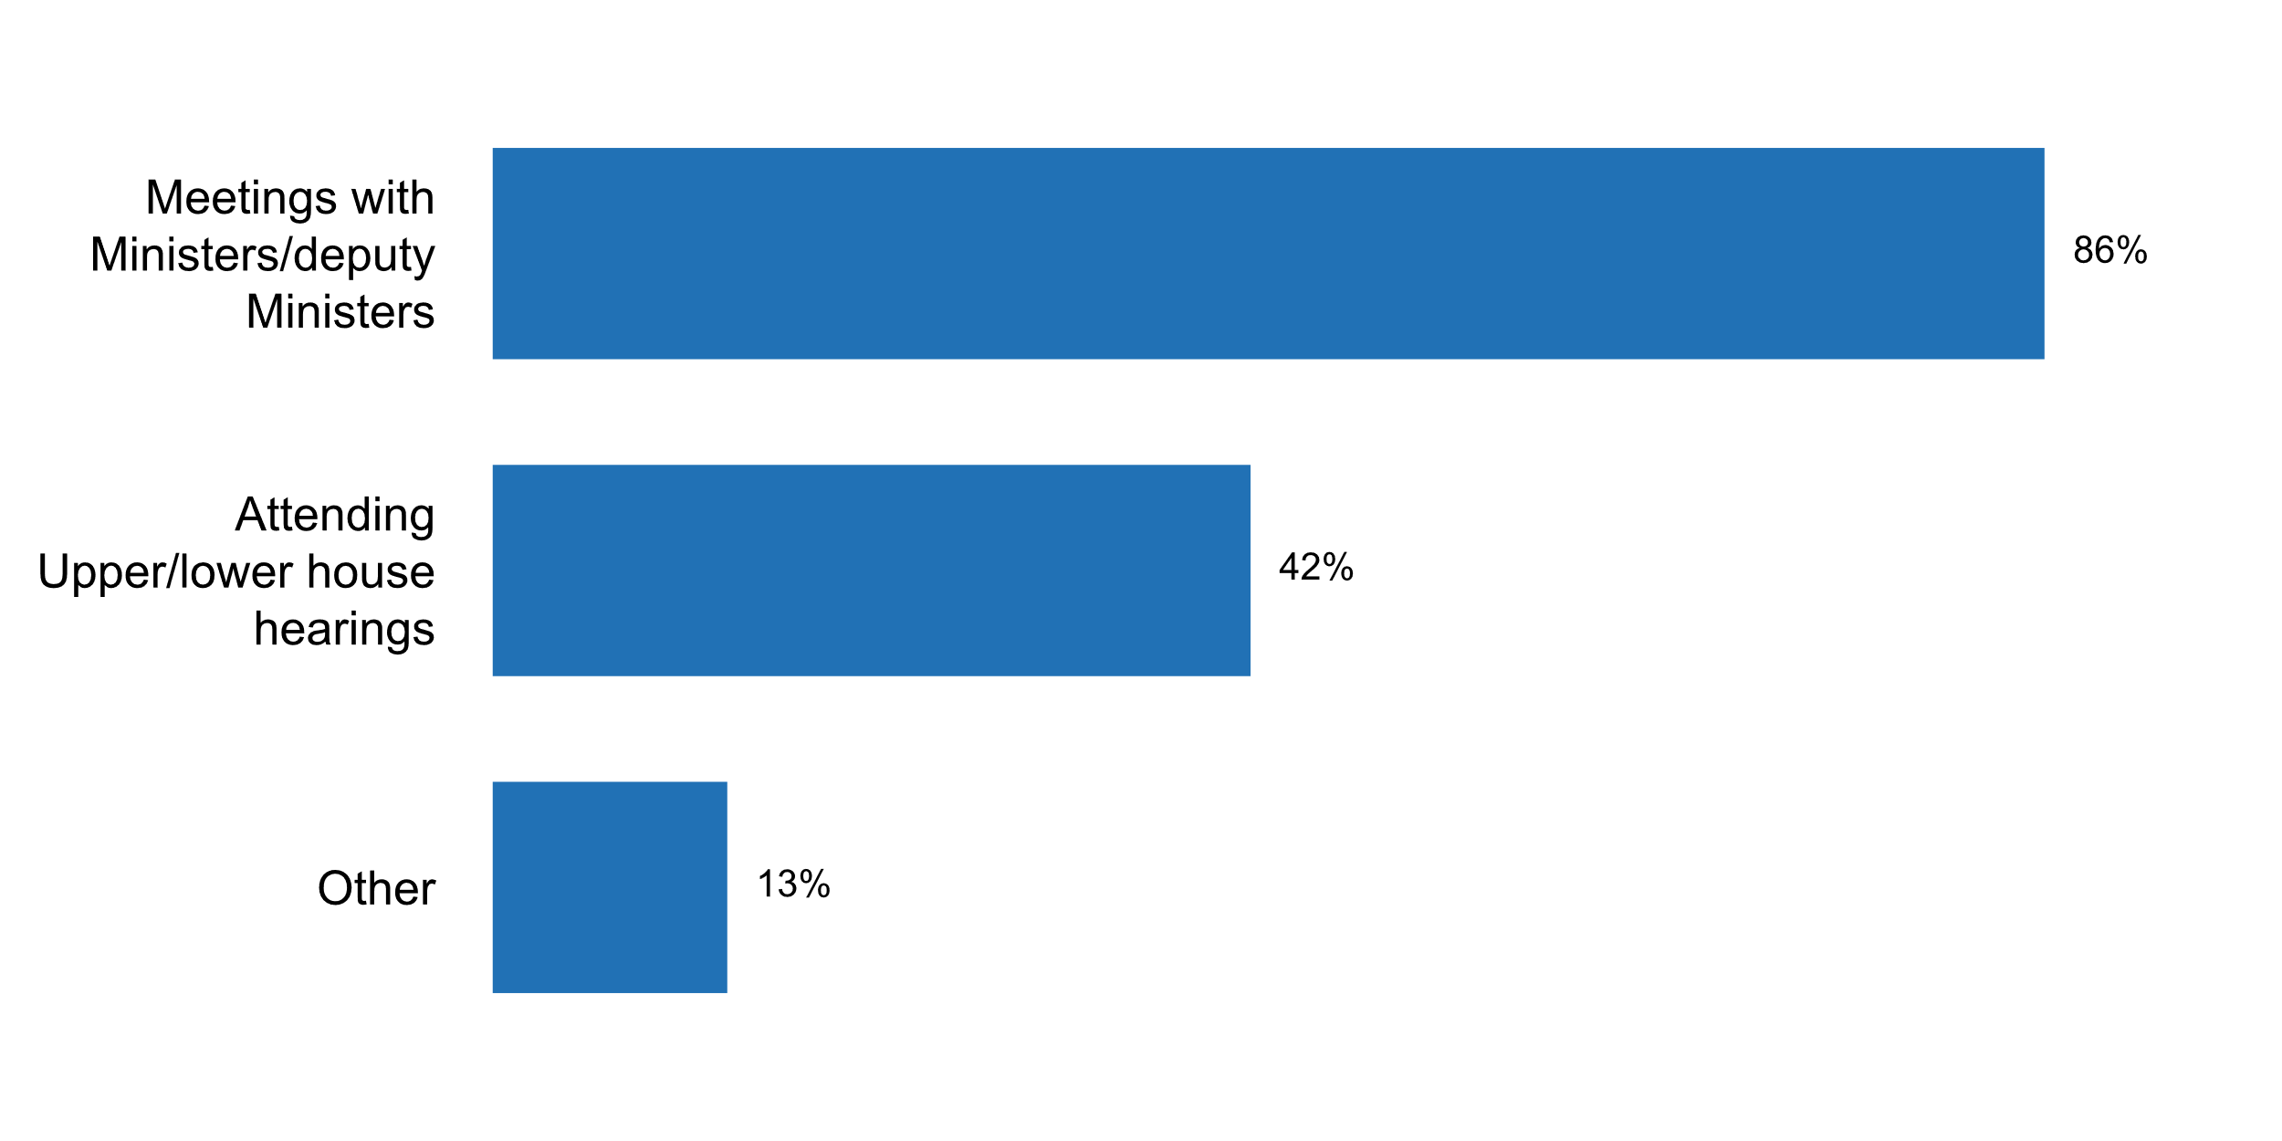

**Plot_19_Q02.2.svg**

**Existence of clear rules for appointment and dismissal of the head of NSO**

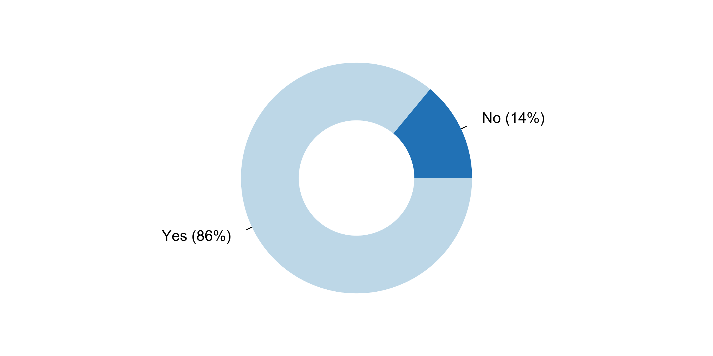

**Plot_20_Q02.2a.svg**

**Aspects regulated in rules for appointment and dismissal of the head of NSO**

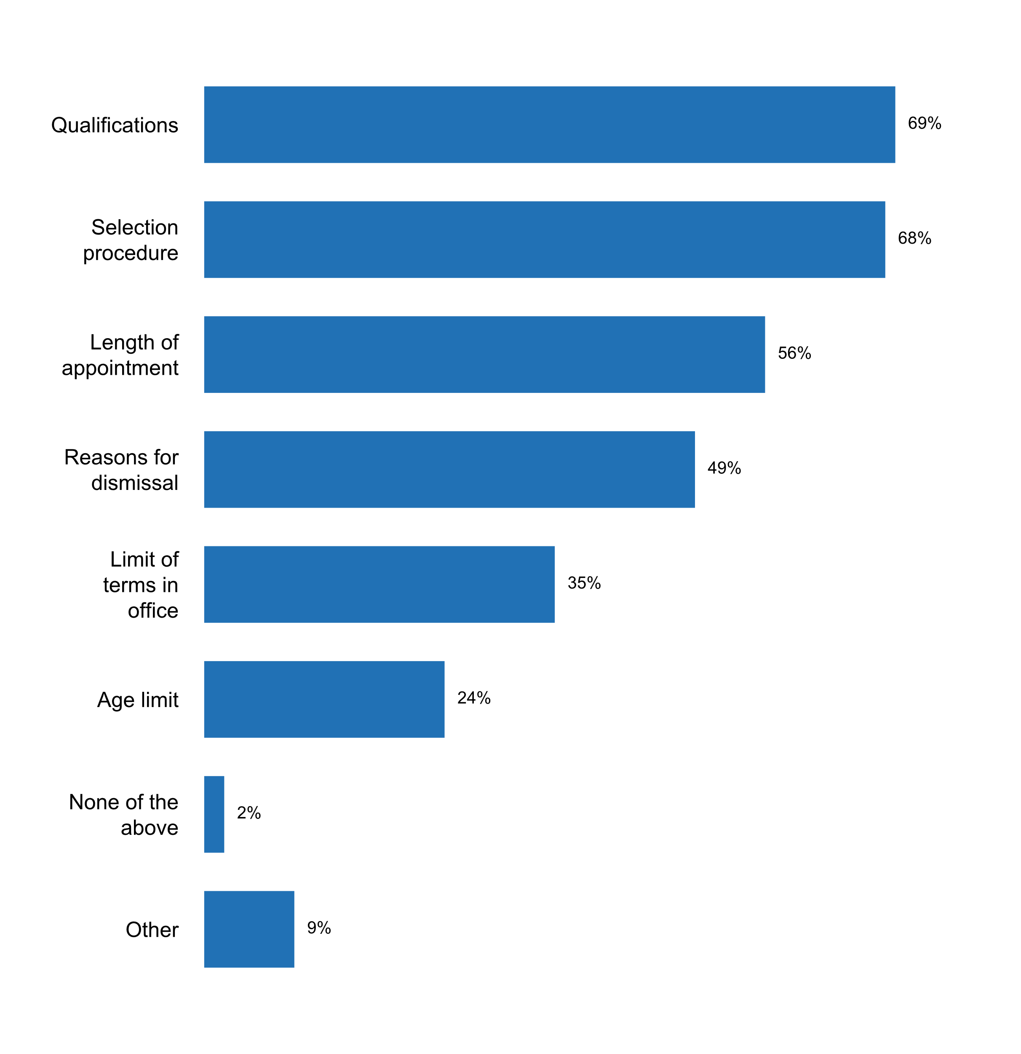

**Plot_21_Q02.3.svg**

**Inquiries (e.g. by the media, the academia, advocacy groups) on procedure for selecting a head of the NSO in the past five years**

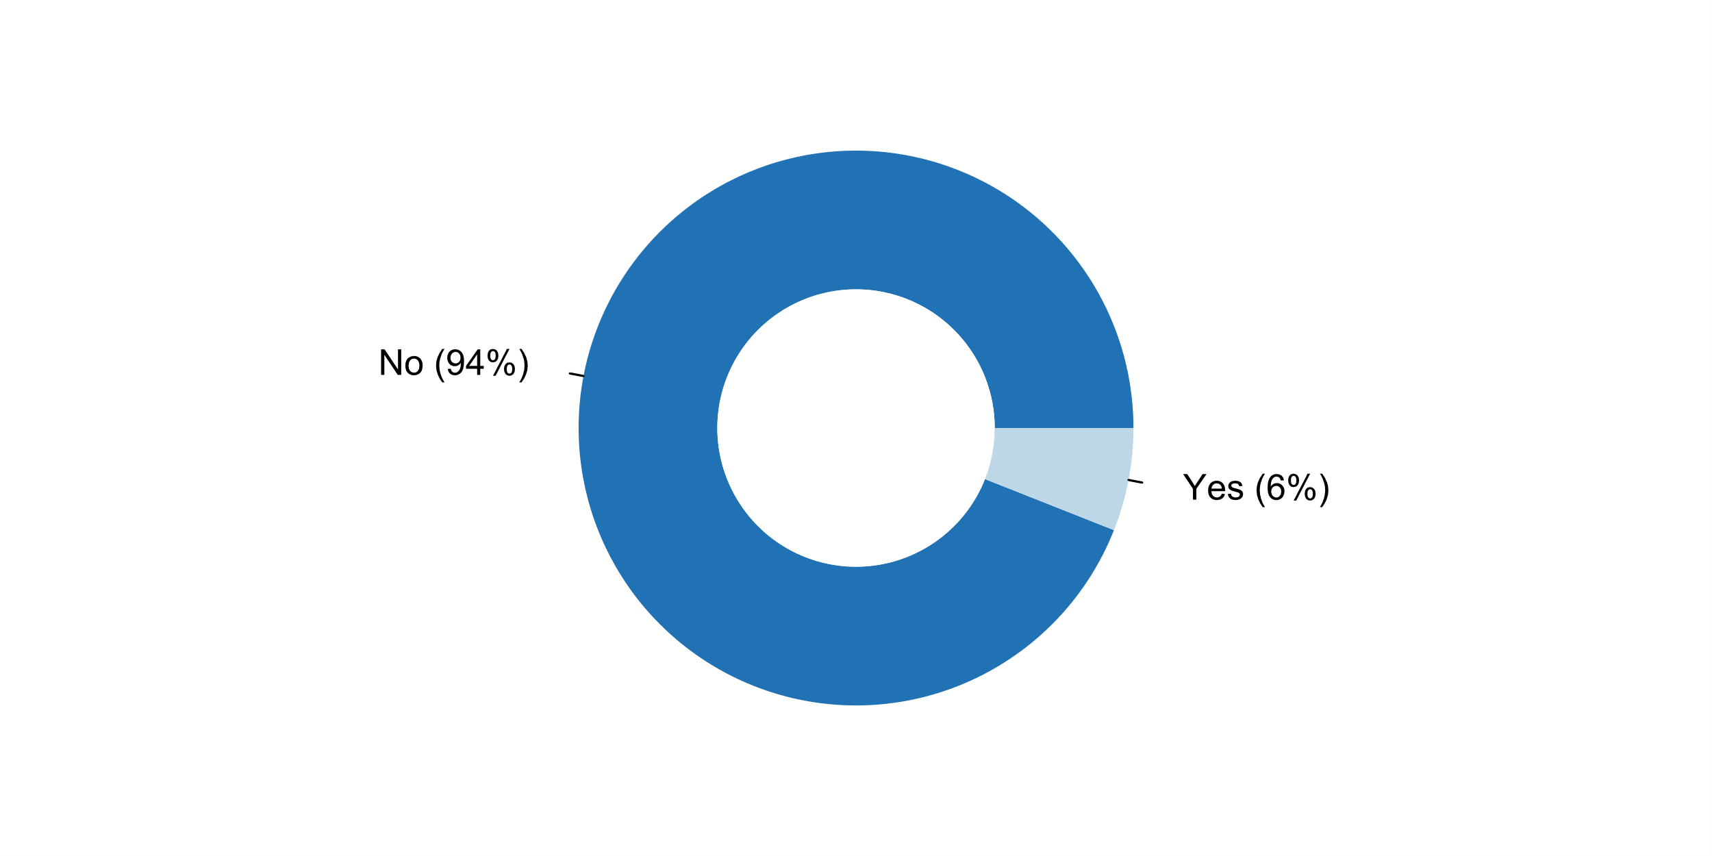

**Plot_22_Q02.4.svg**

**How NSS sought external endorsement of its methodologies and survey designs in the past five years**

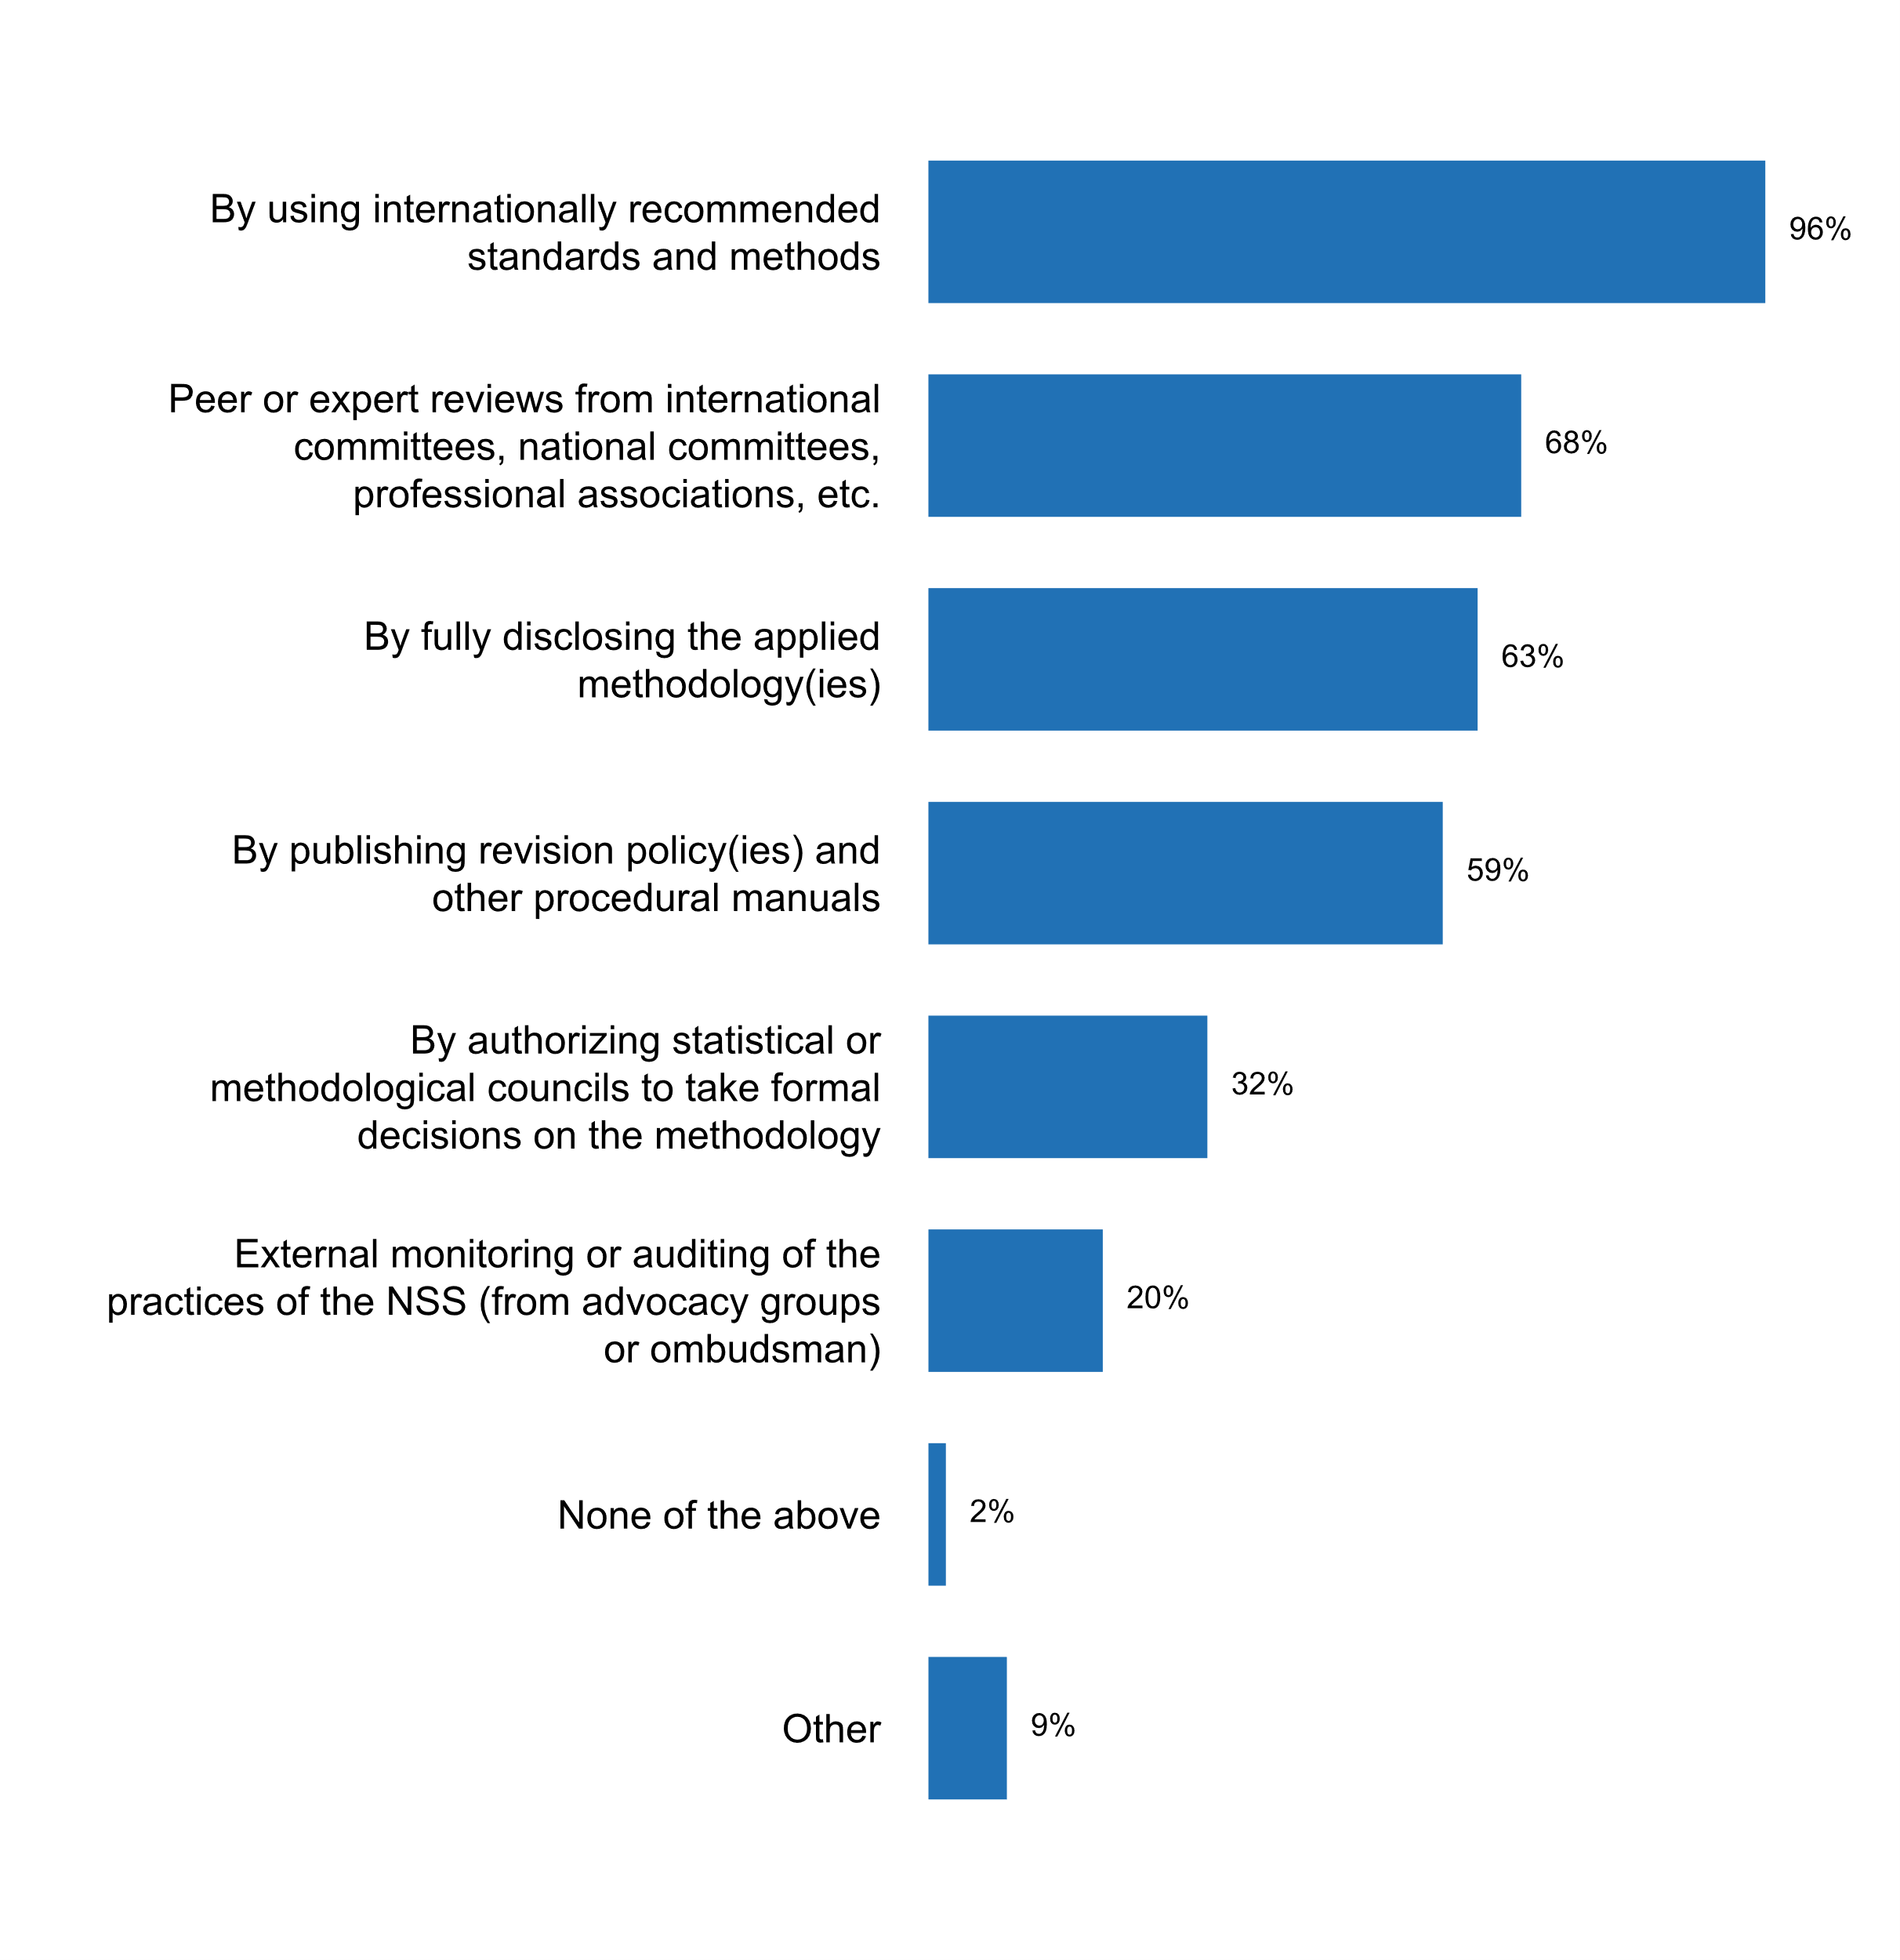

**Plot_23_Q02.5.svg**

**Measures currently being undertaken for coordinating standards and classifications across the NSS**

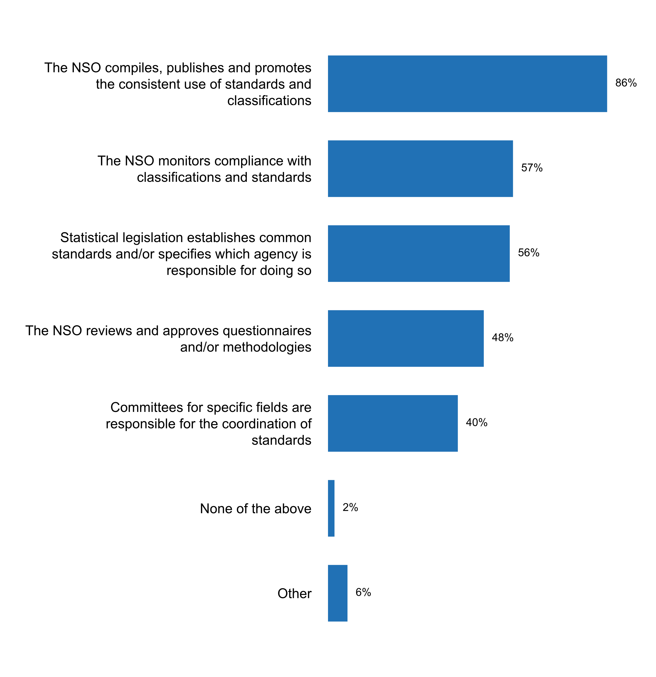

**Plot_24_Q02.6.svg**

**Document(s) providing guidance on professional ethics for staff**

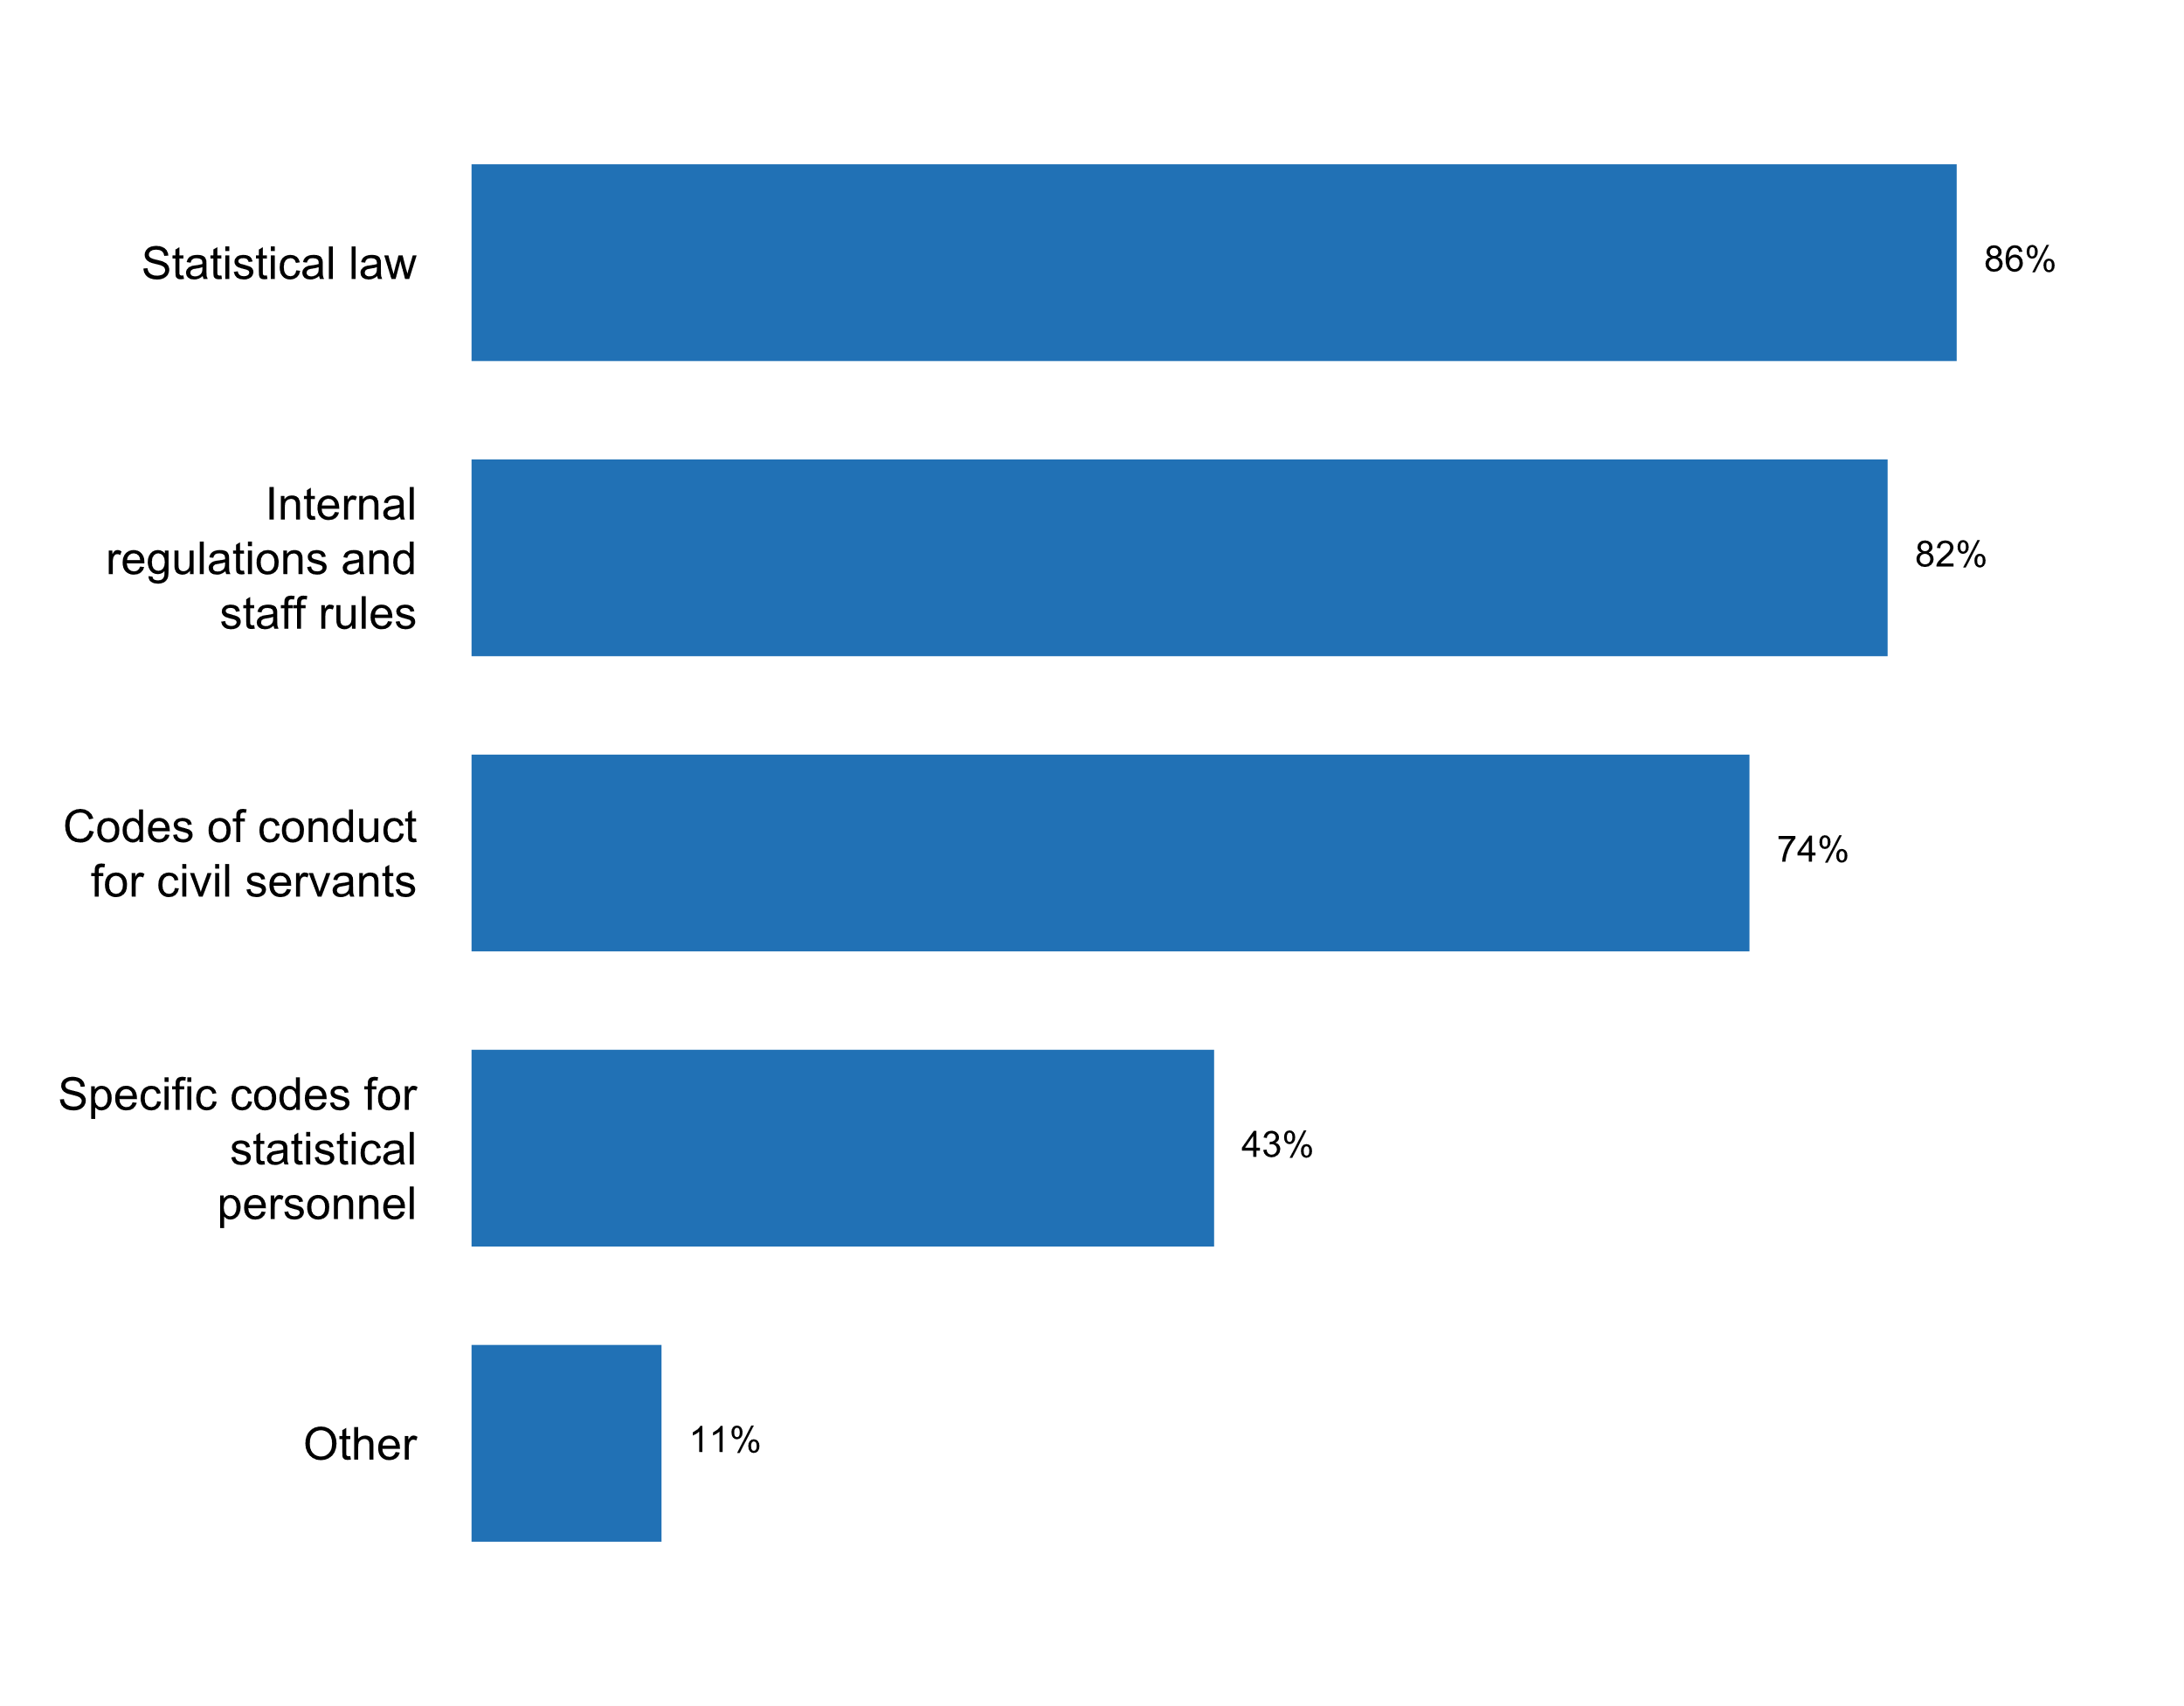

**Plot_25_Q02.7.svg**

**Ways in which staff have been informed and reminded of existing codes of conduct, in the past five years**

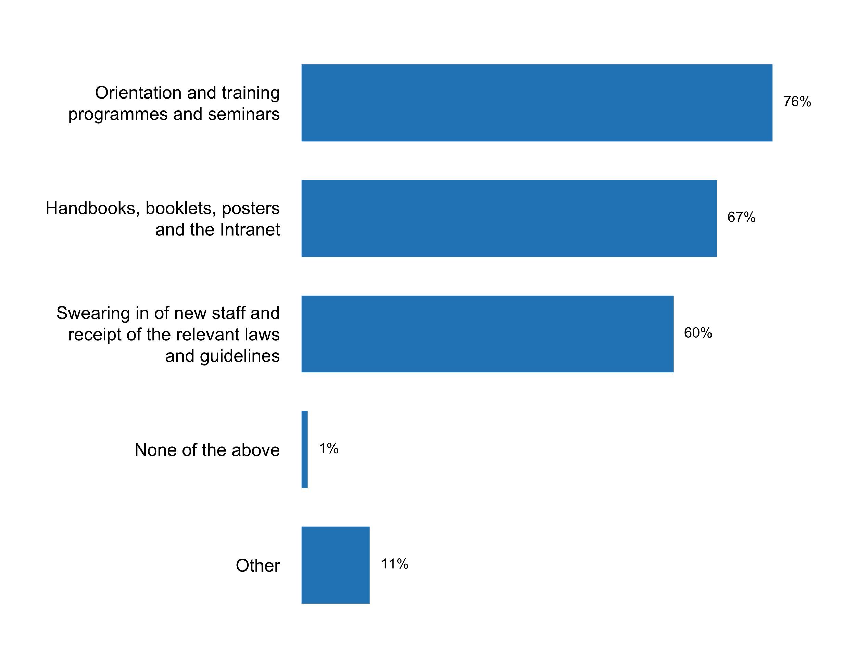

**Plot_26_Q02.9_Q2.10.svg**

**Training concerning open data, data privacy or access to information policies and principles**

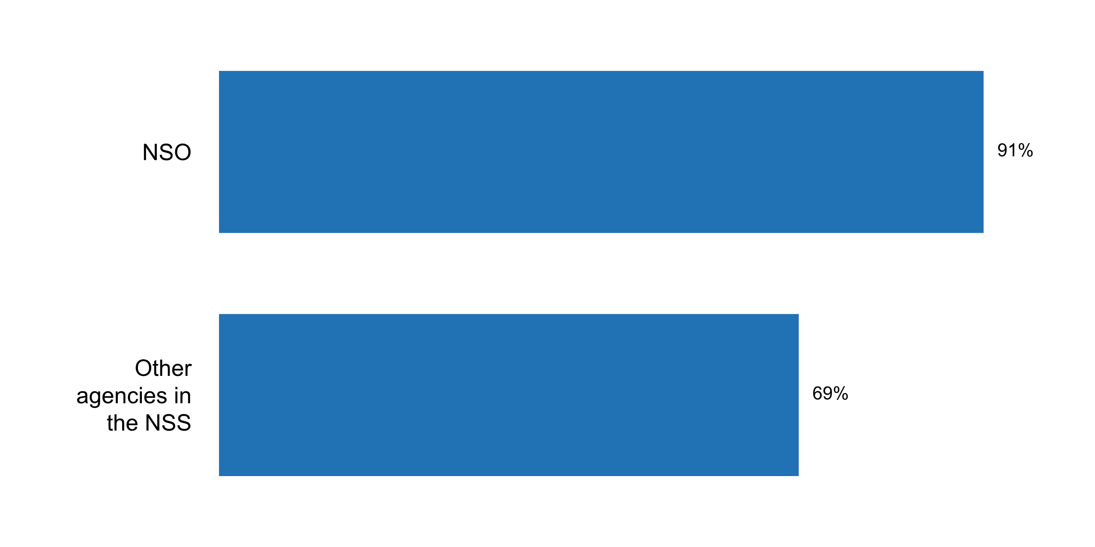

**Plot_27_Q03.1.svg**

**Dissemination channels through which the NSS/NSO makes its data available to the public?**

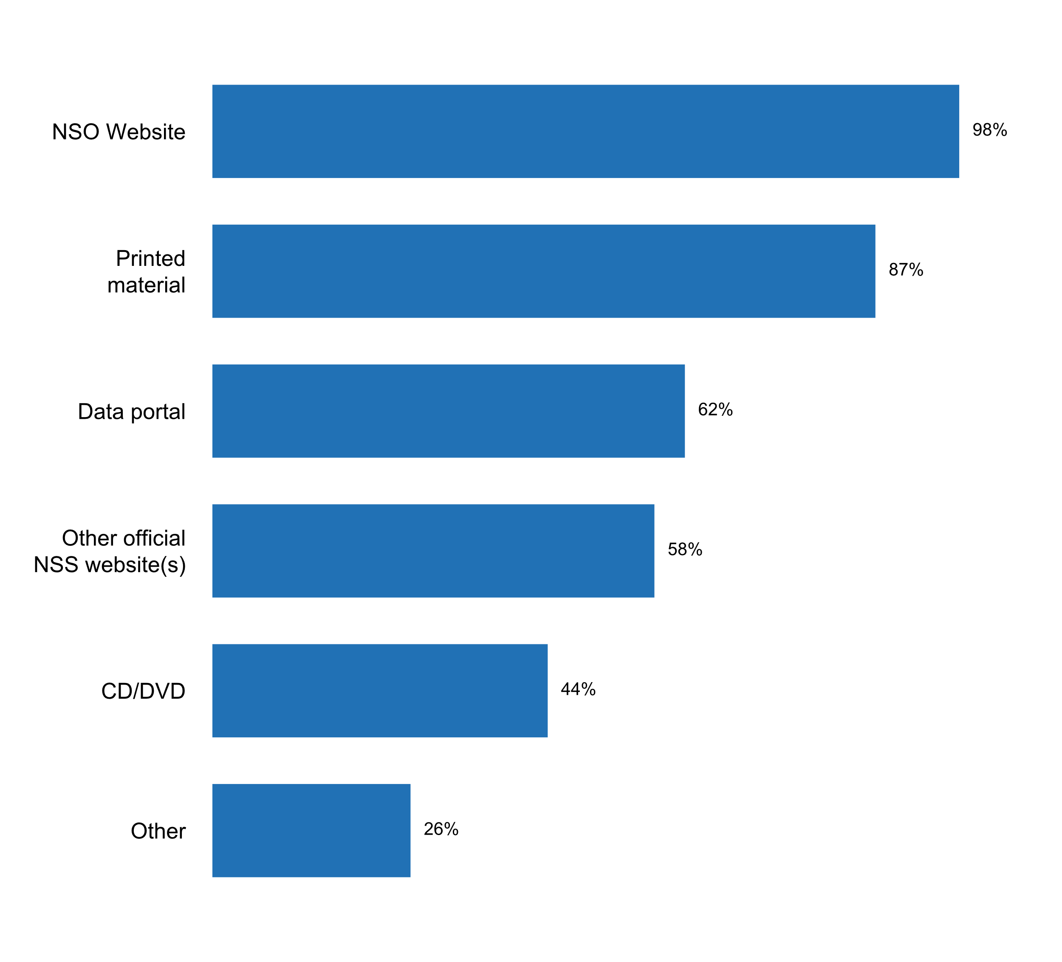

**Plot_28_Q03.2.svg**

**How users are informed of the quality of published data**

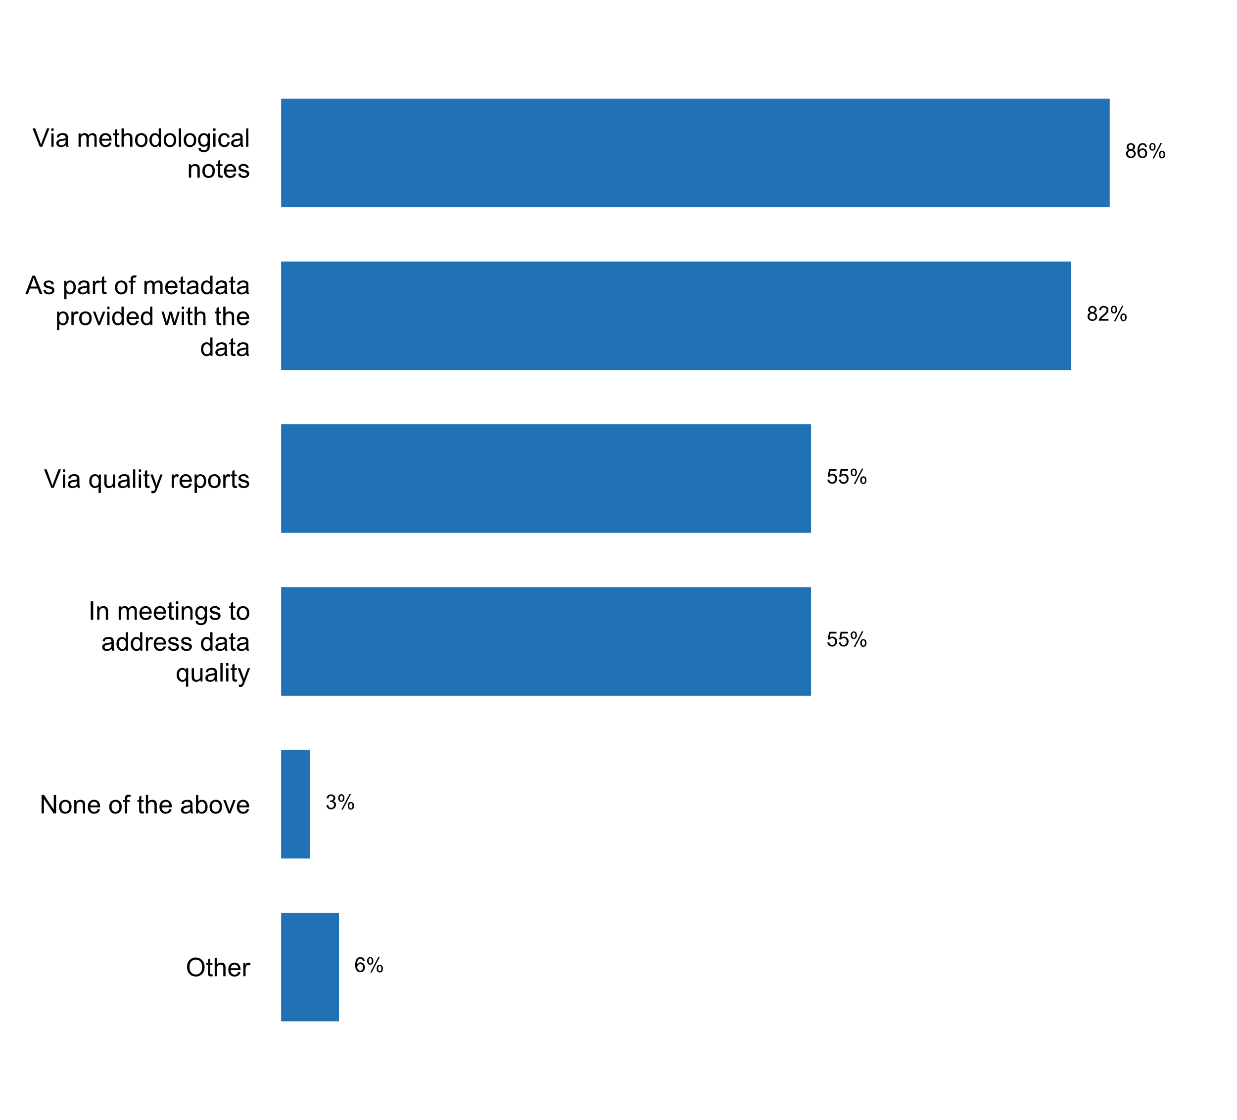

**Plot_29_Q03.3.svg**

**Types of explanatory texts that accompany published data**

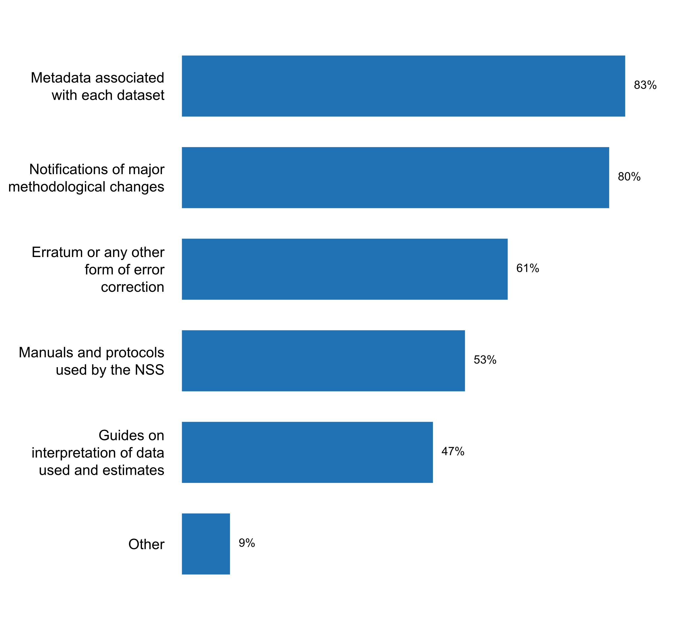

**Plot_30_Q03.3b.svg**

**Information included in explanatory texts that accompany published data**

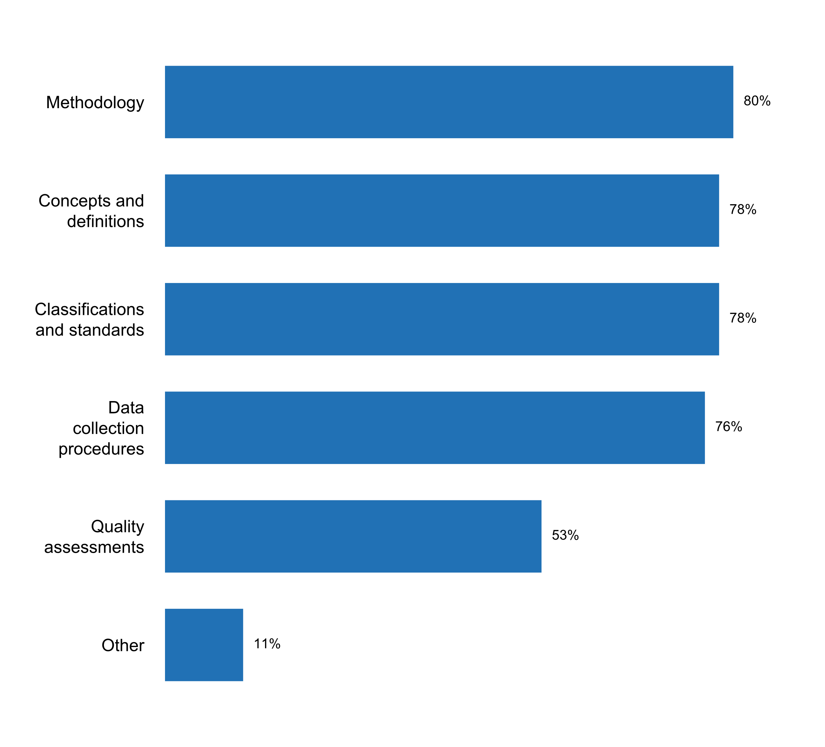

**Plot_31_Q03.3d.svg**

**Types of manuals and protocols made available with published data**

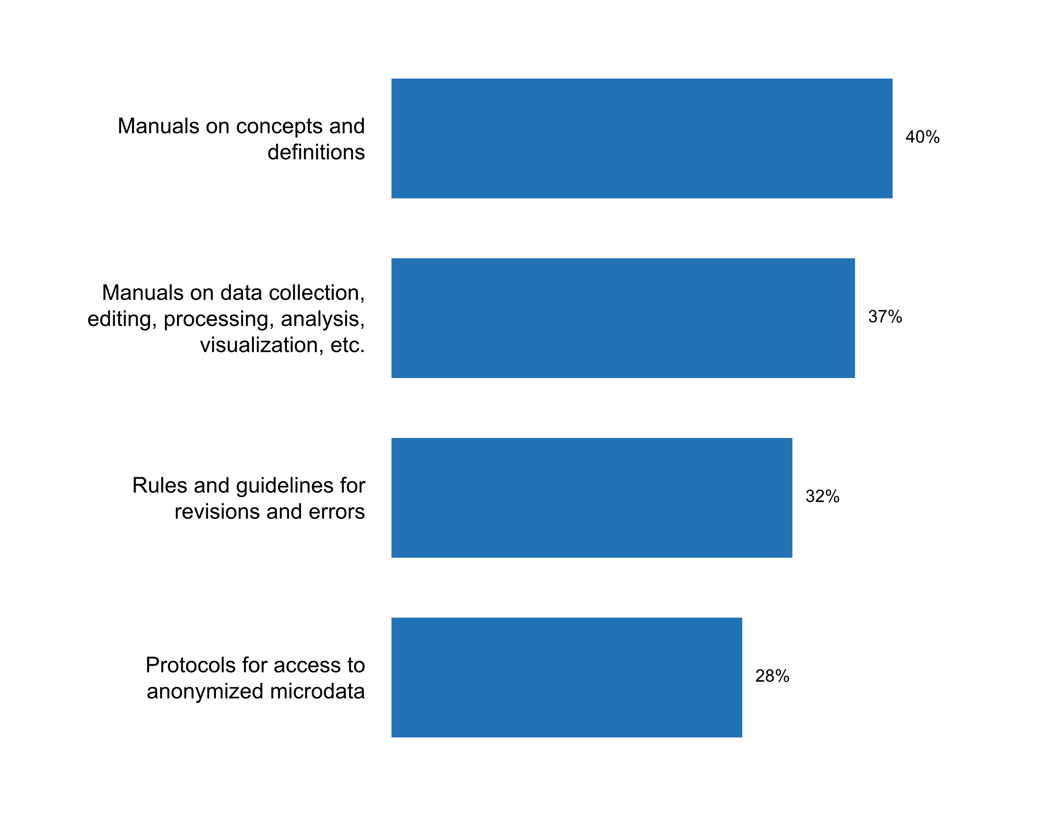

**Plot_32_Q03.4.svg**

**Data platforms(s) currently used by NSS/NSO to disseminate statistical data**

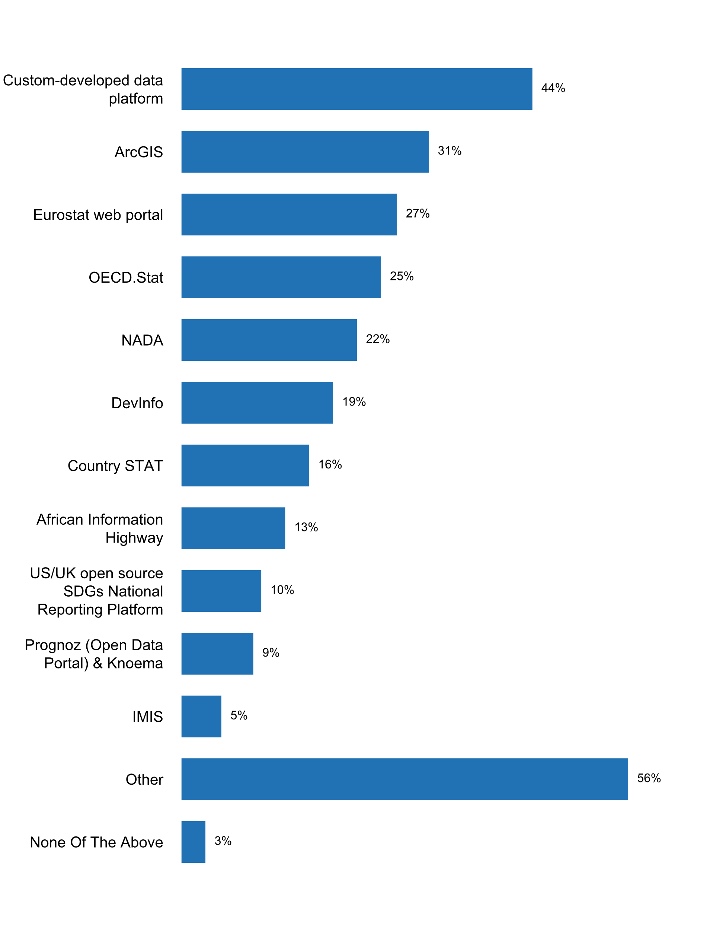

**Plot_33_Q04.1.svg**

**The NSO/NSS has reacted to erroneous interpretation and misuse of statistics during the past five years**

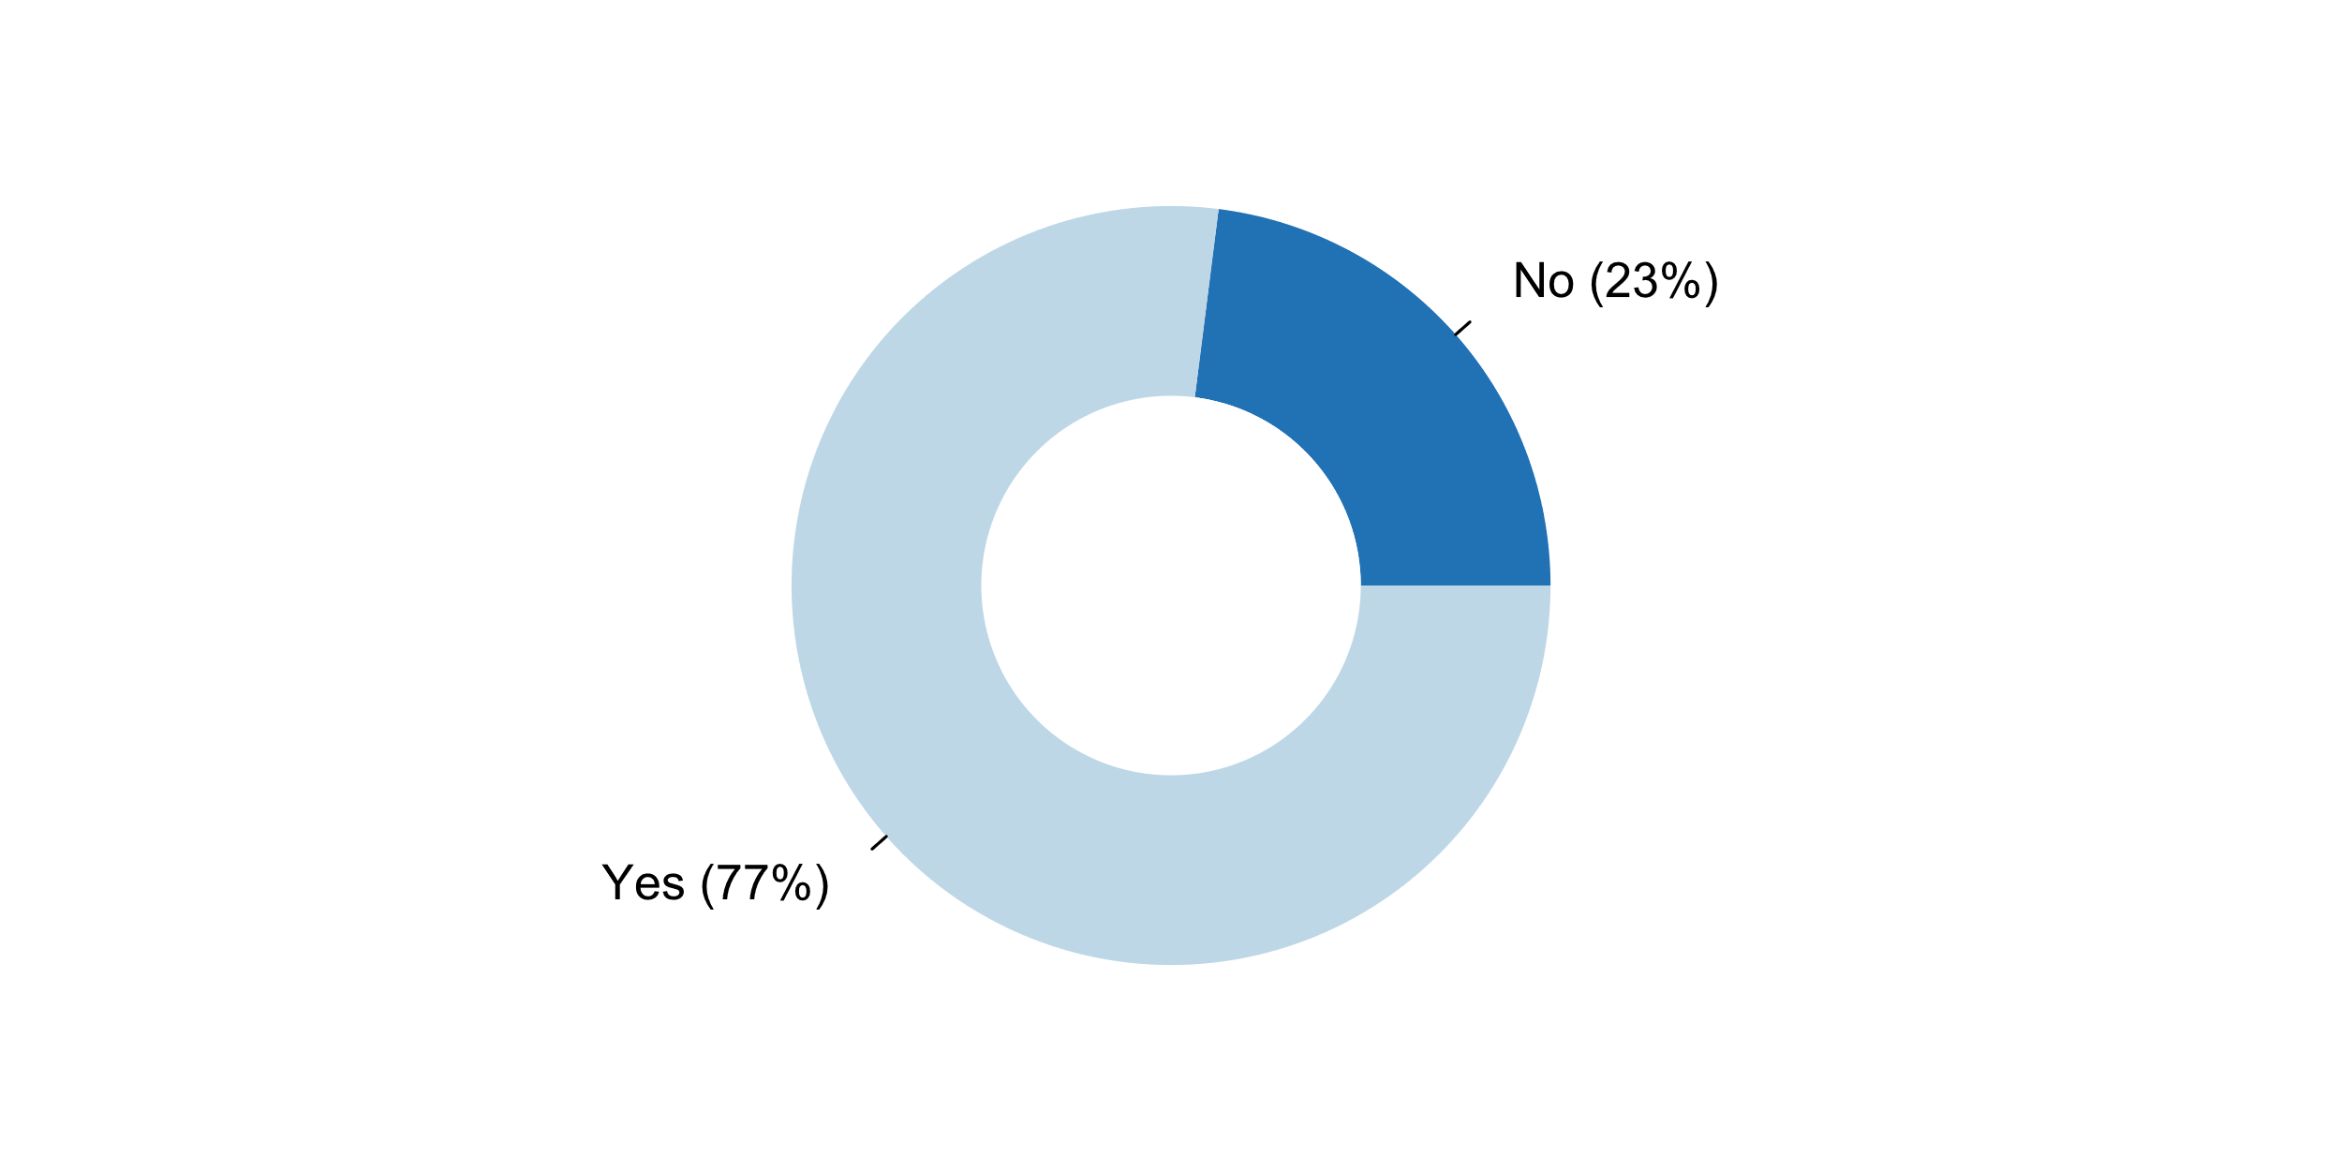

**Plot_34_Q04.2.svg**

**How NSO/NSS reacted to erroneous interpretations and misuse of statistics during the past five years**

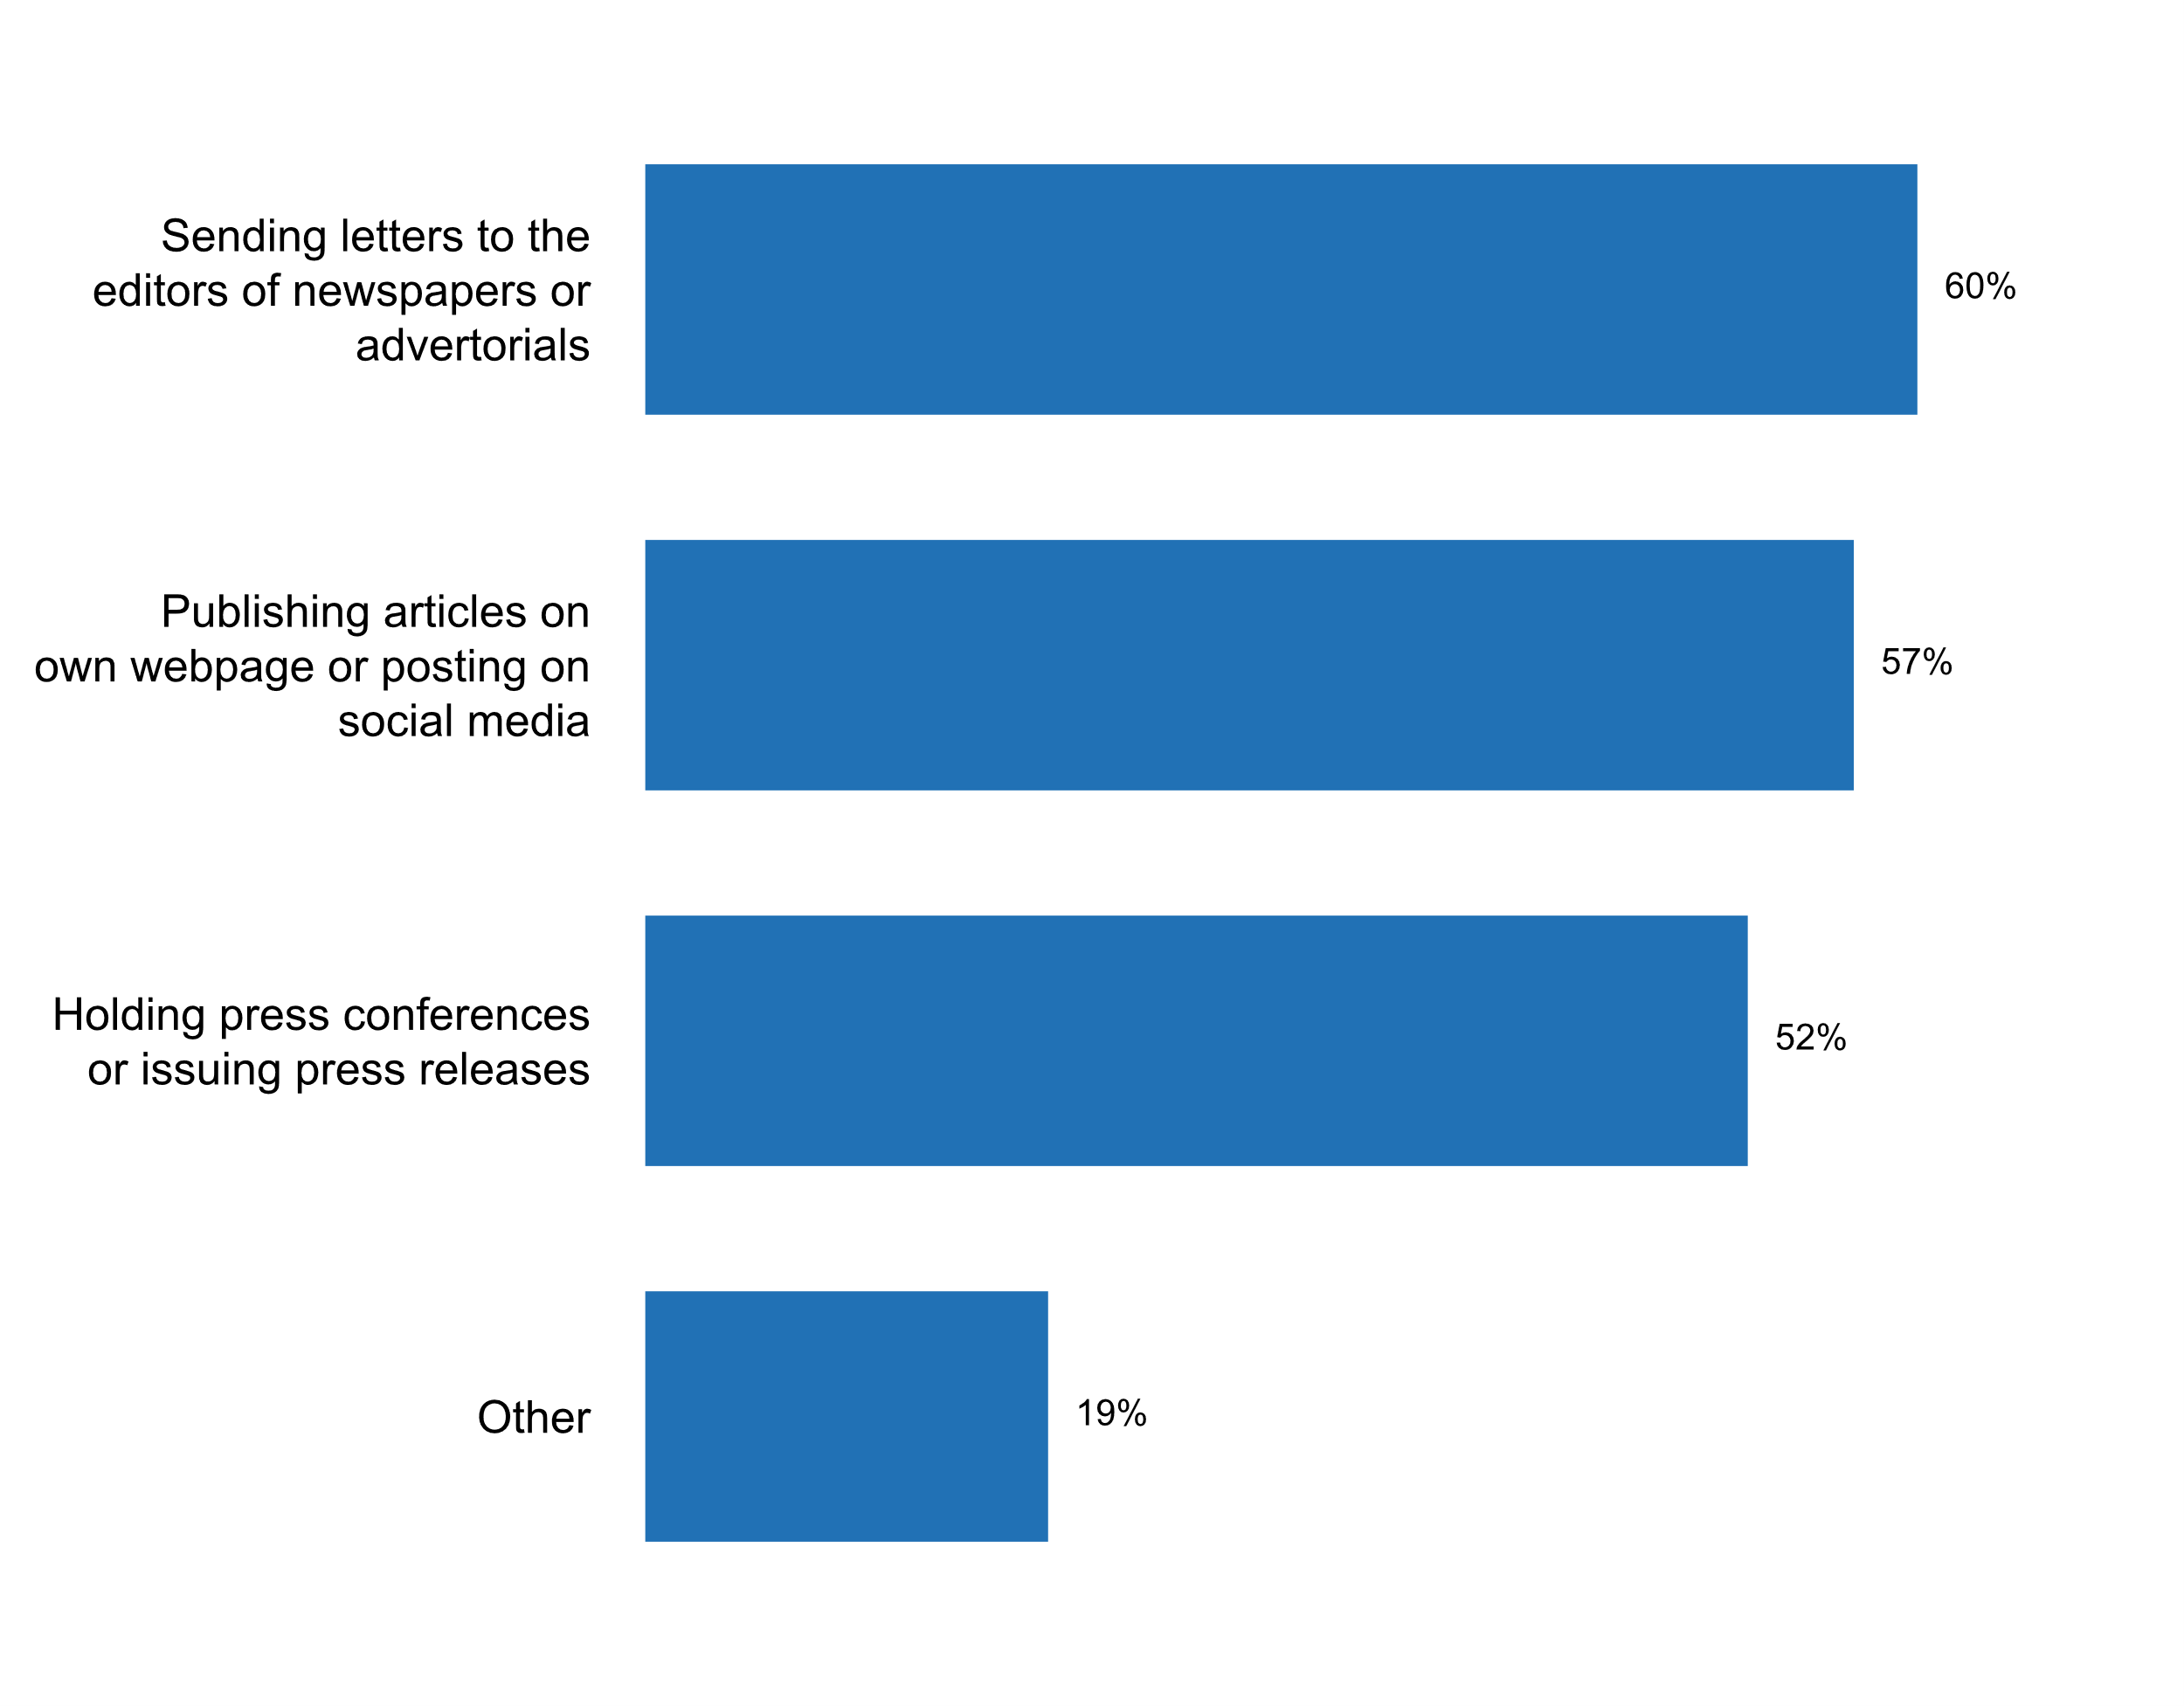

**Plot_35_Q04.2a.svg**

**Types of misuse identified in the past two years?**

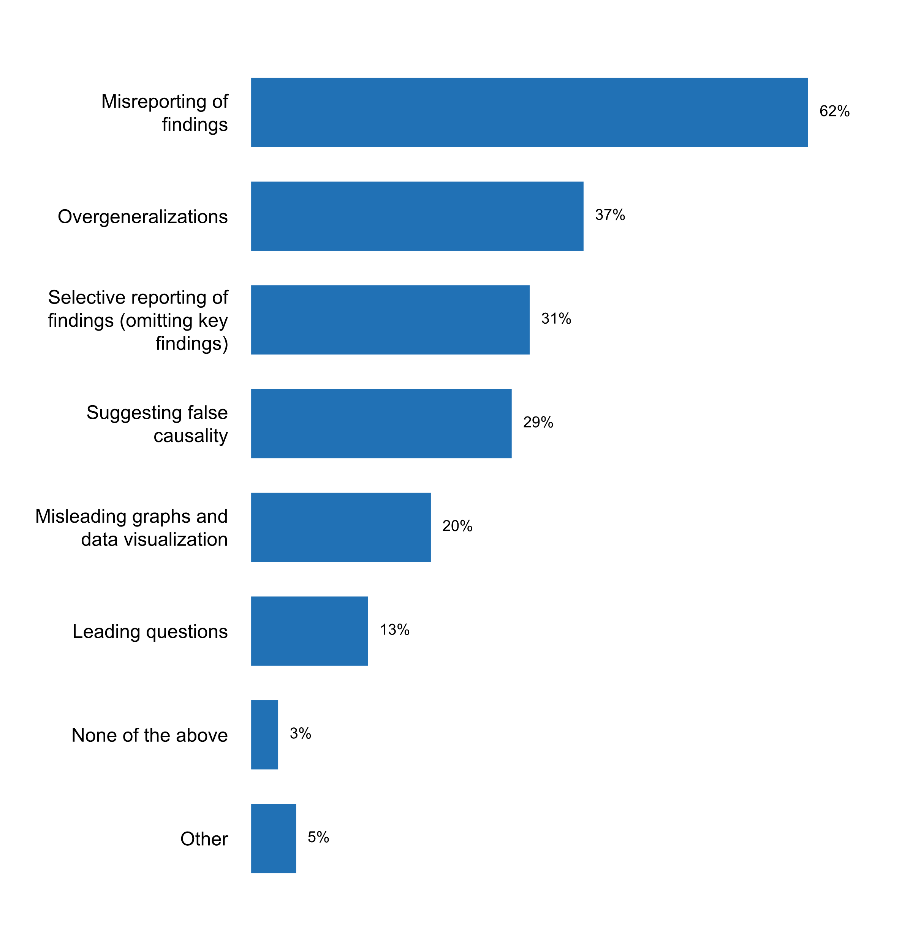

**Plot_36_Q04.2b.svg**

**Number of times the NSO/NSS commented on erroneous interpretation and misuse of statistics in the past five years**

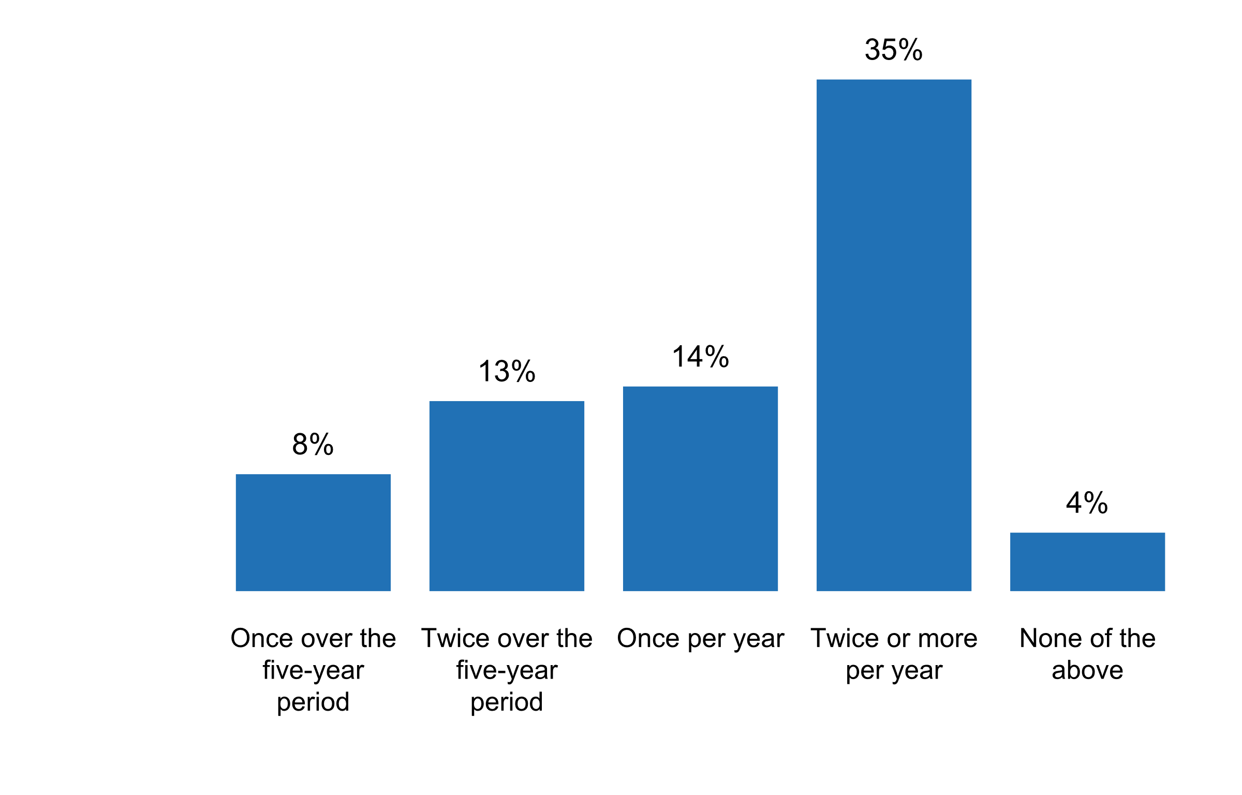

**Plot_37_Q04.3.svg**

**Activities carried out by the NSO/NSS to educate data users in the past five years, including the media**

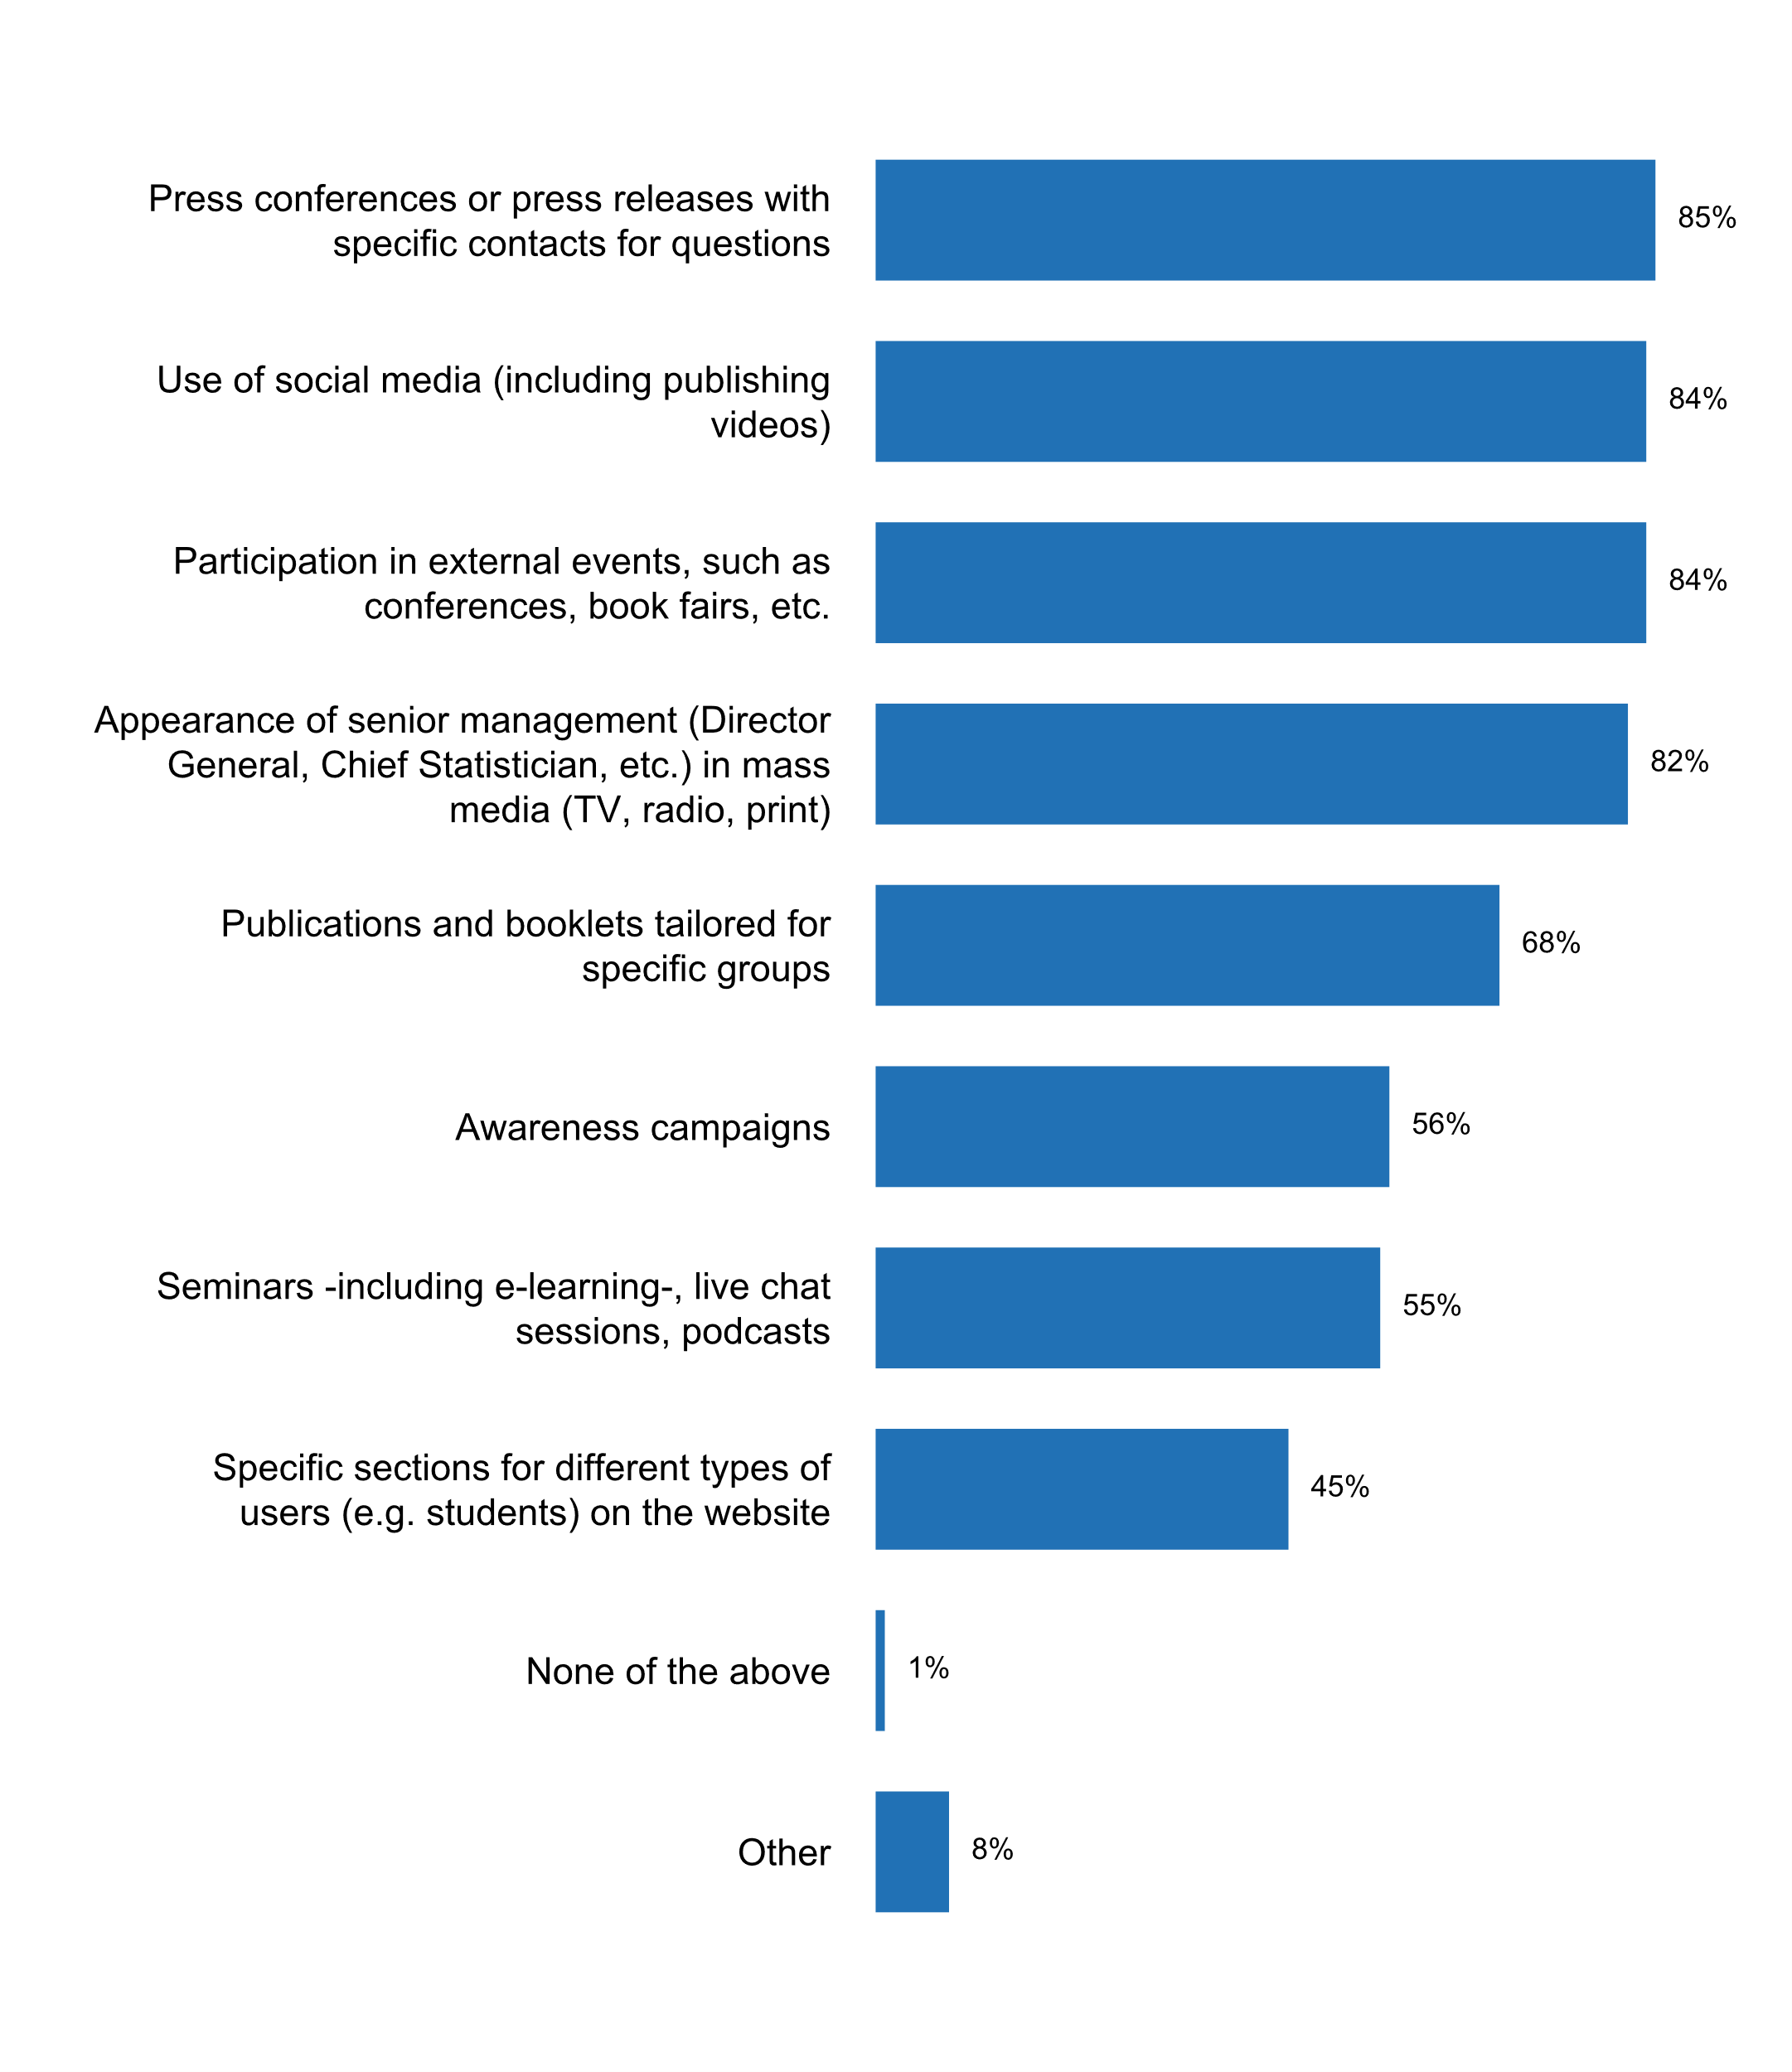

**Plot_38_Q04.3a.svg**

**Number of times "seminars, participation in external events, and/or appearance in mass media" took place to educate users in the past five years**

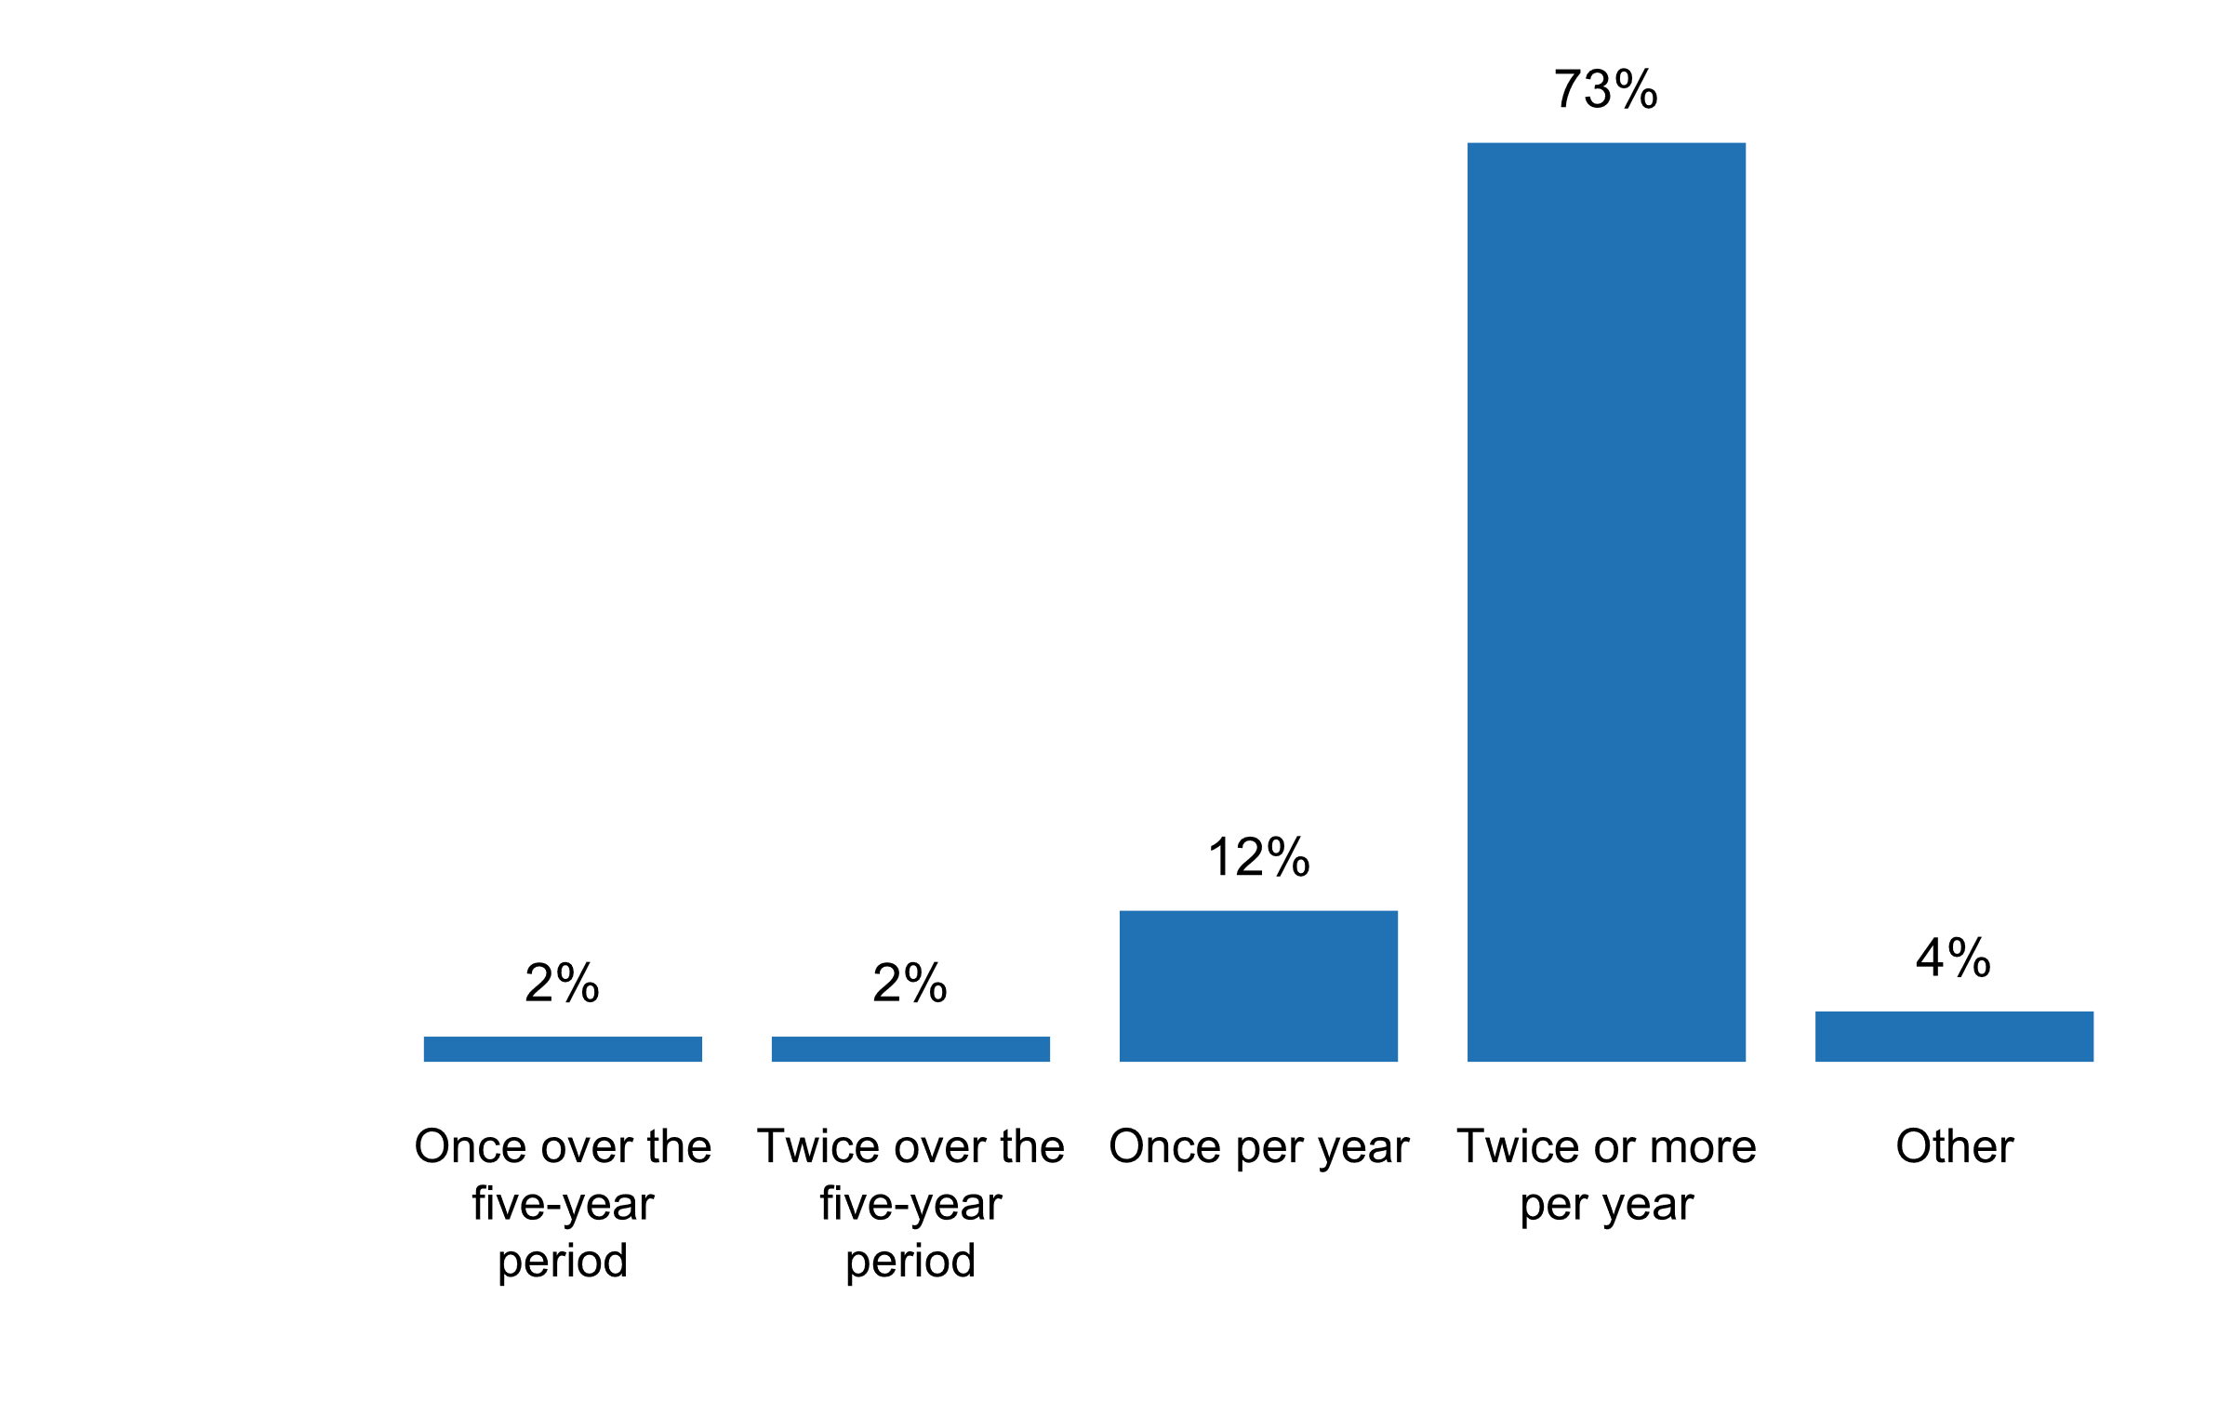

**Plot_39_Q05.1.svg**

**Sources of data currently used by the NSO**

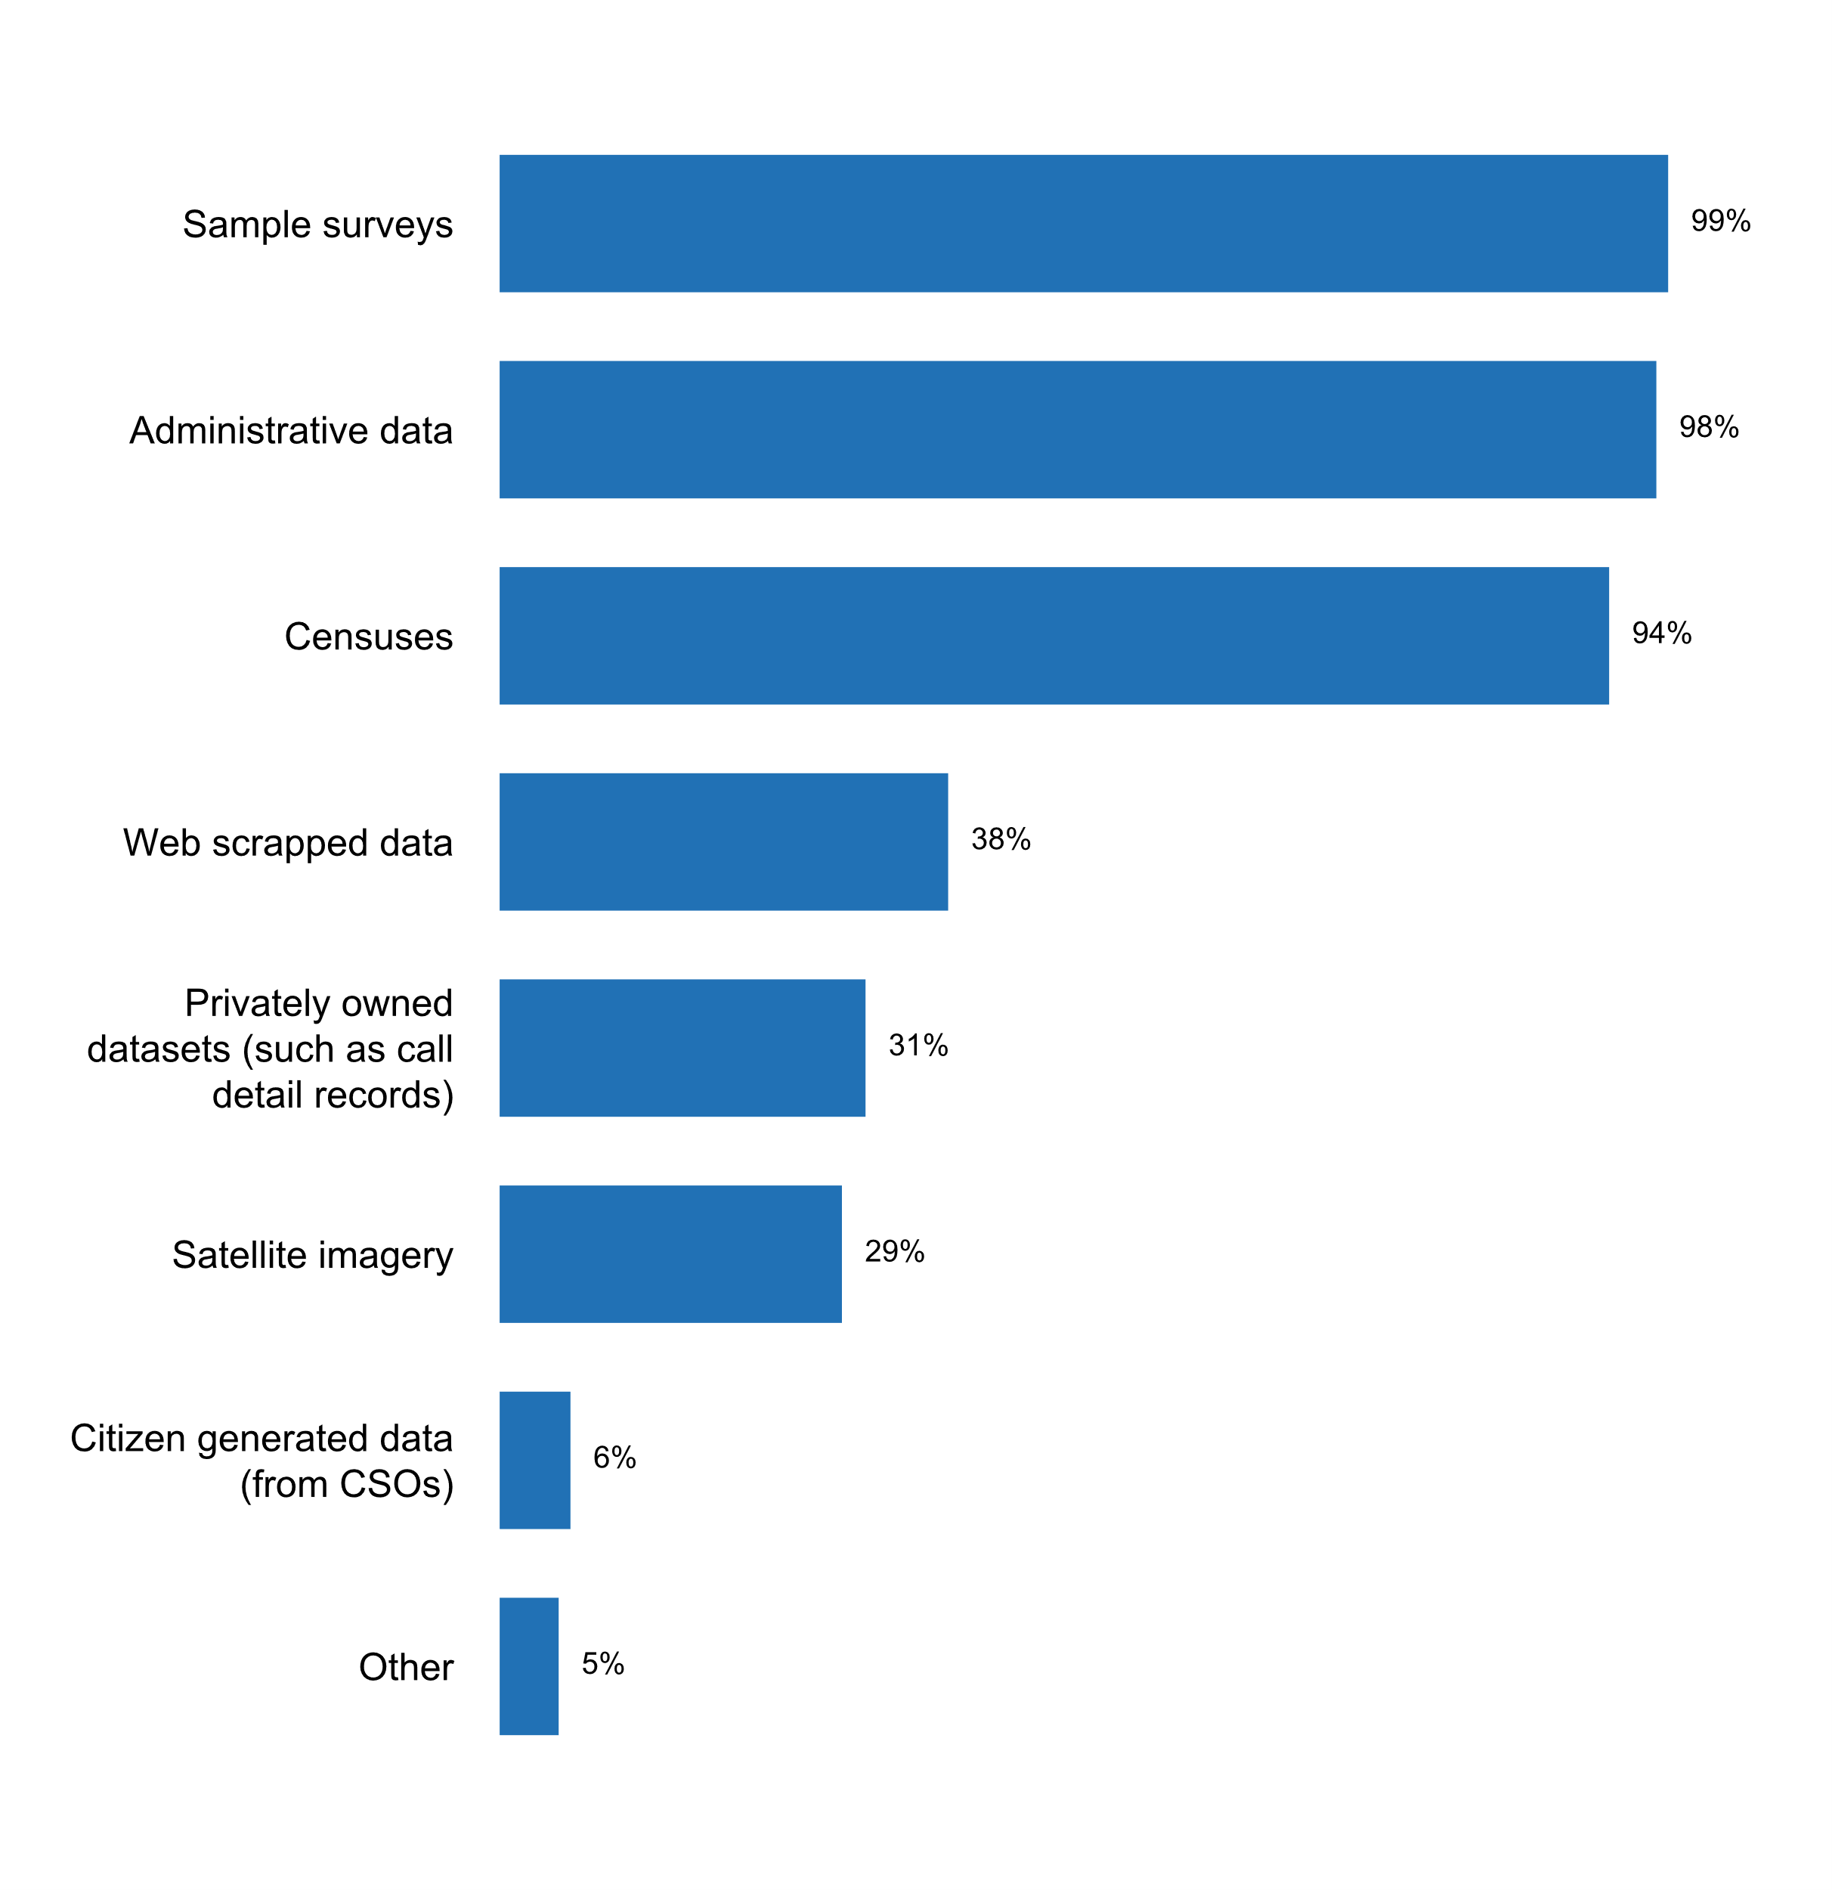

**Plot_40_Q05.1a.svg**

**How administrative records are currently used**

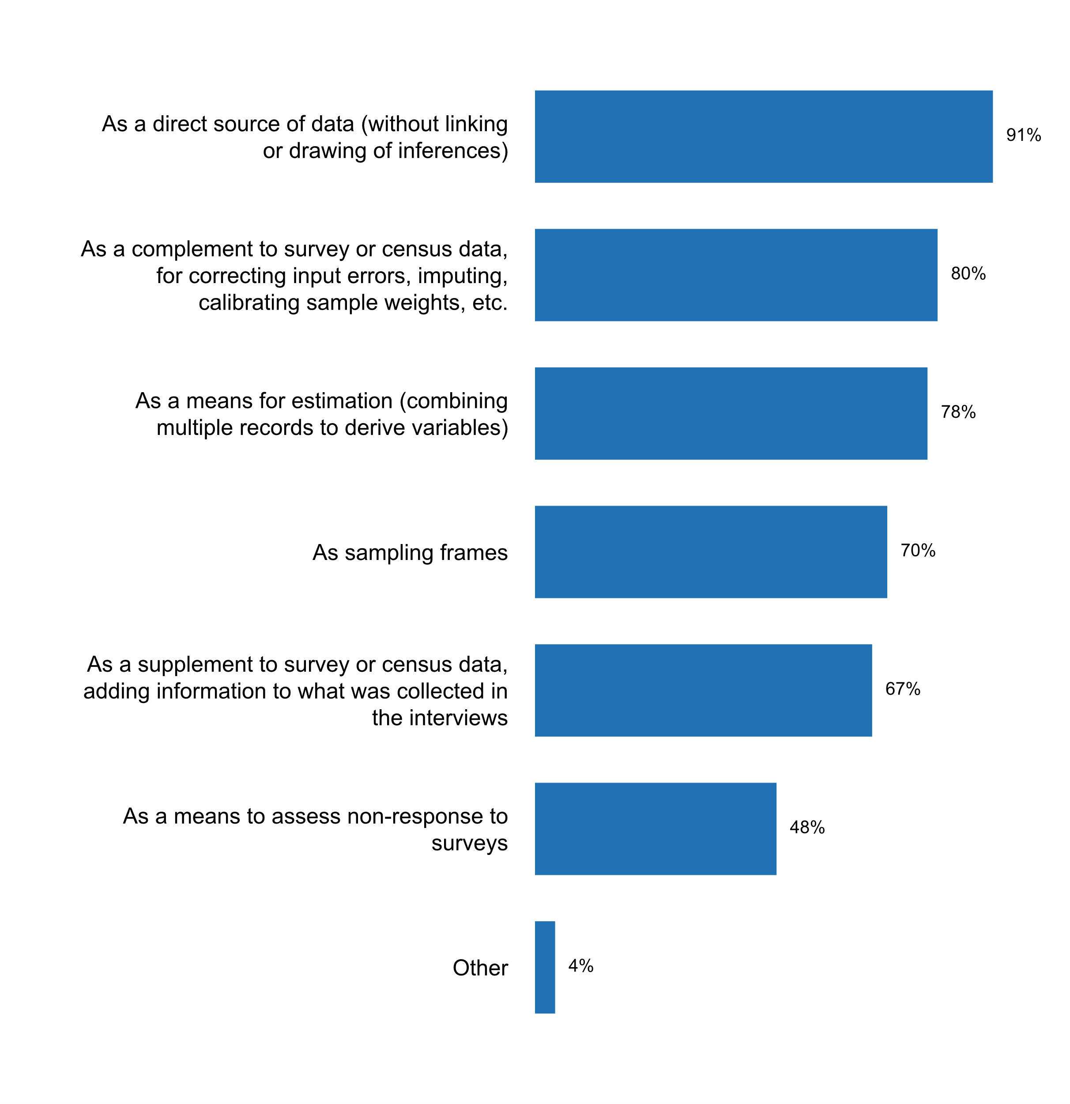

**Plot_41_Q05.1b.svg**

**Actions are being taken for adapting administrative records to statistical purposes**

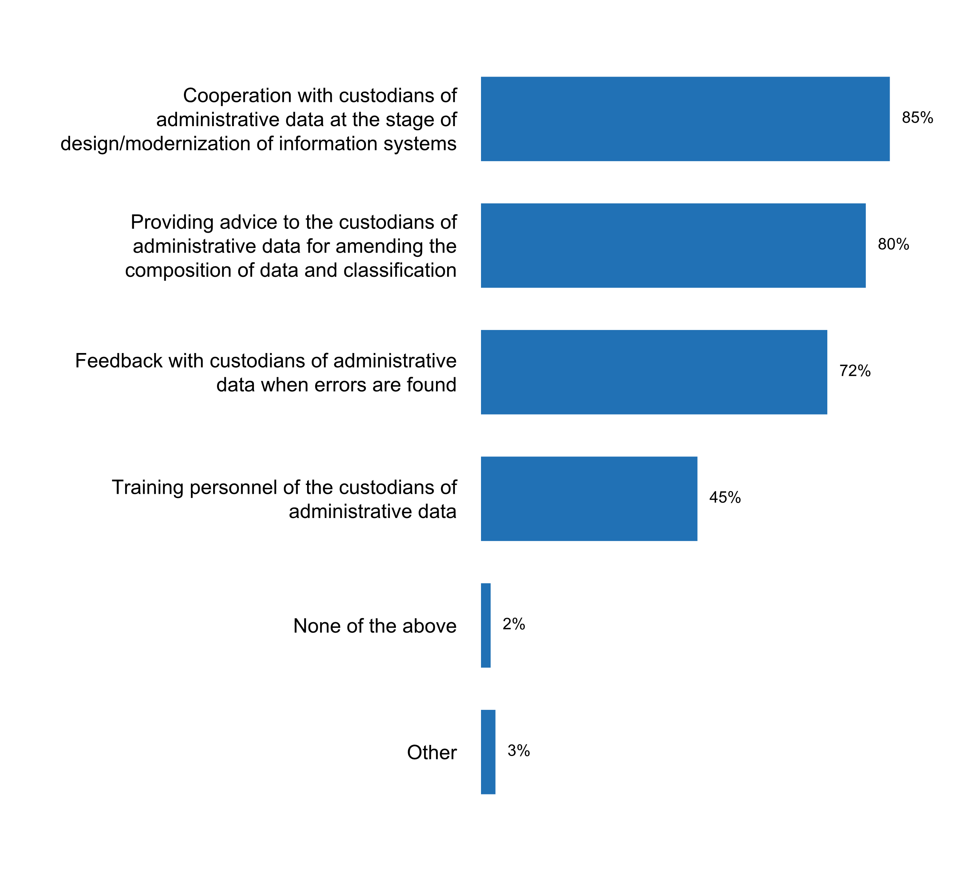

**Plot_42_Q05.1c.svg**

**How the NSS accesses and uses big data or citizen-generated data**

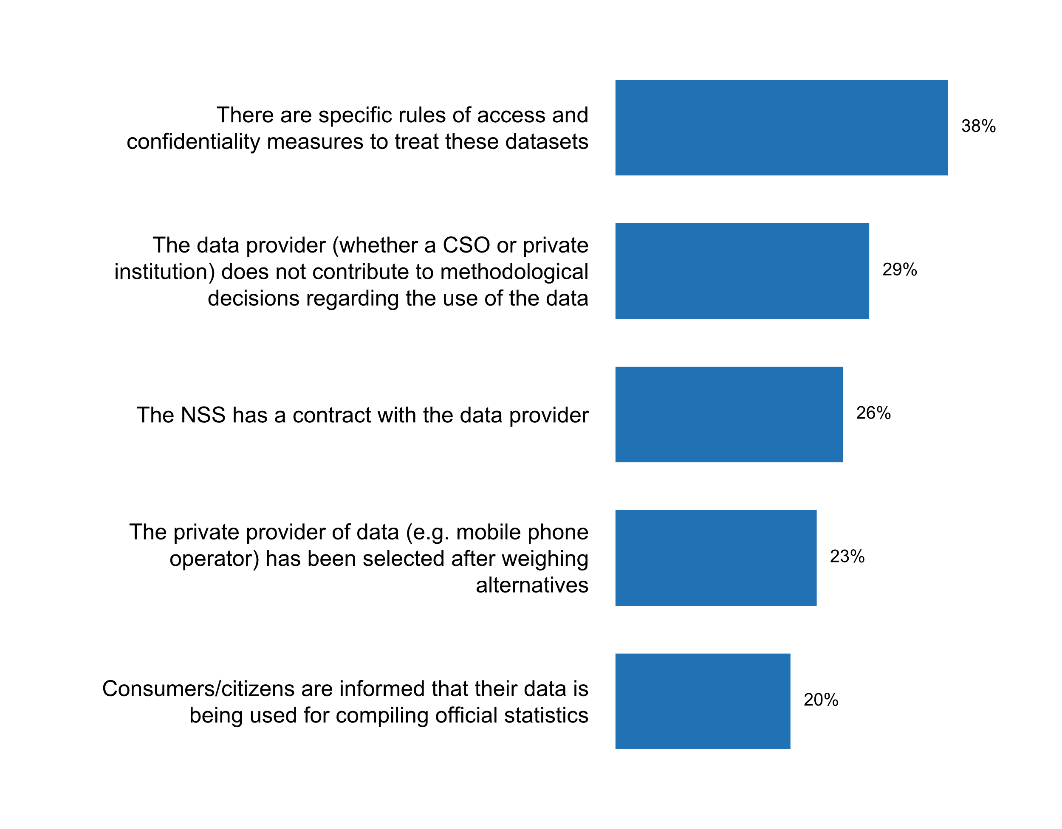

**Plot_43_Q05.2.svg**

**Measures taken to ensure timely release of survey results and/or statistical publications/bulletins**

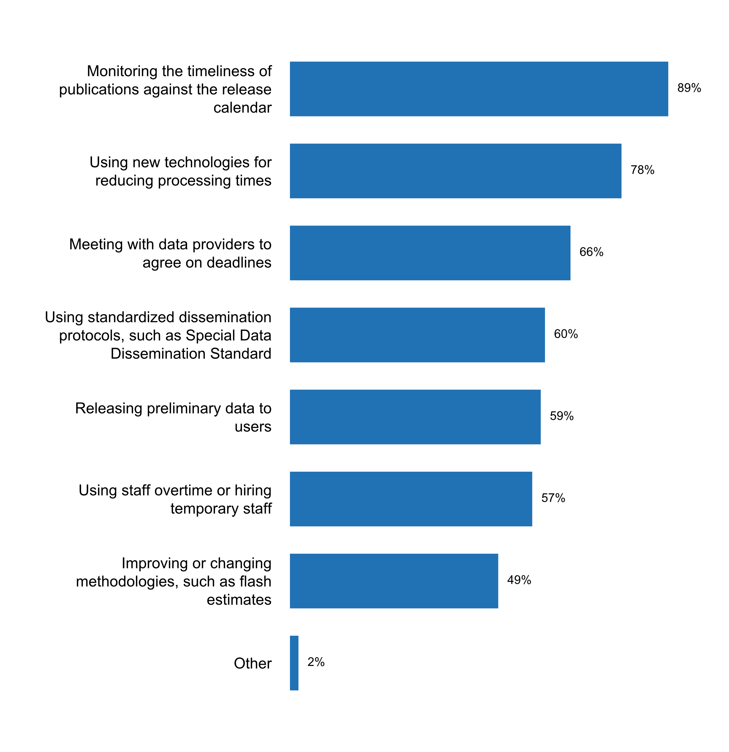

**Plot_44_Q05.3.svg**

**Quality management framework(s) currently applied by the NSO**

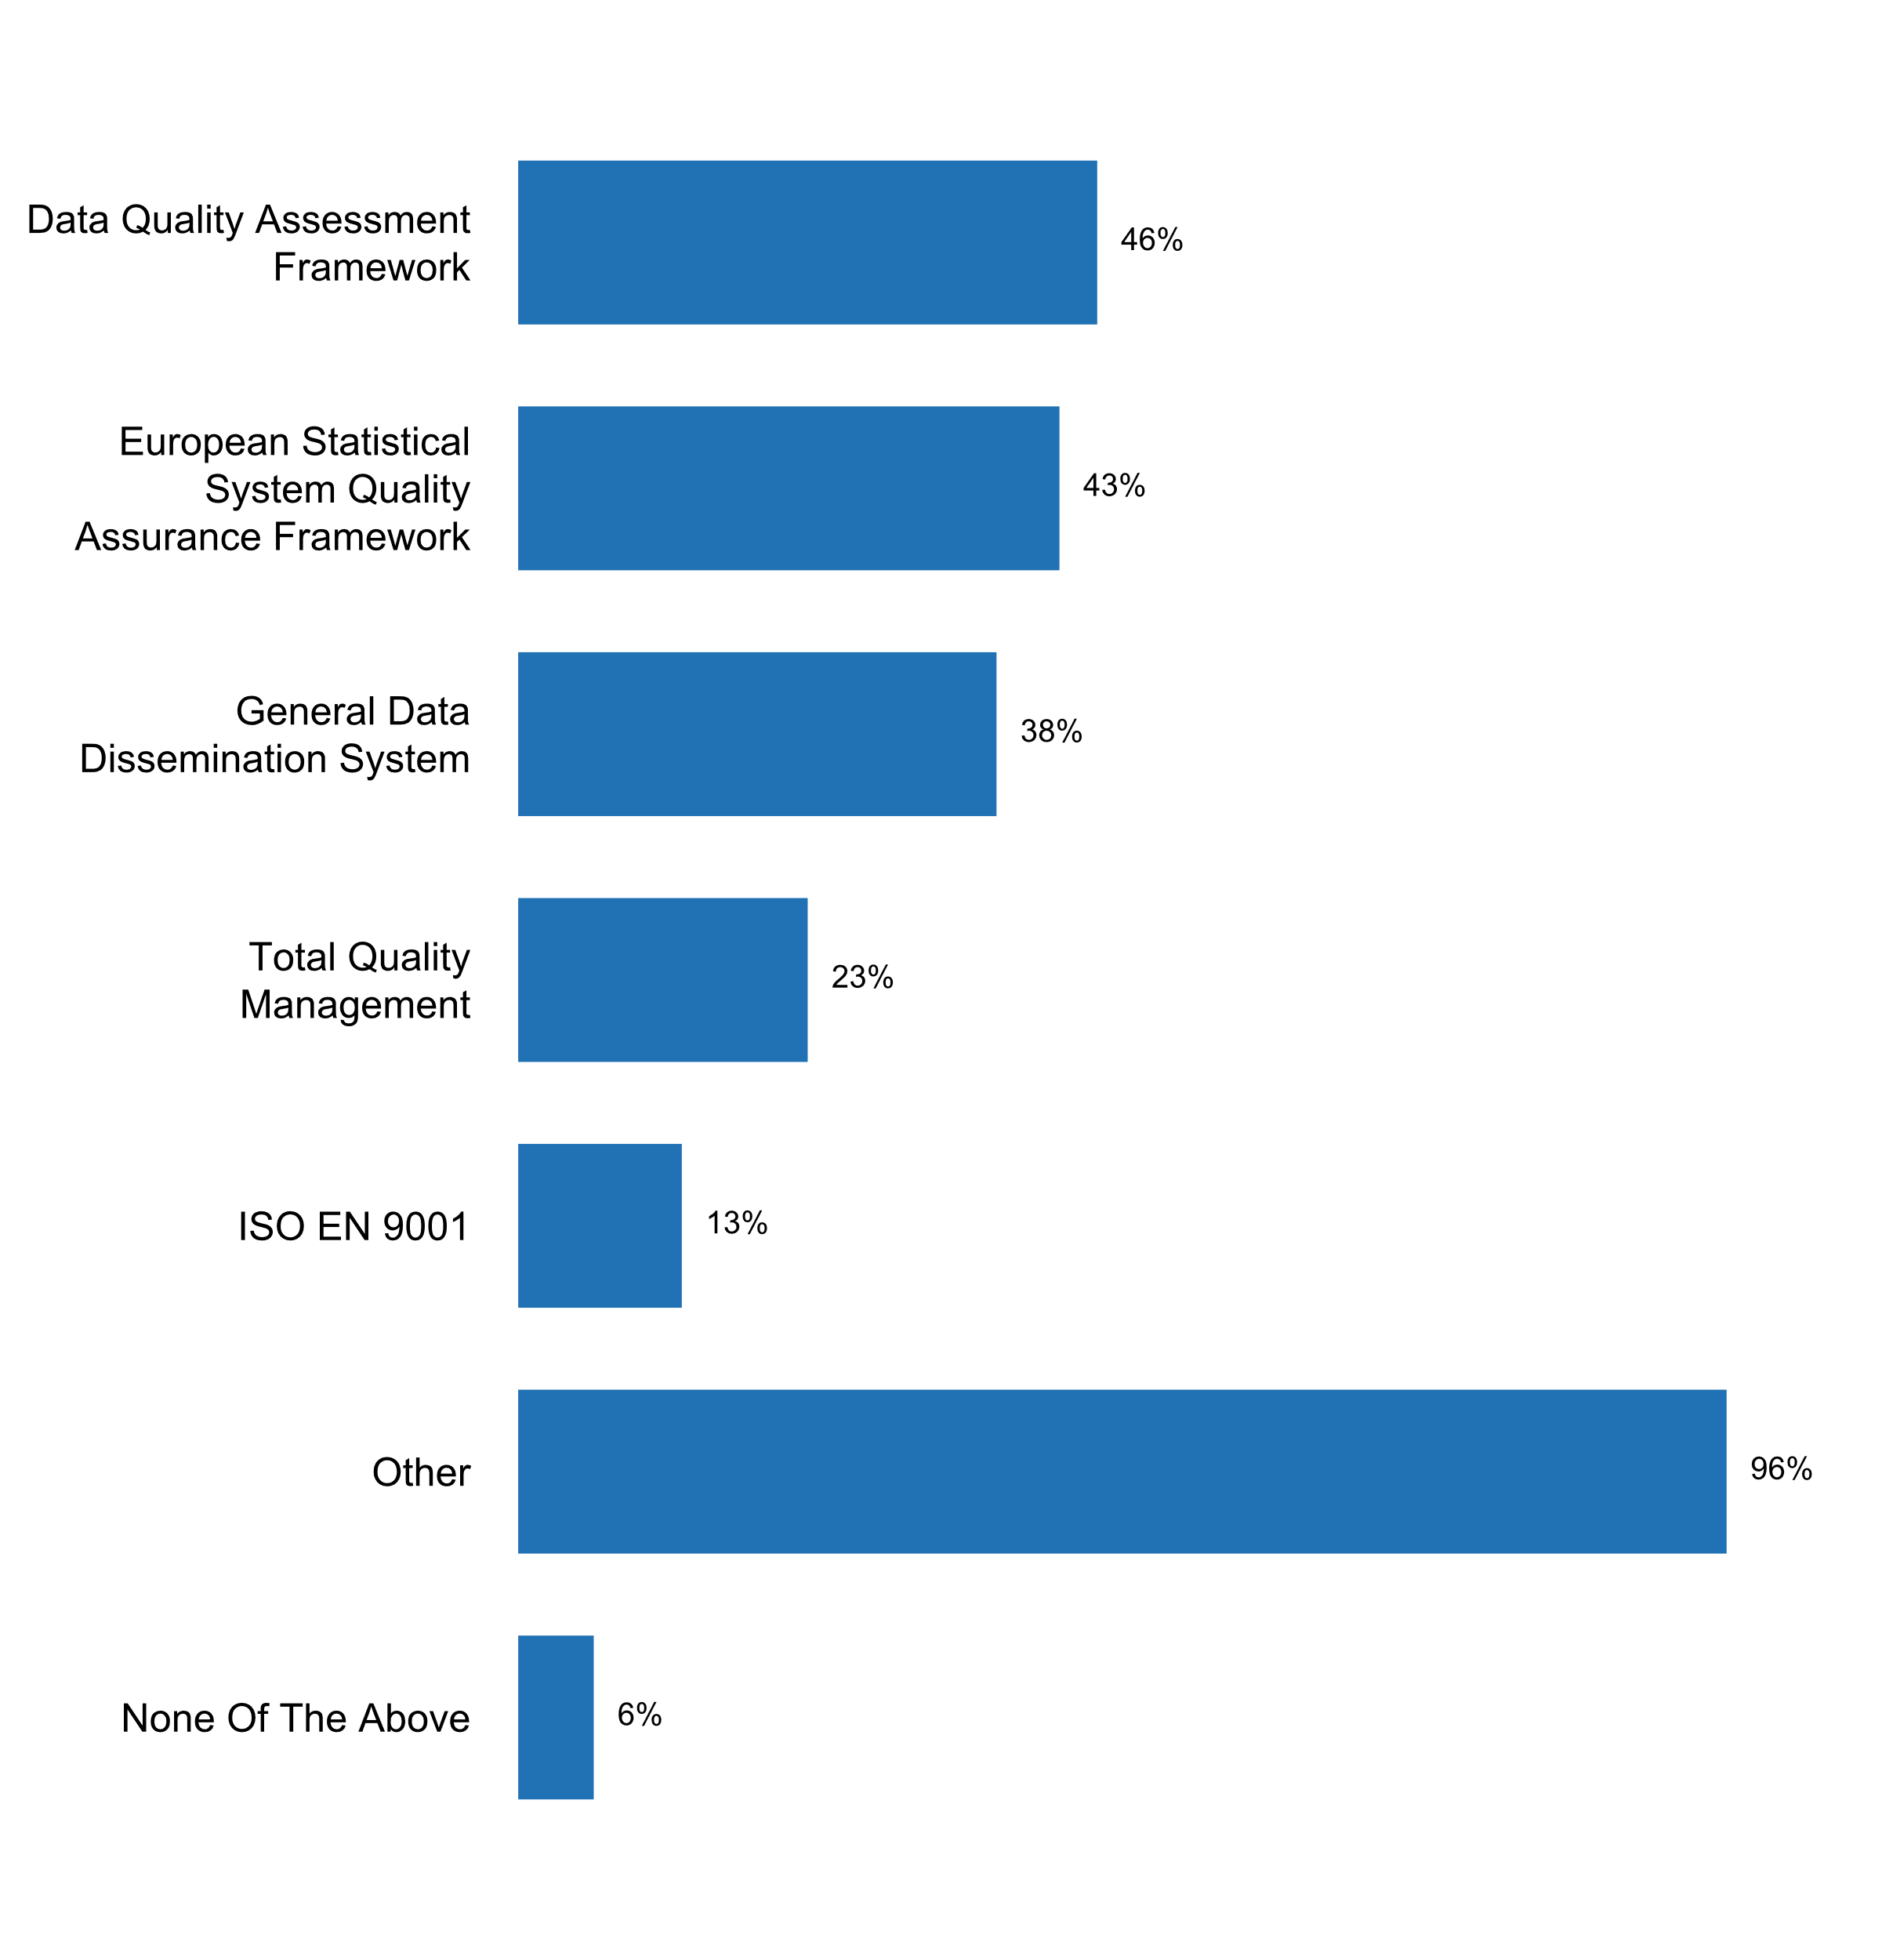

**Plot_45_Q05.3a.svg**

**Aspects considered in the quality management framework**

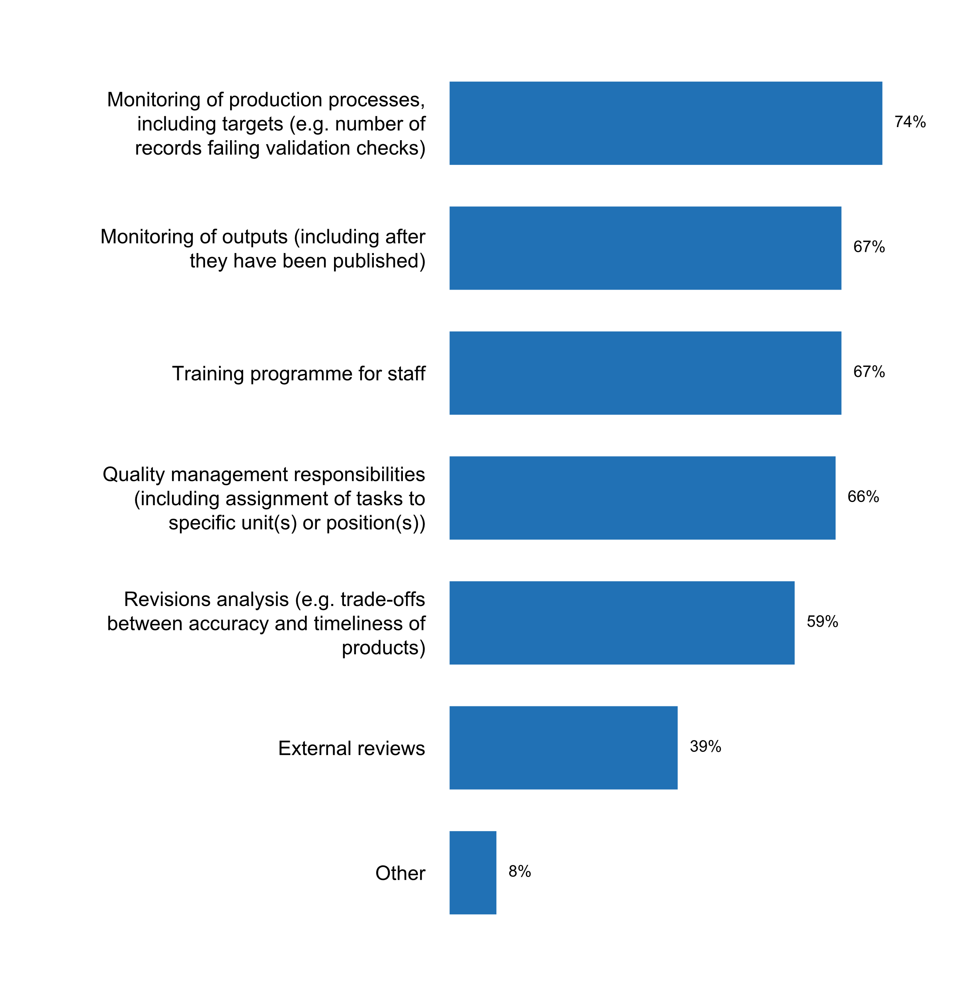

**Plot_46_Q05.4.svg**

**Measure(s) being applied to reduce respondent burden**

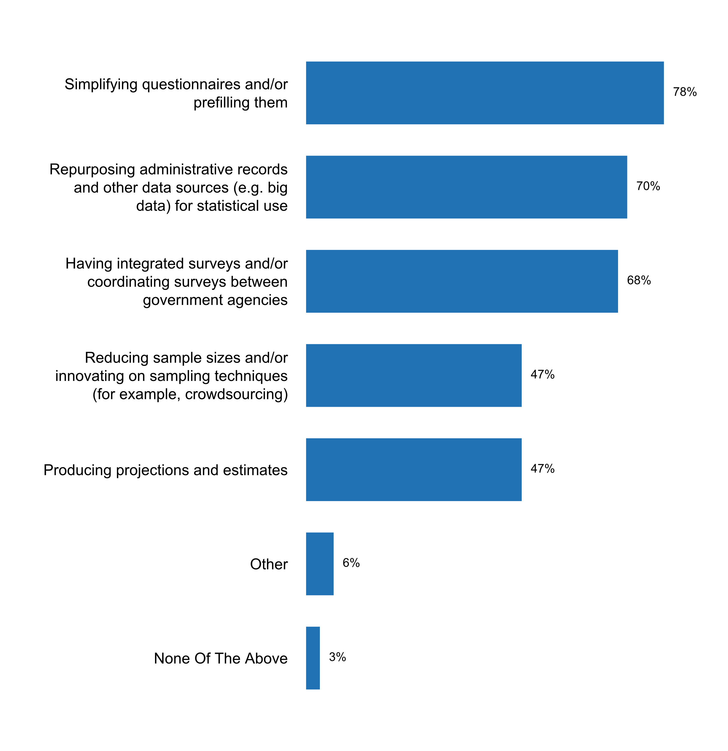

**Plot_47_Q06.1a.svg**

**Confidentiality provision in the laws applies to…**

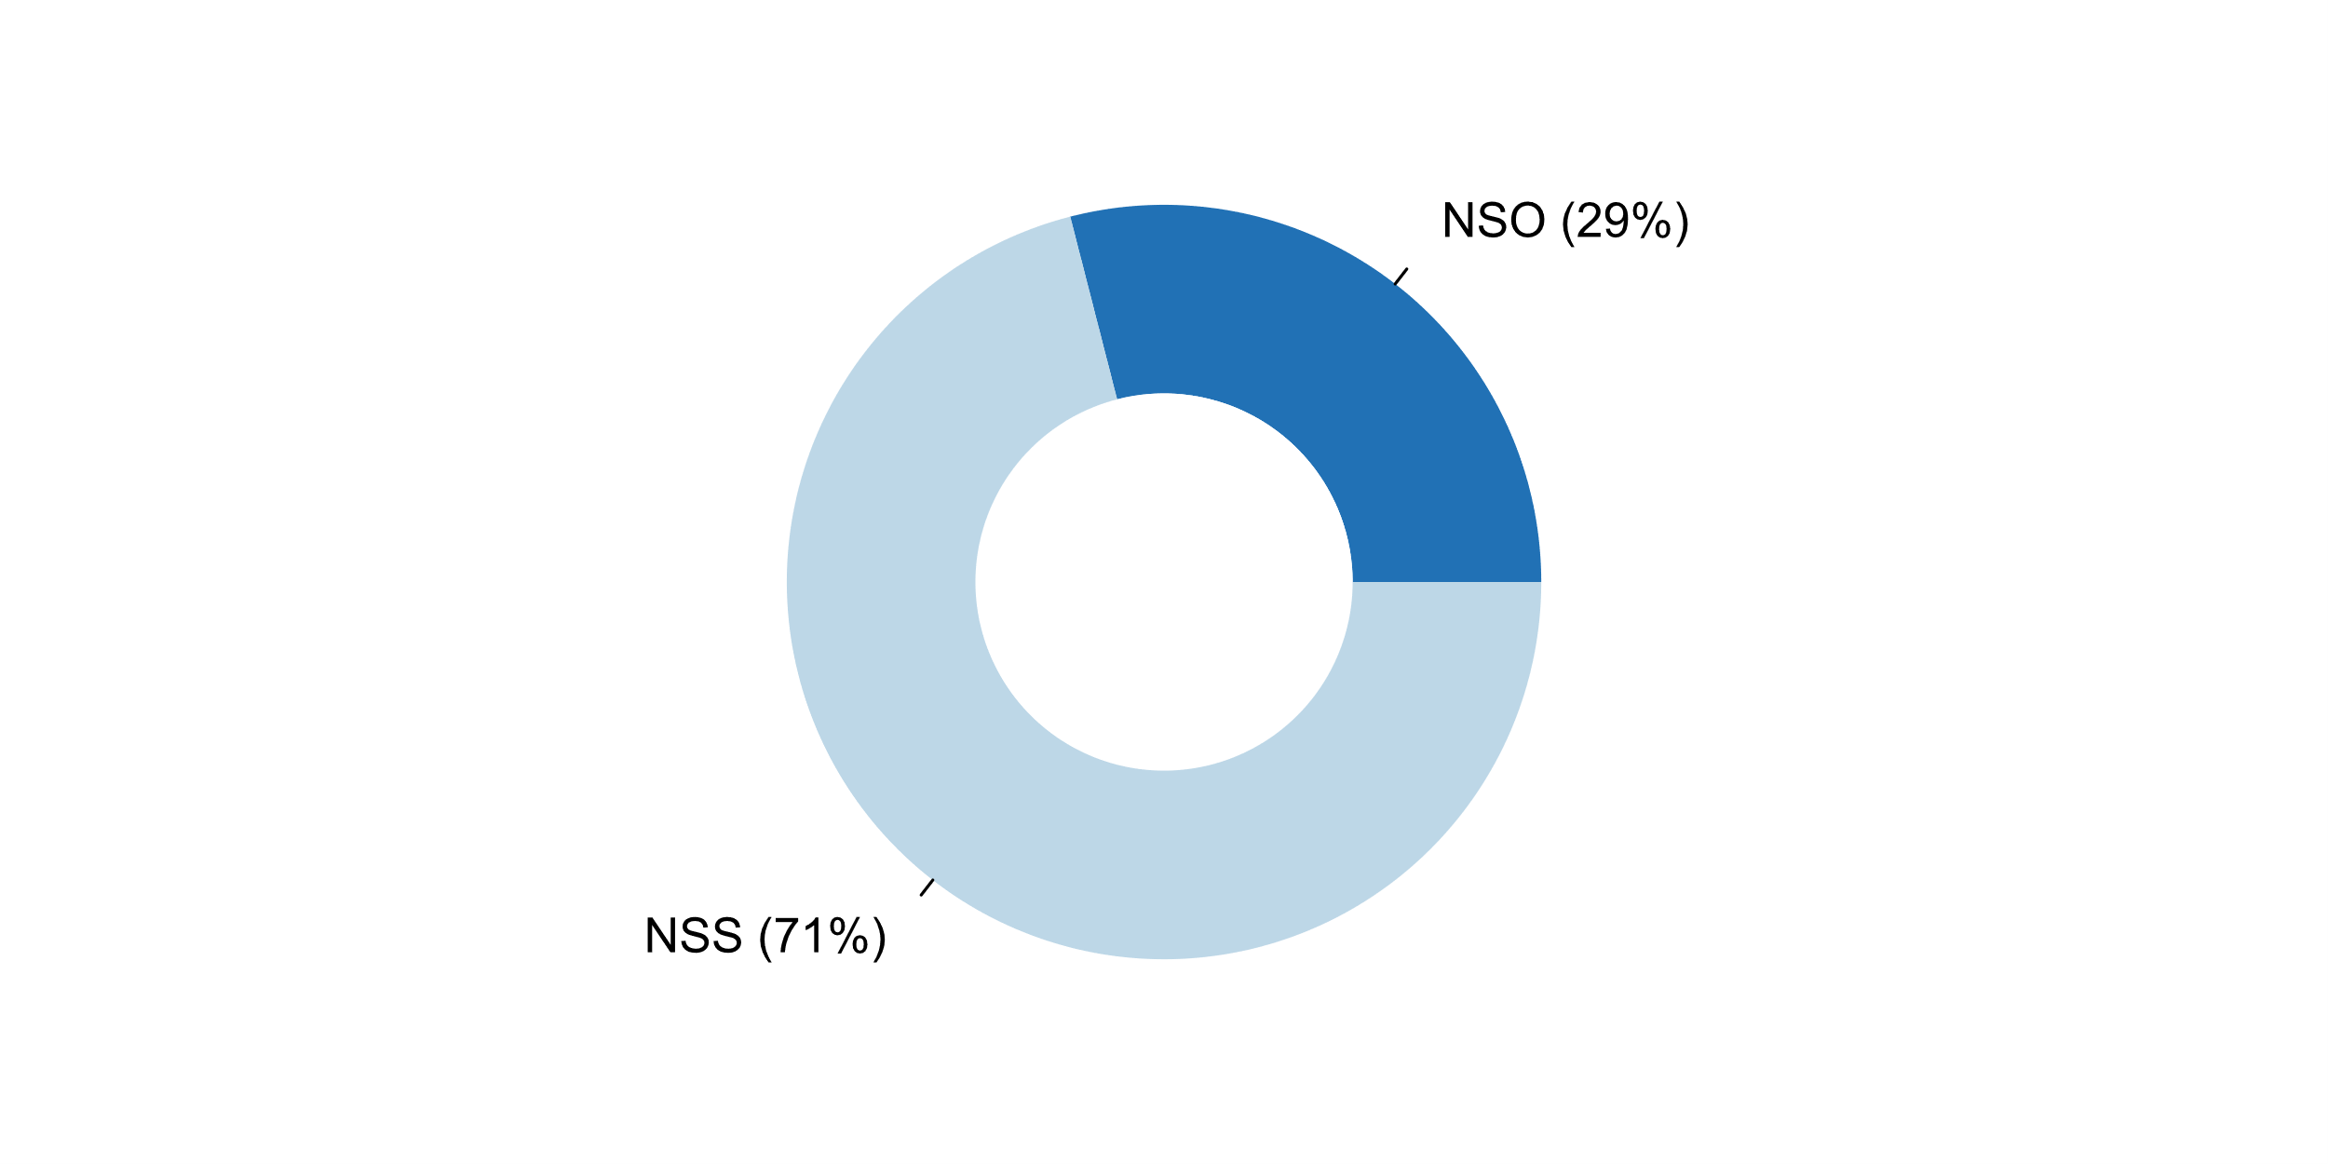

**Plot_48_Q06.2.svg**

**Aspects considered in the confidentiality policy of the NSO**

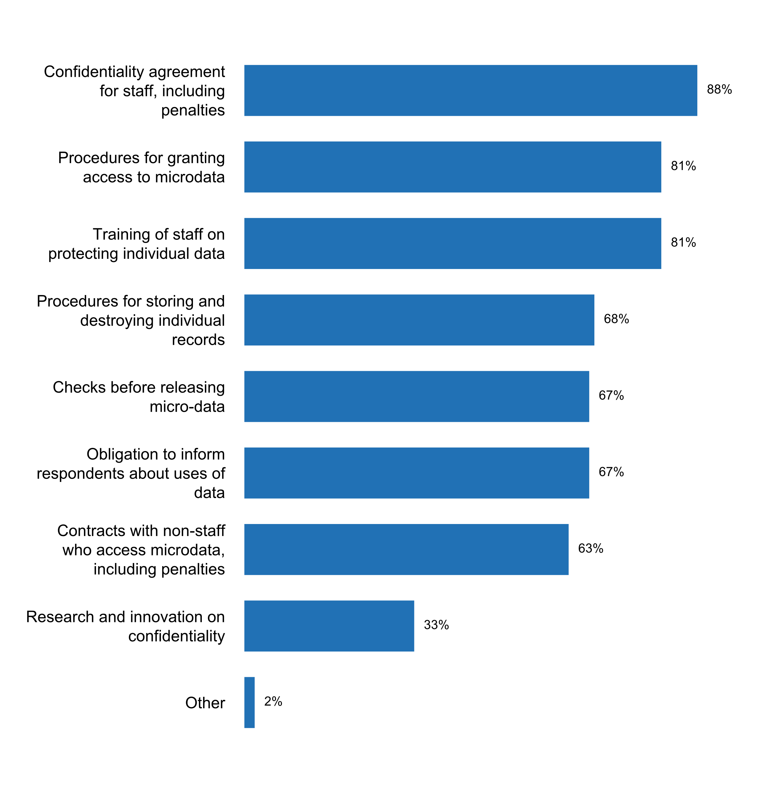

**Plot_49_Q06.3.svg**

**Practices being implemented to anonymize statistical data**

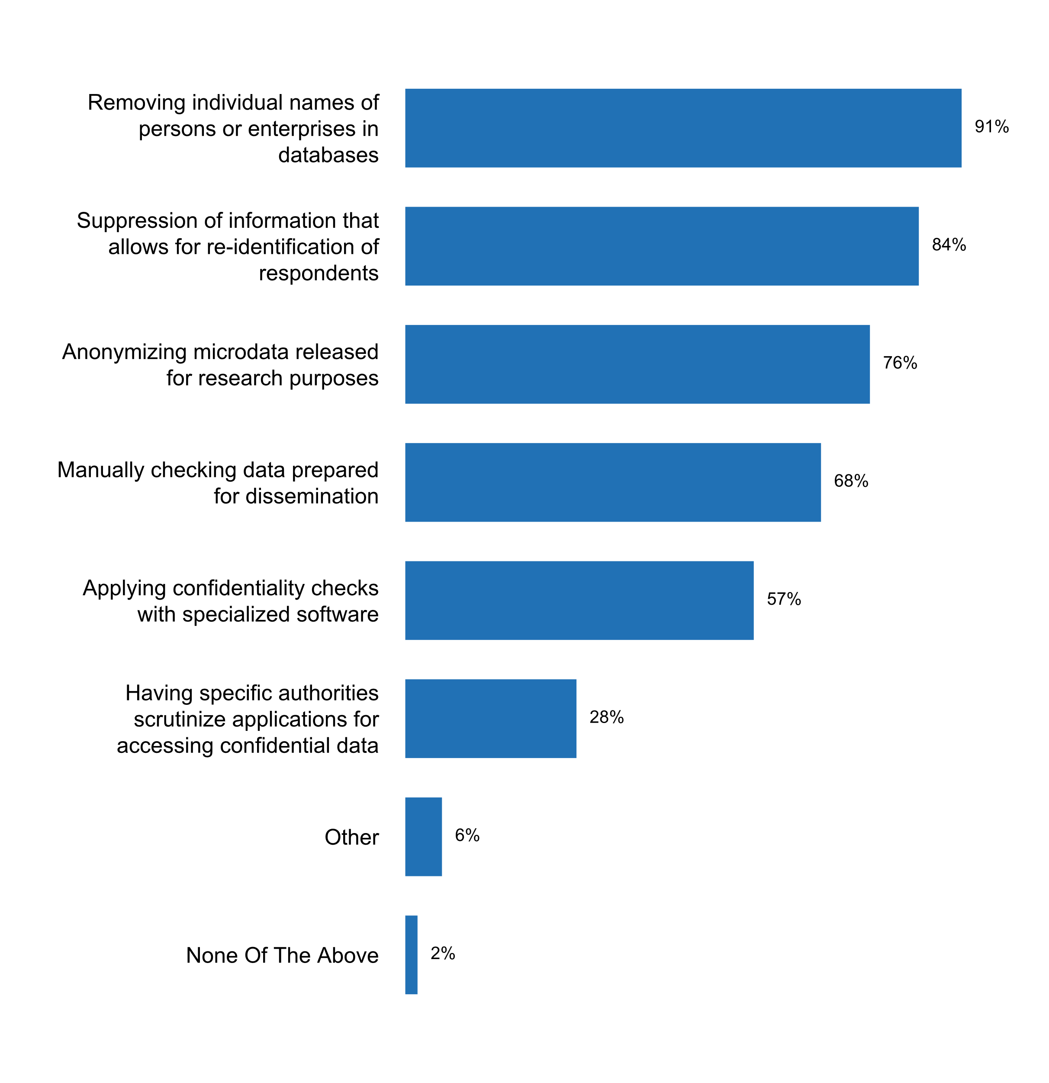

**Plot_50_Q06.4.svg**

**Circumstances under which identifiable individual data can be disclosed to third parties**

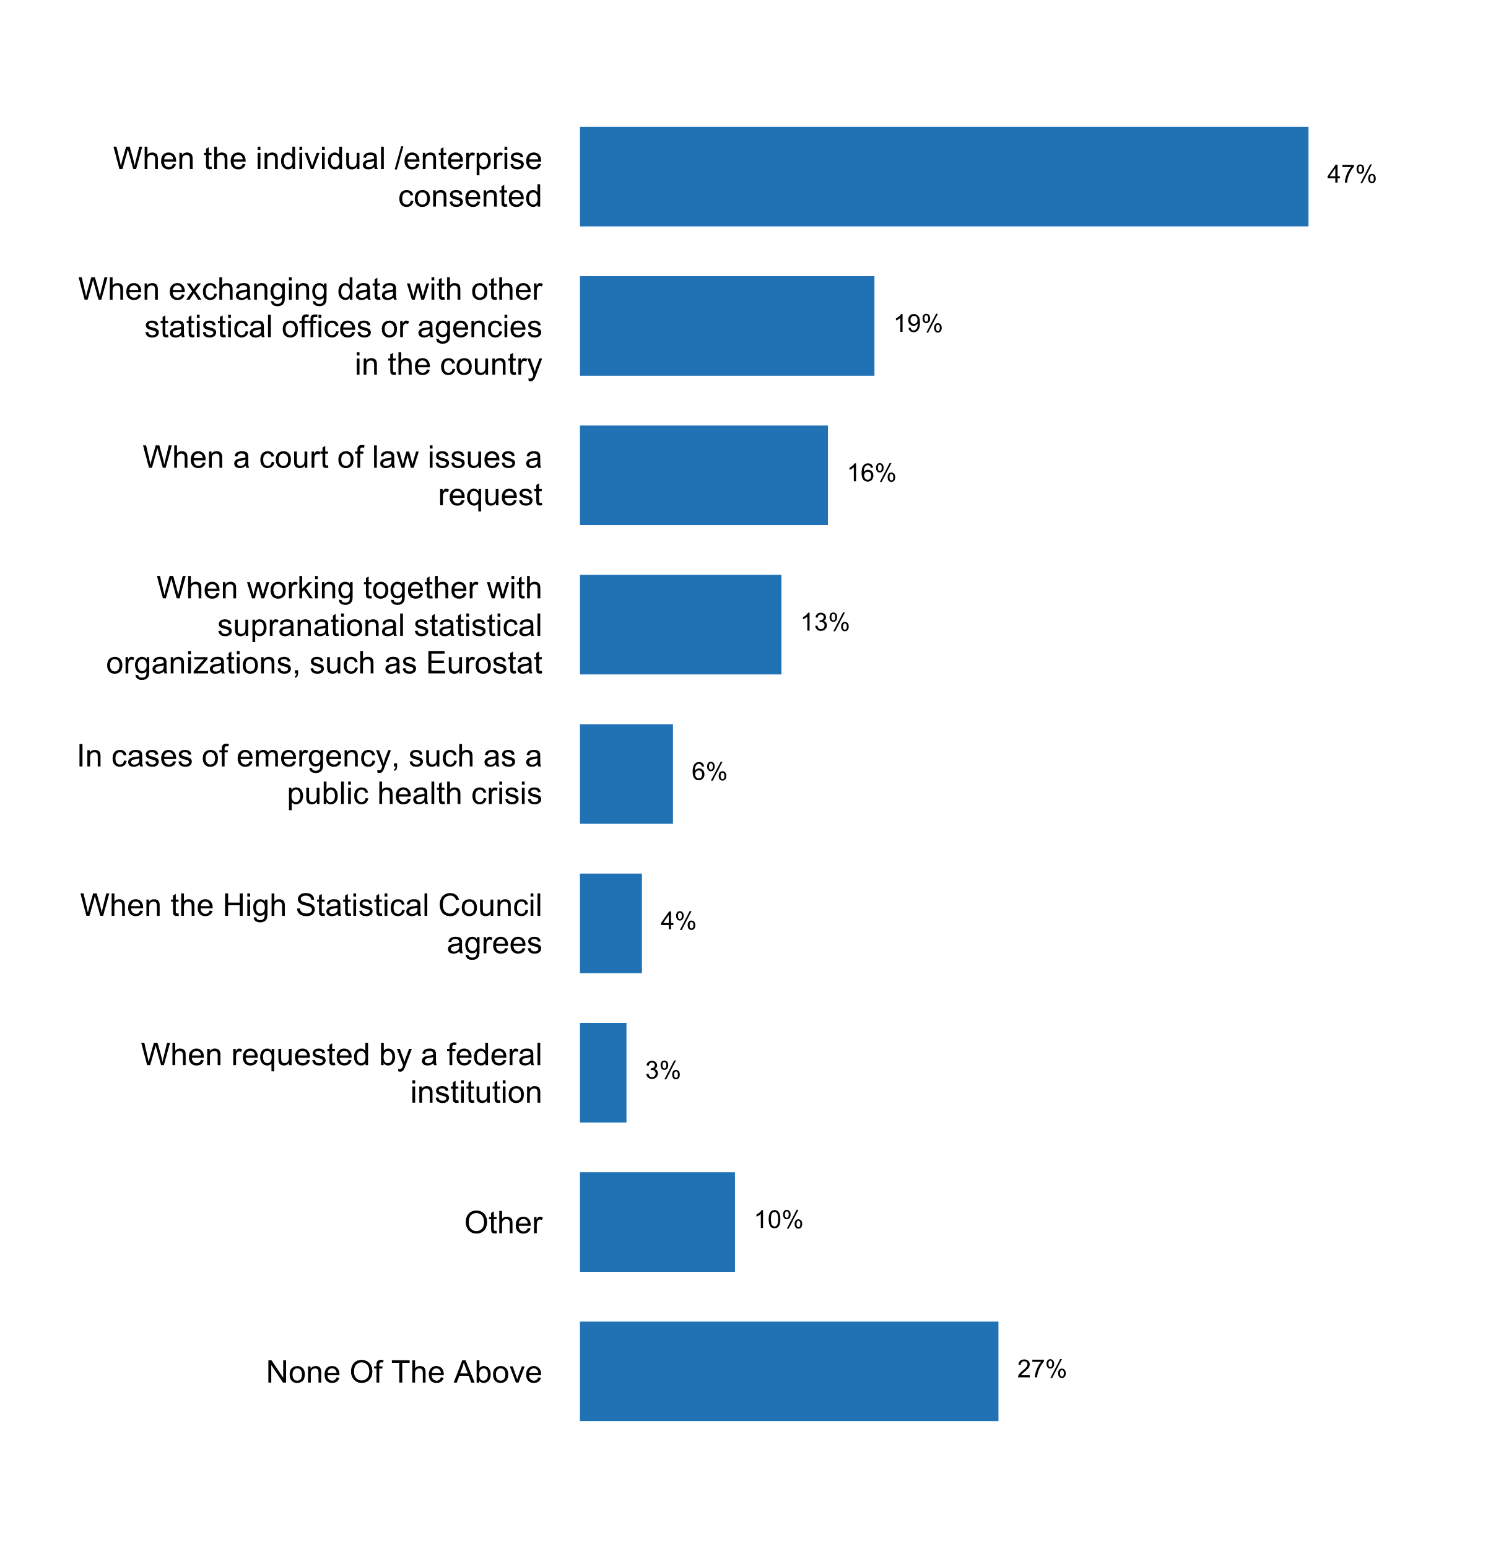

**Plot_51_Q07.1.svg**

**Existence of a general statistics law in the country**

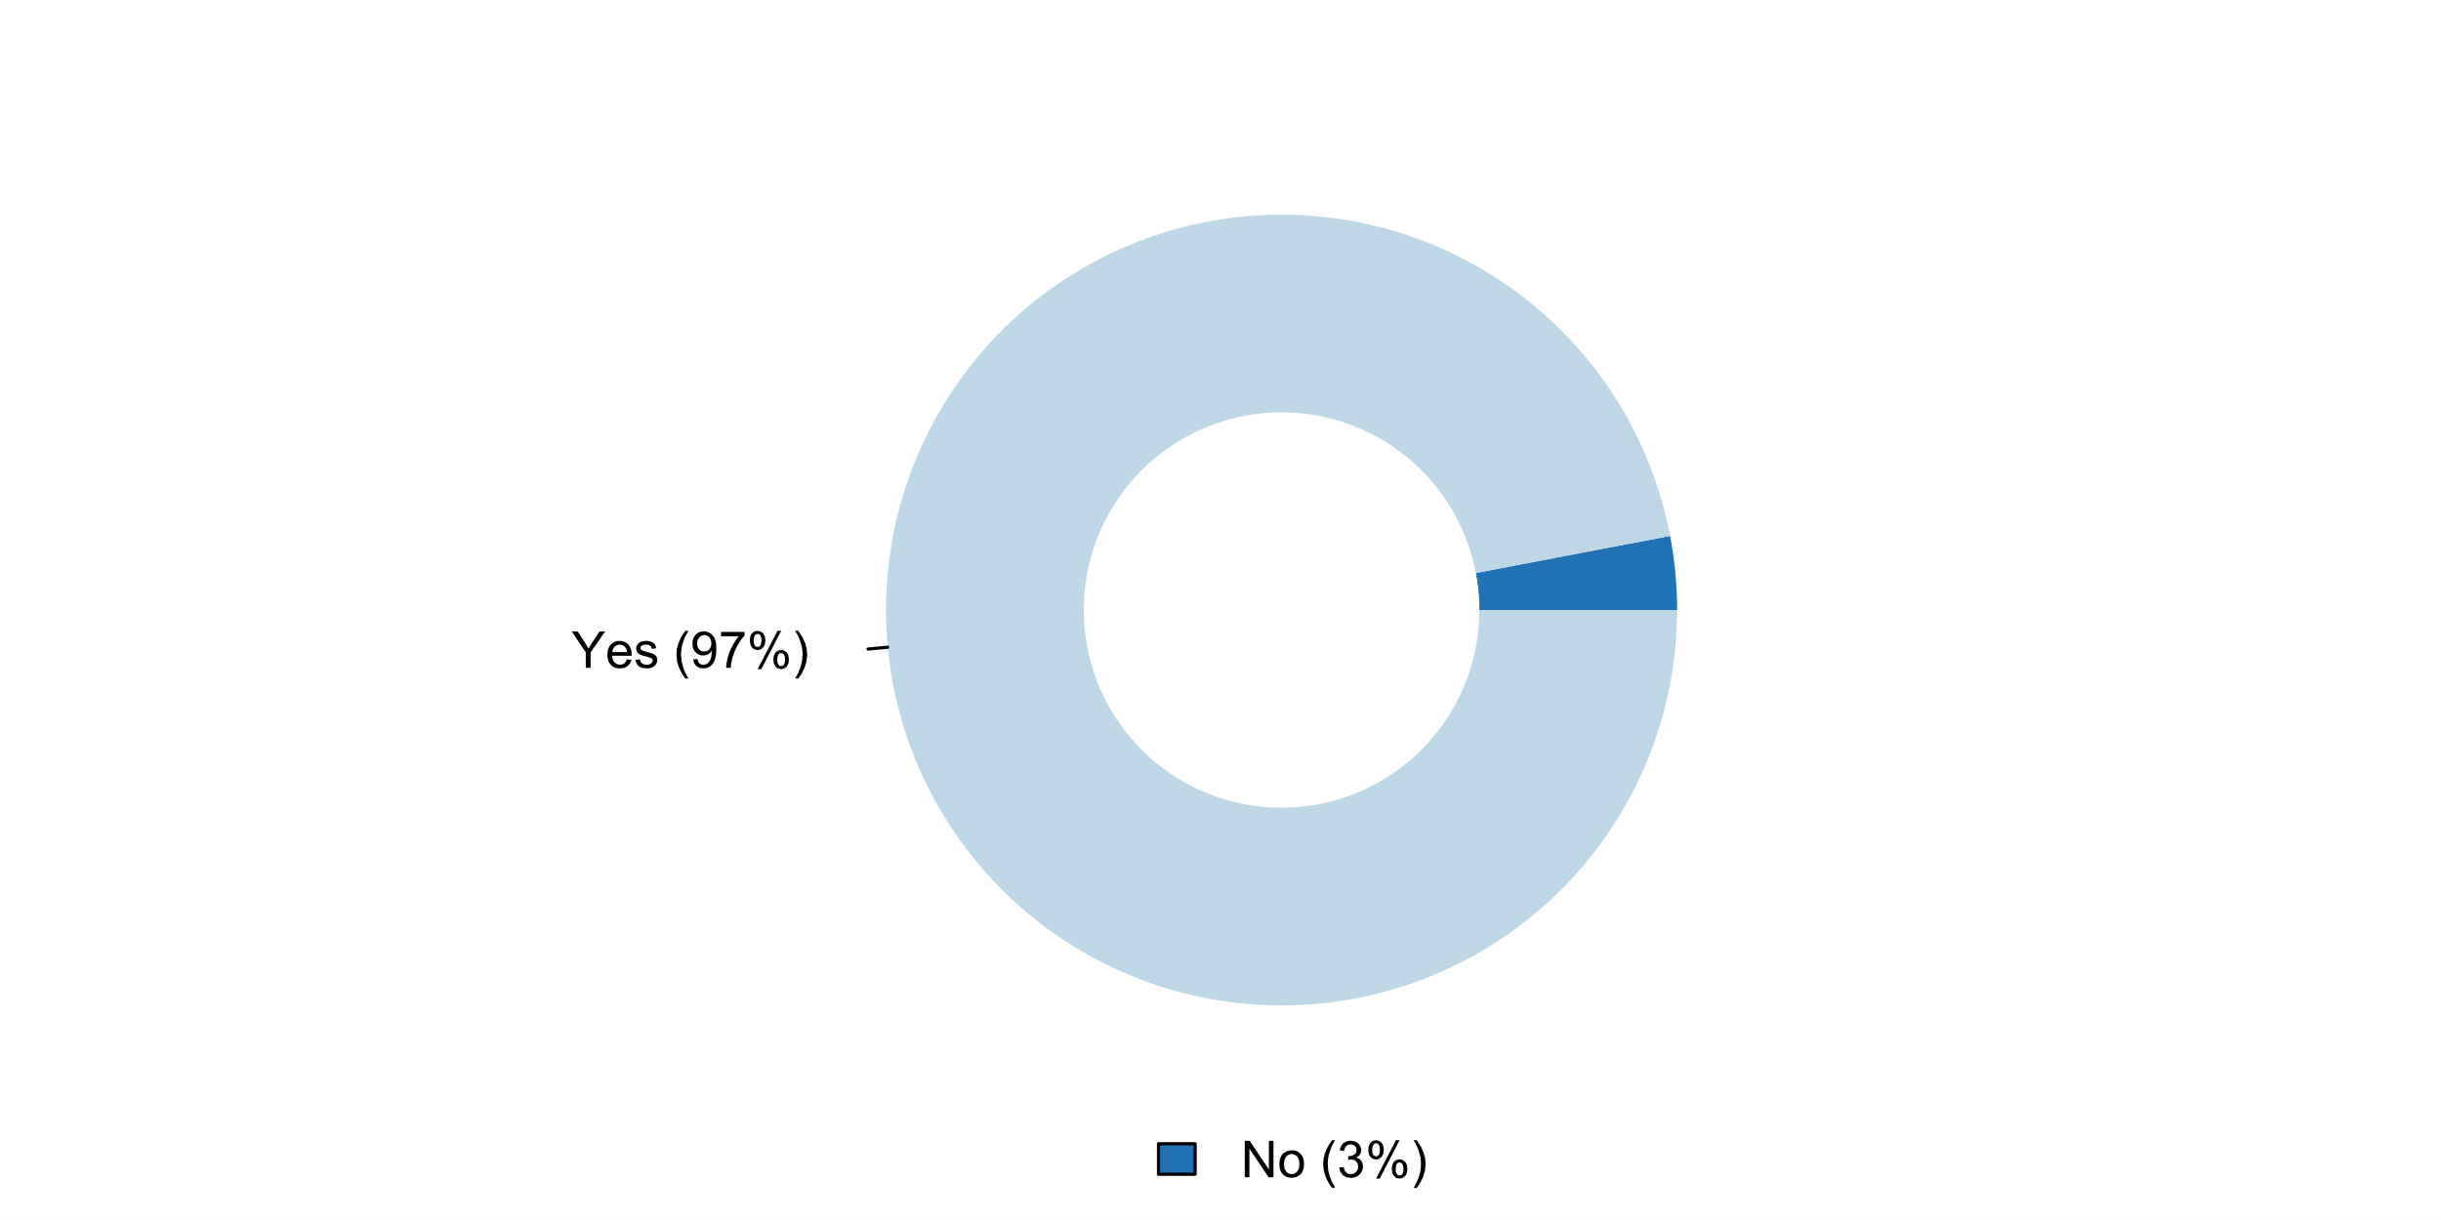

**Plot_52_Q07.2.svg**

**Aspects of the NSS covered by regulations (e.g. Statistical Law, presidential decrees)**

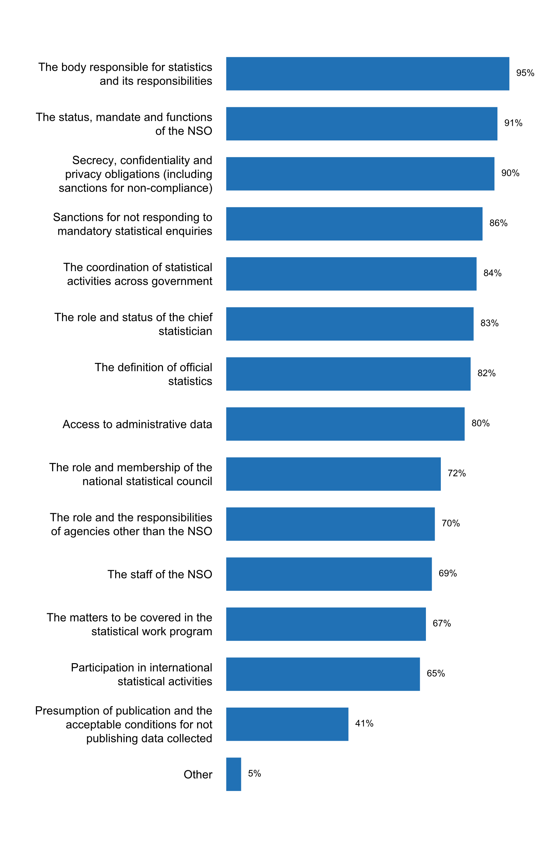

**Plot_53_Q07.3.svg**

**How the NSO has encouraged respondents to answer surveys during the past five years**

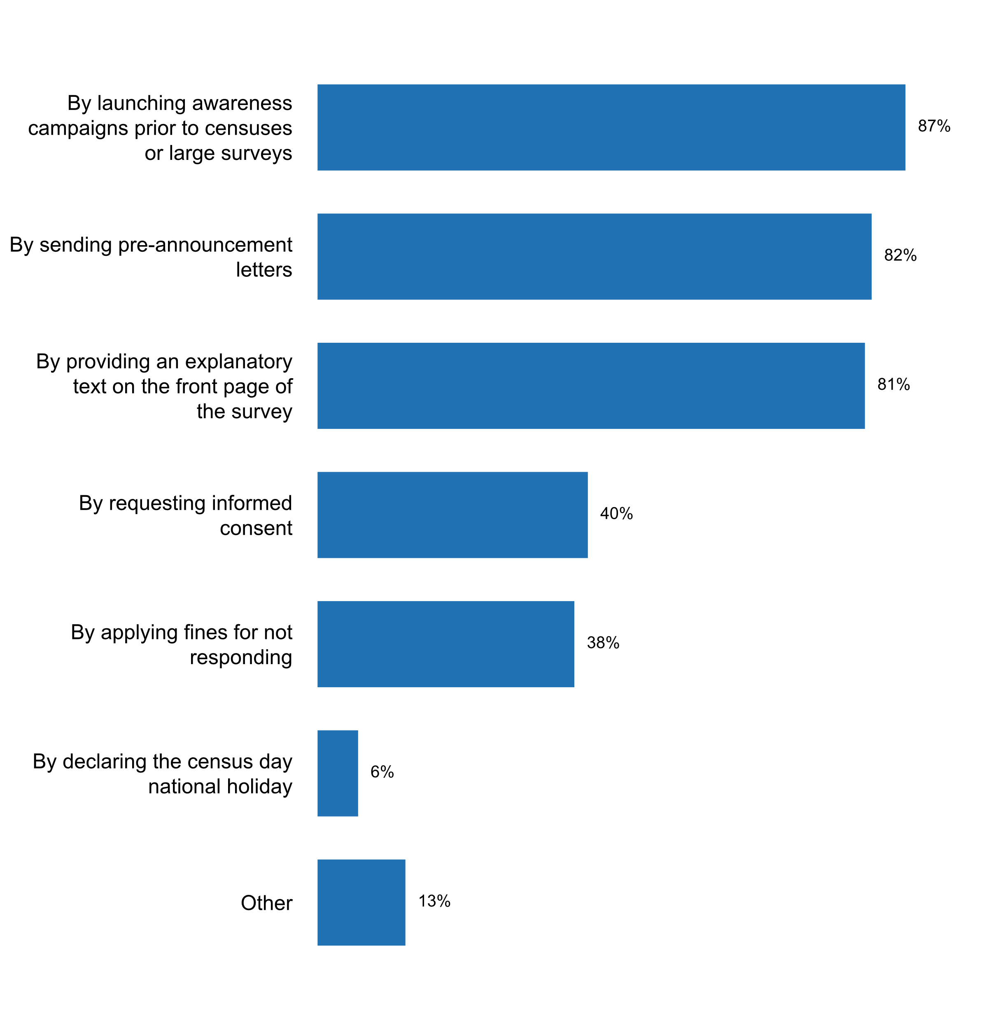

**Plot_54_Q07.4 .svg**

**Person/office within the government to whom the head of the NSO reports**

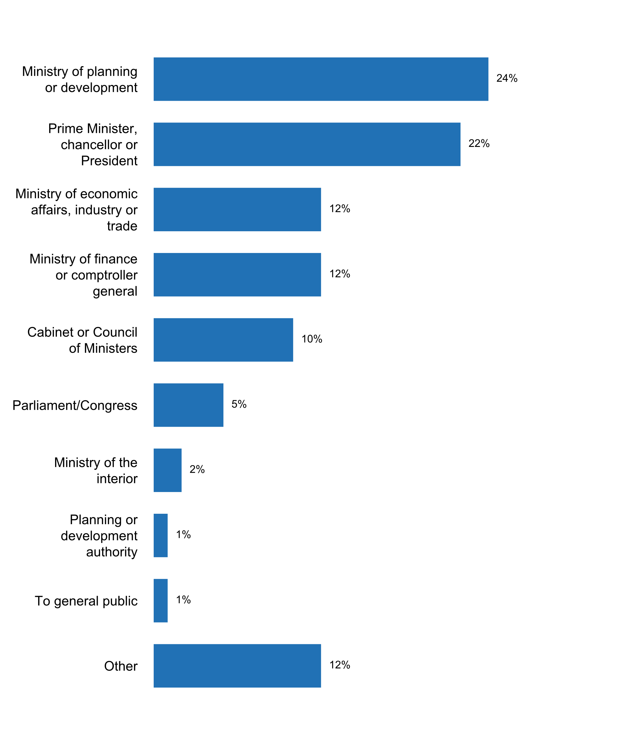

**Plot_55_Q07.5 .svg**

**A Freedom of Information or Access to Information law covers the NSS**

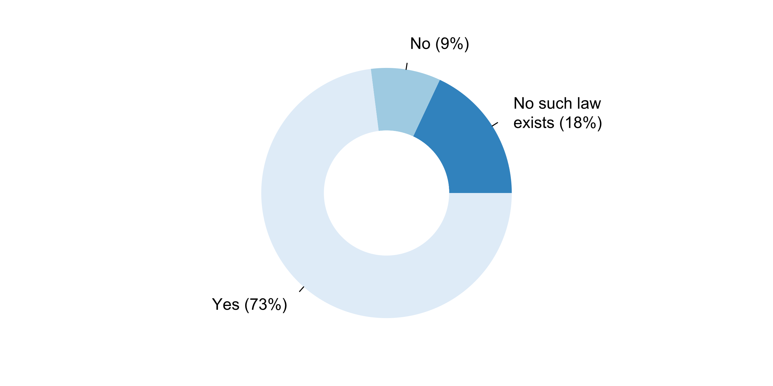

**Plot_56_Q08.1.svg**

**Agencies other than the NSO which produce official statistics on behalf of the government**

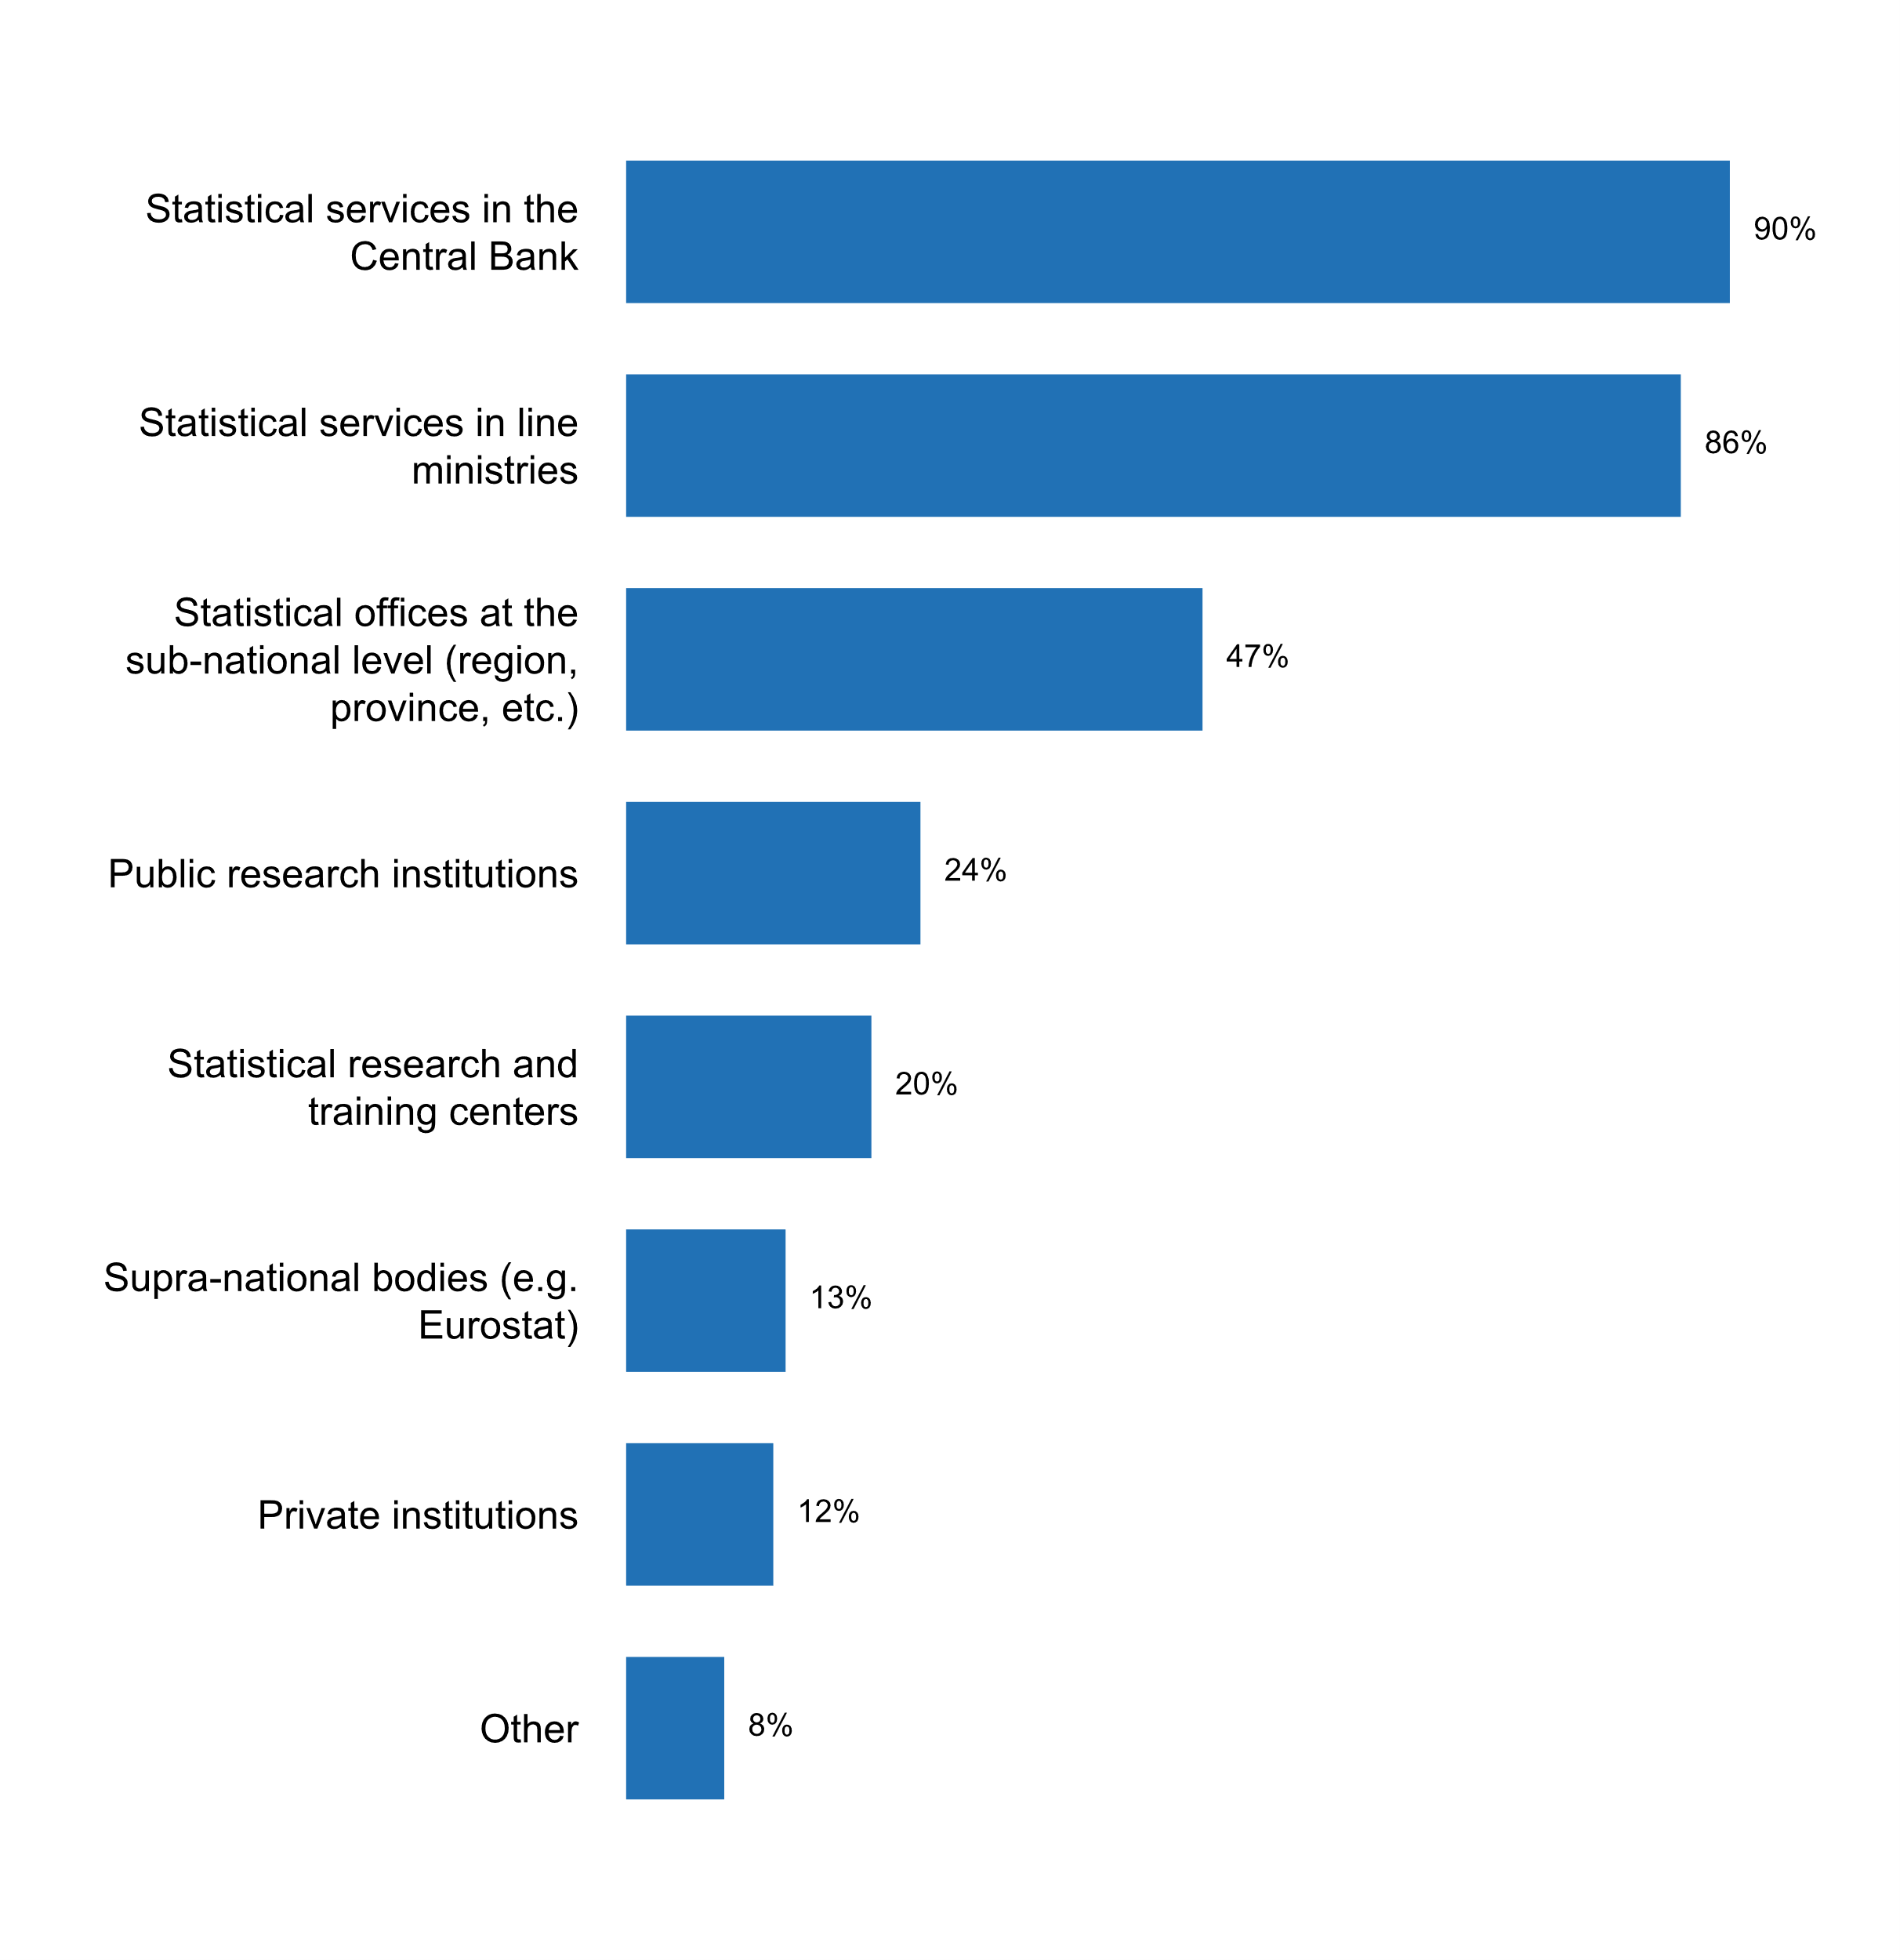

**Plot_57_Q08.2.svg**

**Activities currently being implemented for coordinating the NSS**

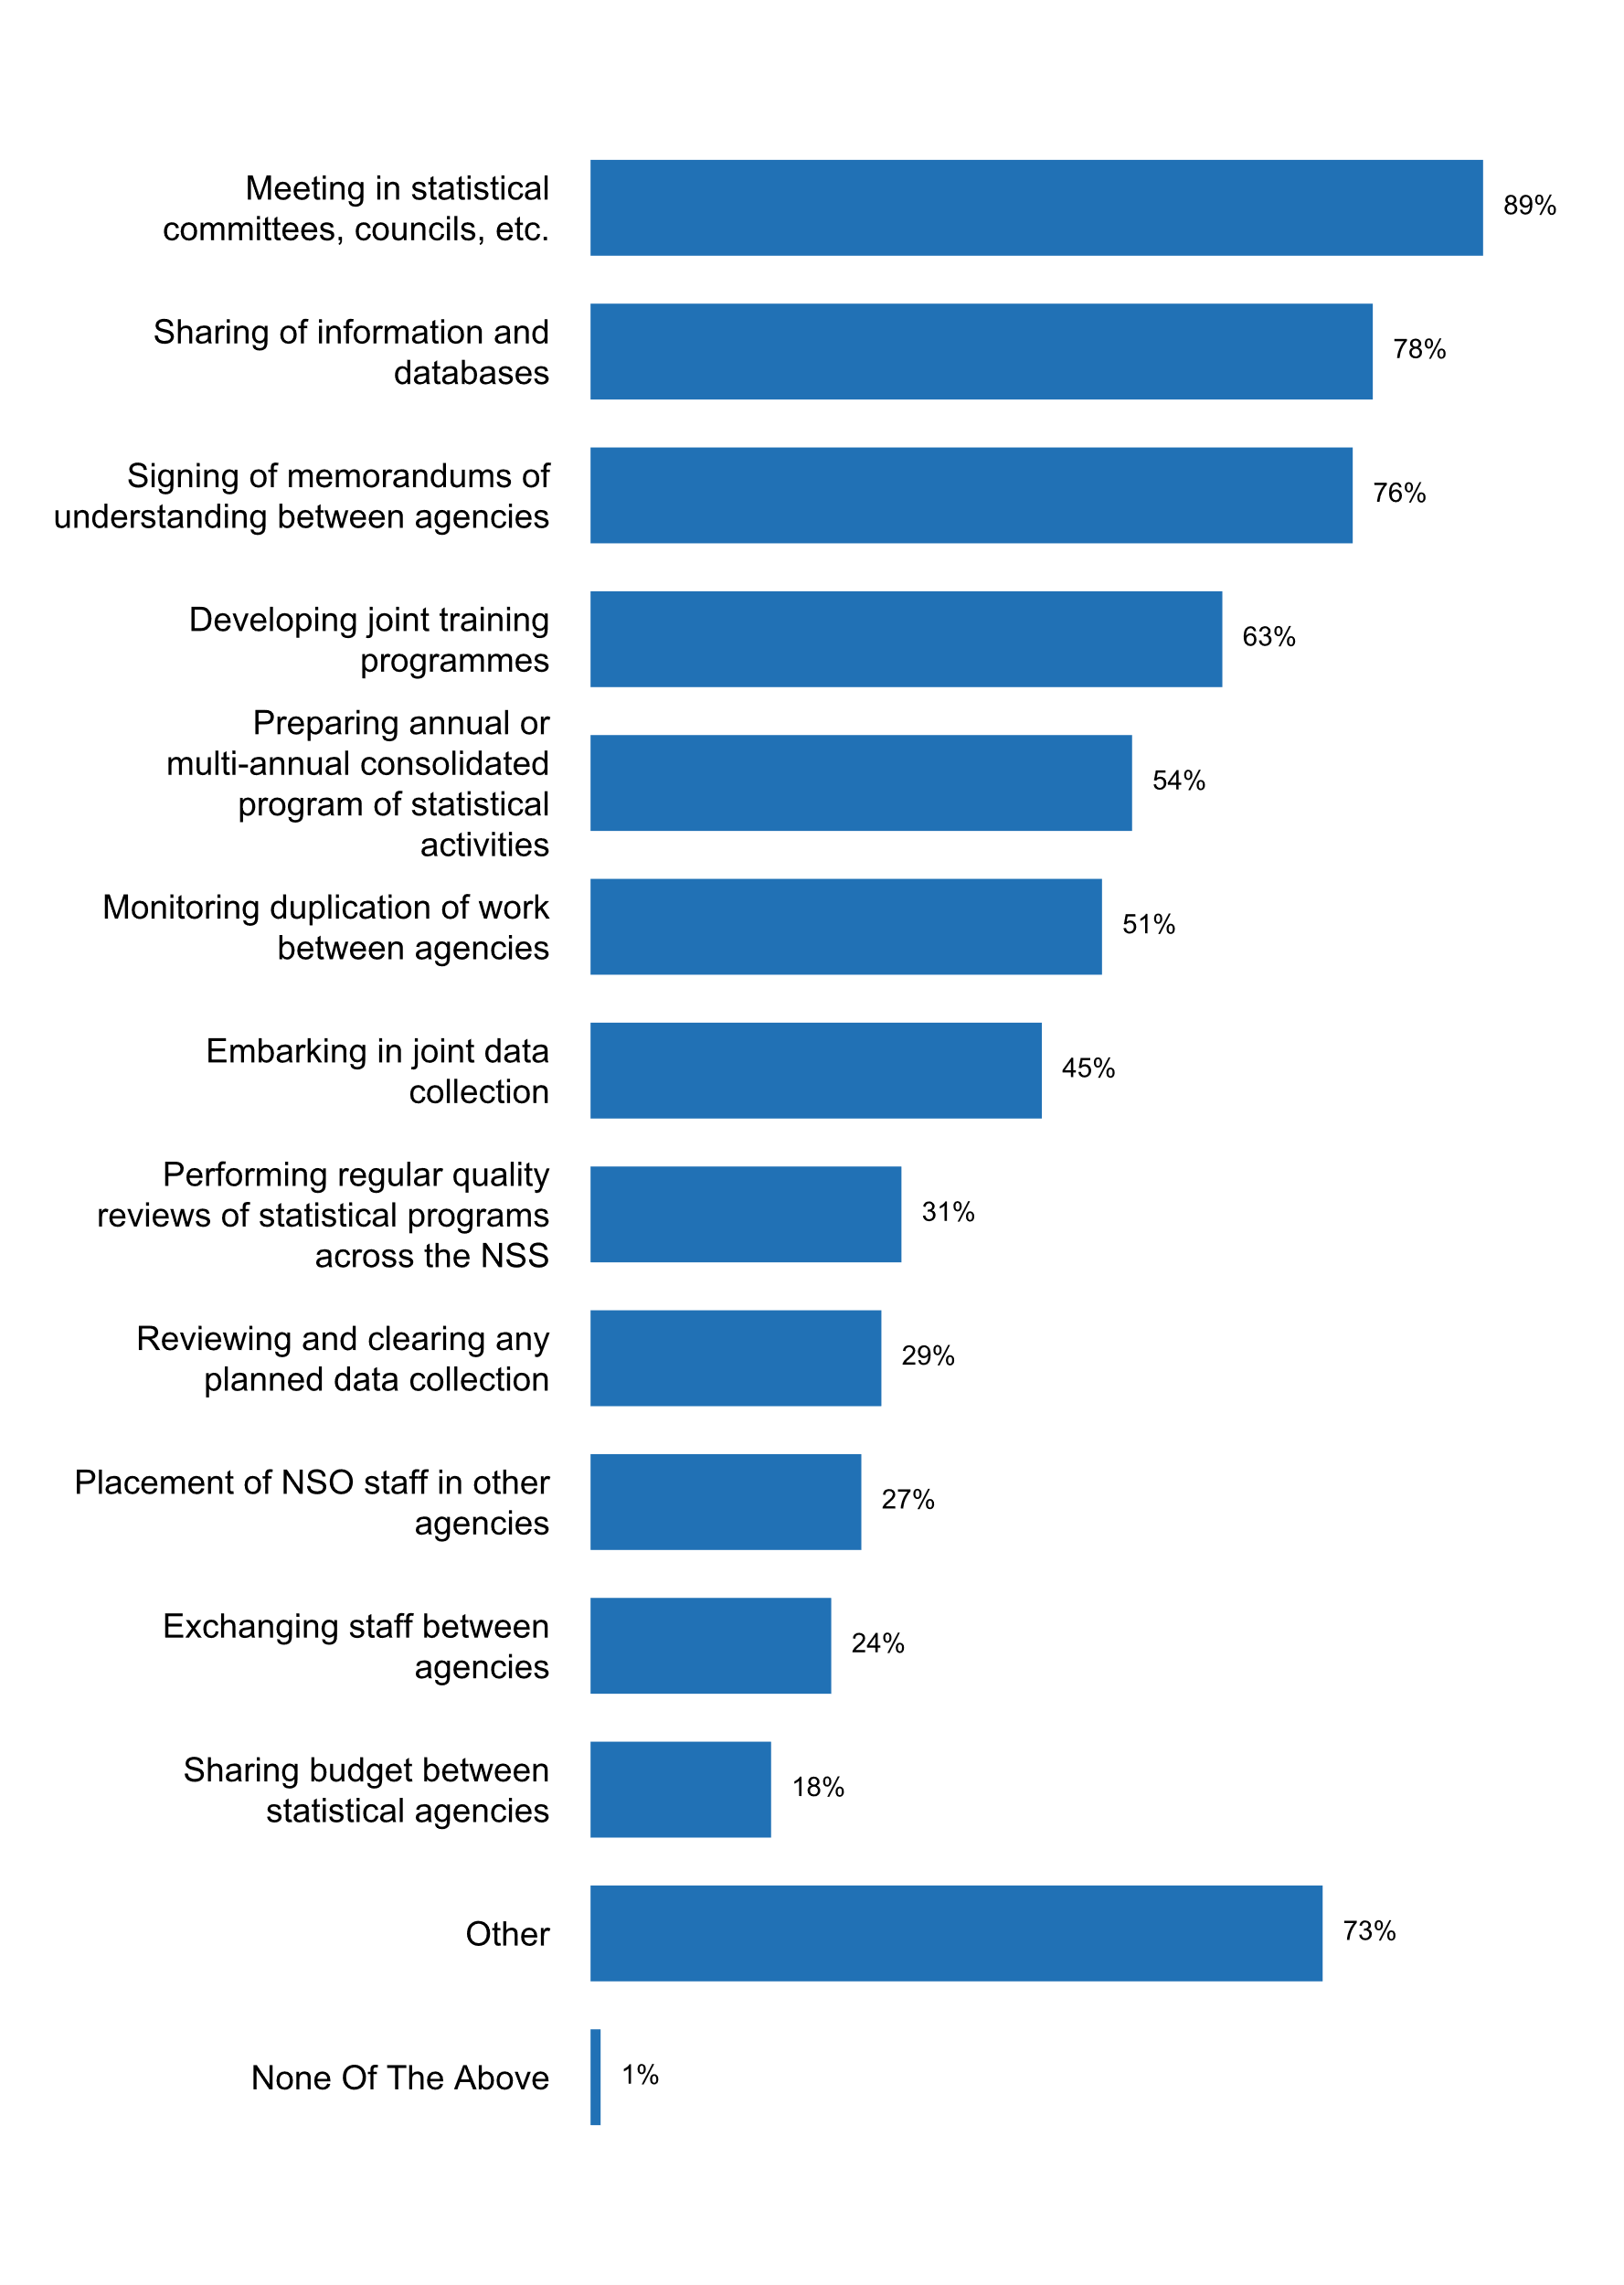

**Plot_58_Q08.3.svg**

**Frequency of meetings between producers of official statistics during the past five years**

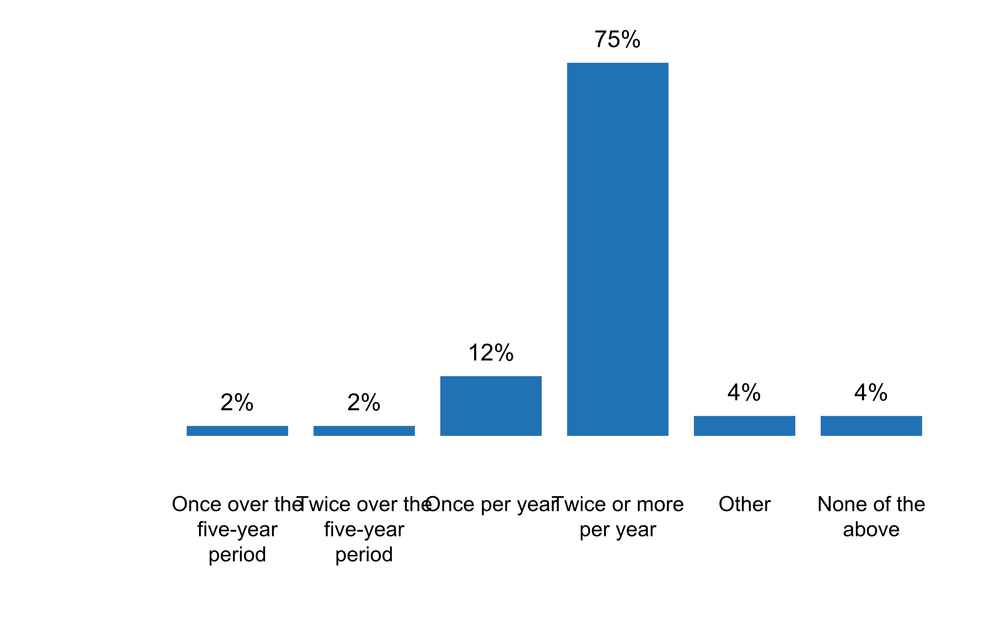

**Plot_59_Q08.4.svg**

**How is dissemination coordinated across the NSS**

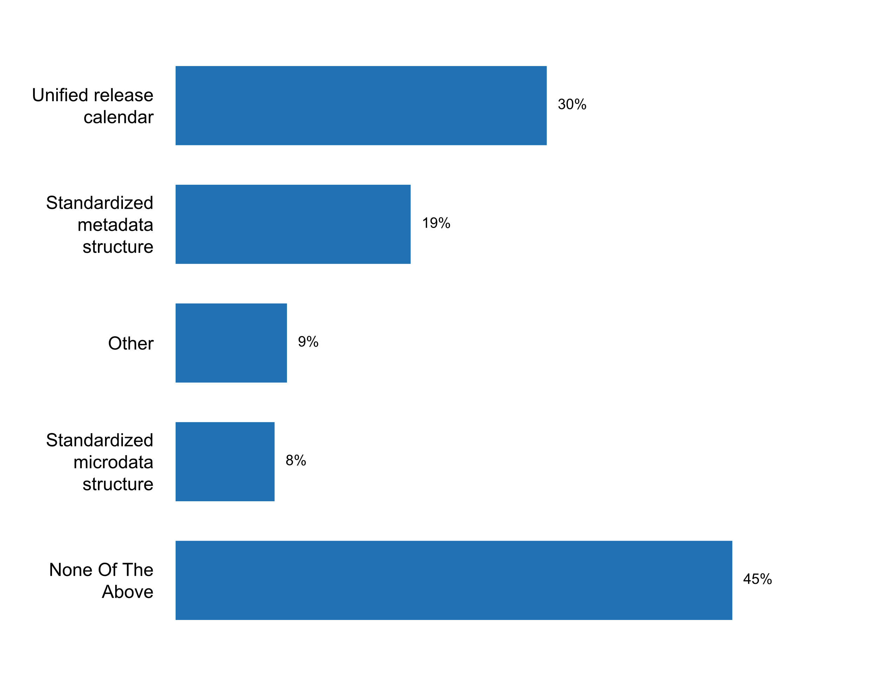

**Plot_60_Q08.5.svg**

**Existence of a central data portal where different members of the NSS publish official statistical data**

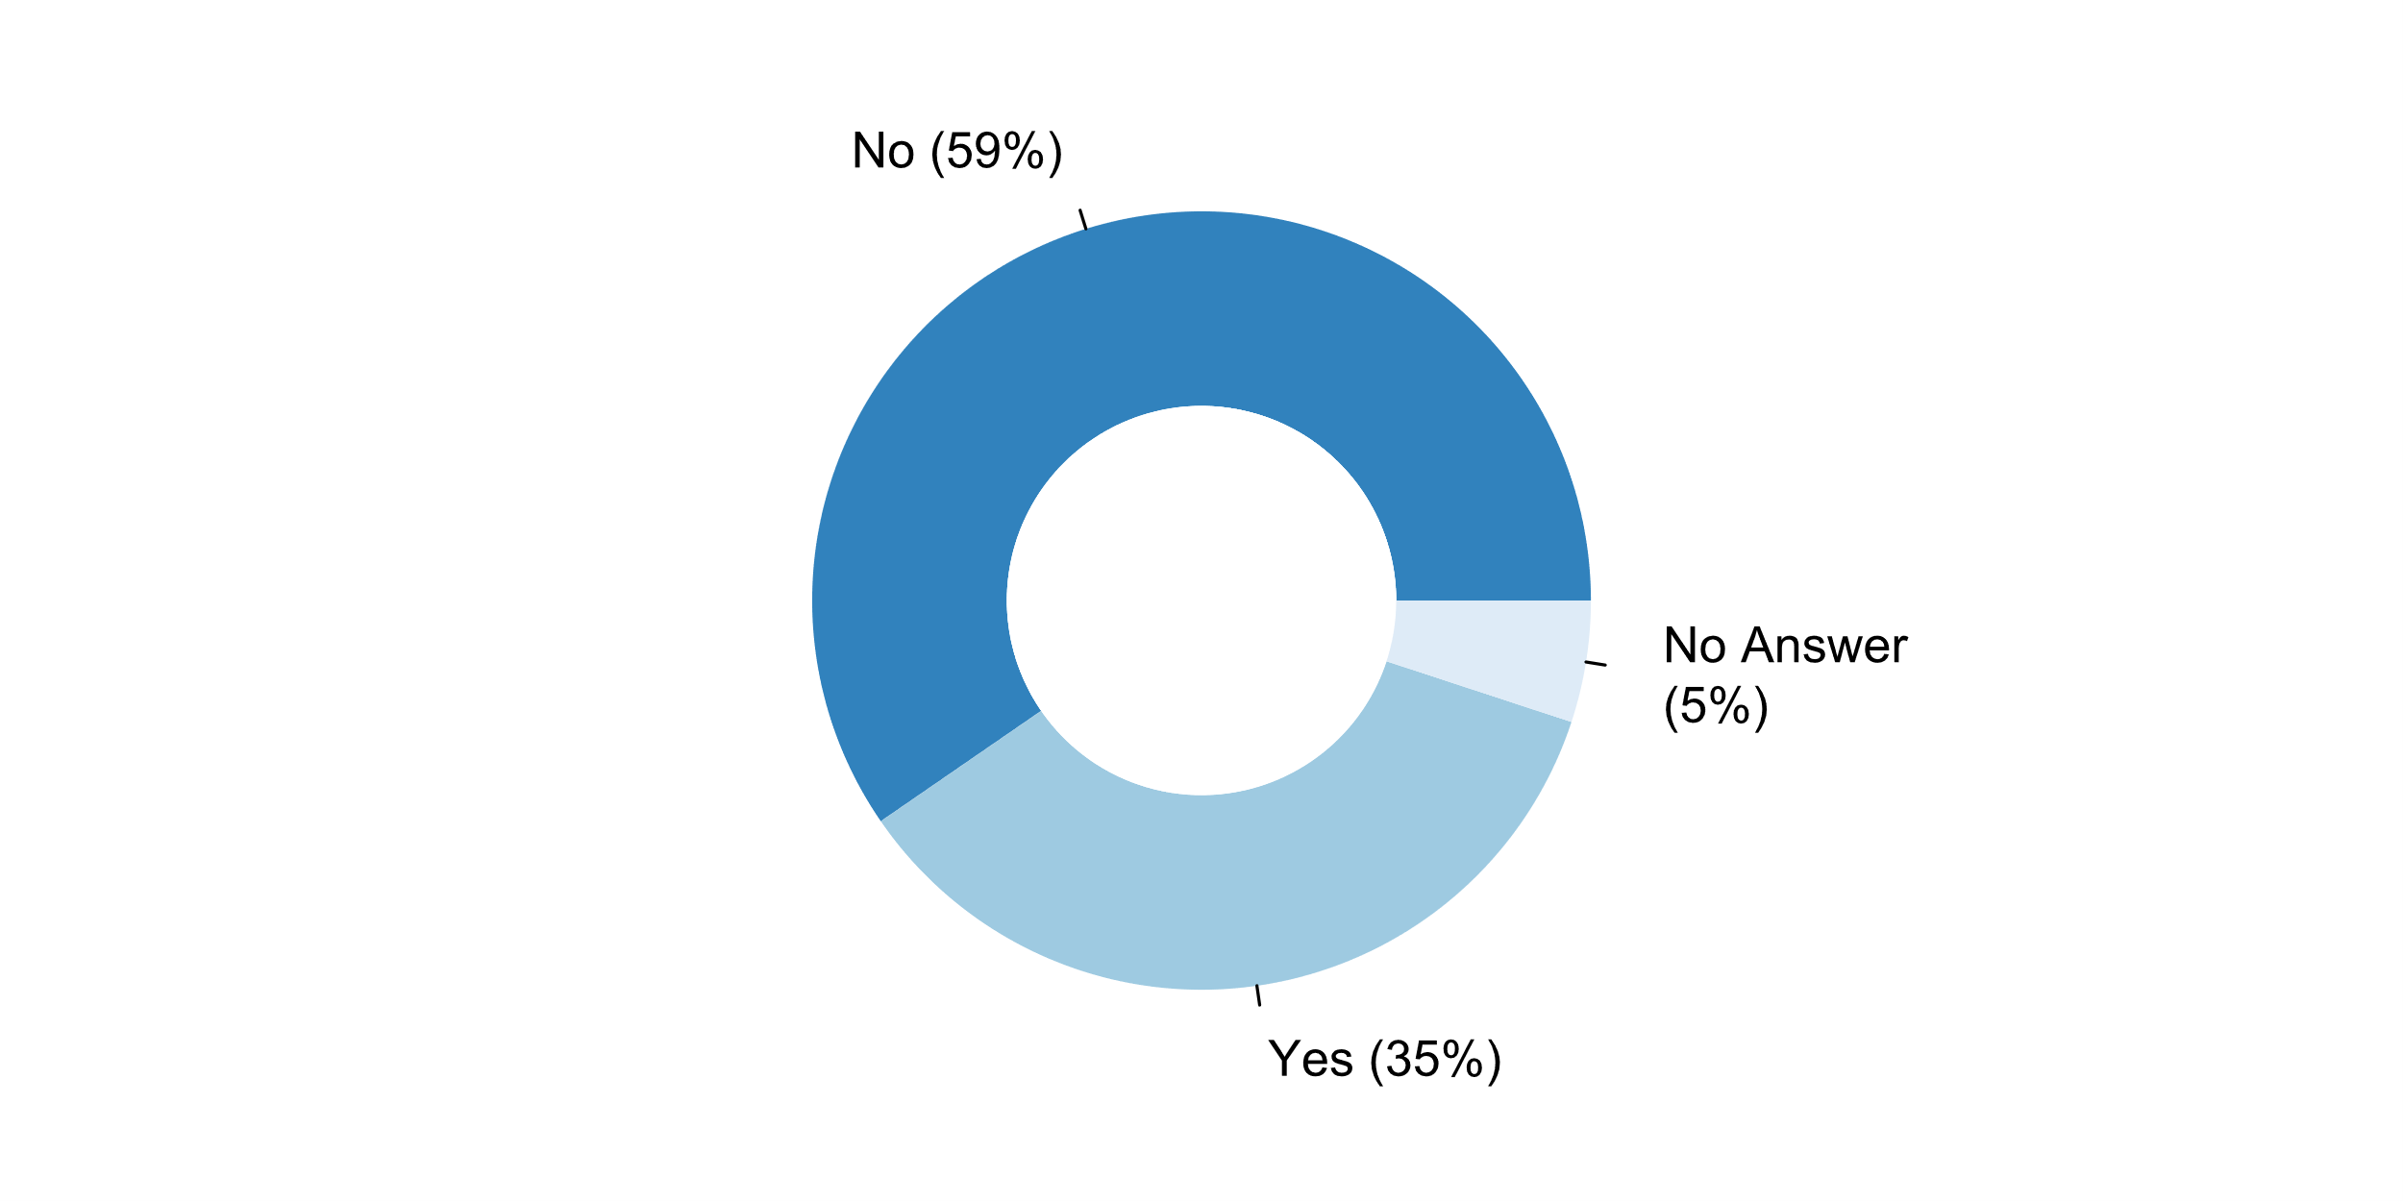

**Plot_61_Q09.1.svg**

**Version of the SNA currently used**

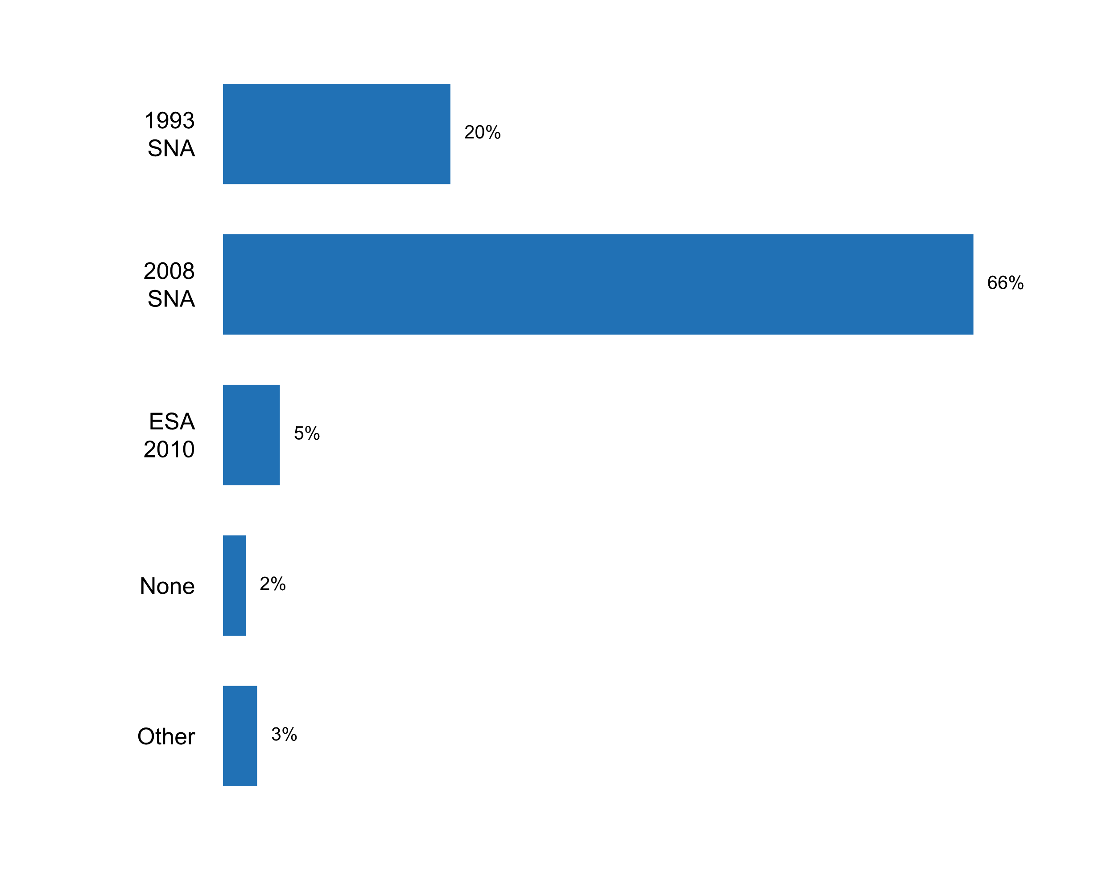

**Plot_62_Q09.2.svg**

**Extent to which Principles and Recommendations for Population and Housing Censuses, Rev. 3 (for census undertaken after 2015) or Rev. 2 (for census undertaken before 2015) are being implemented in the latest census programme**

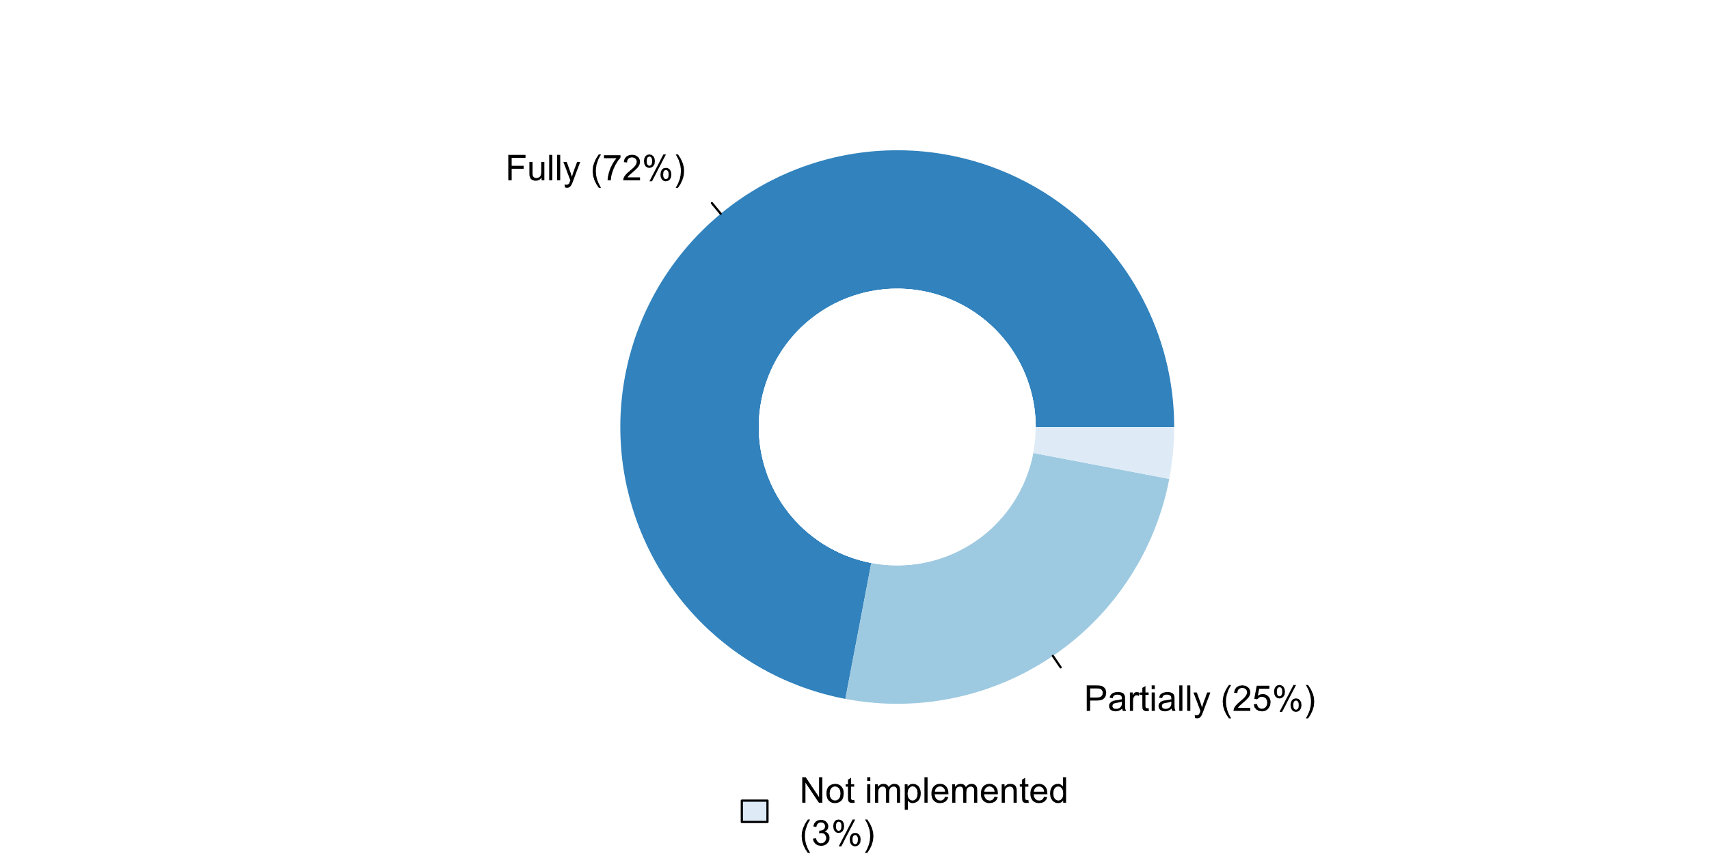

**Plot_63_Q09.3.svg**

**Use of the International Classification of Activities for Time Use Statistics 2016 (ICATUS 2016)**

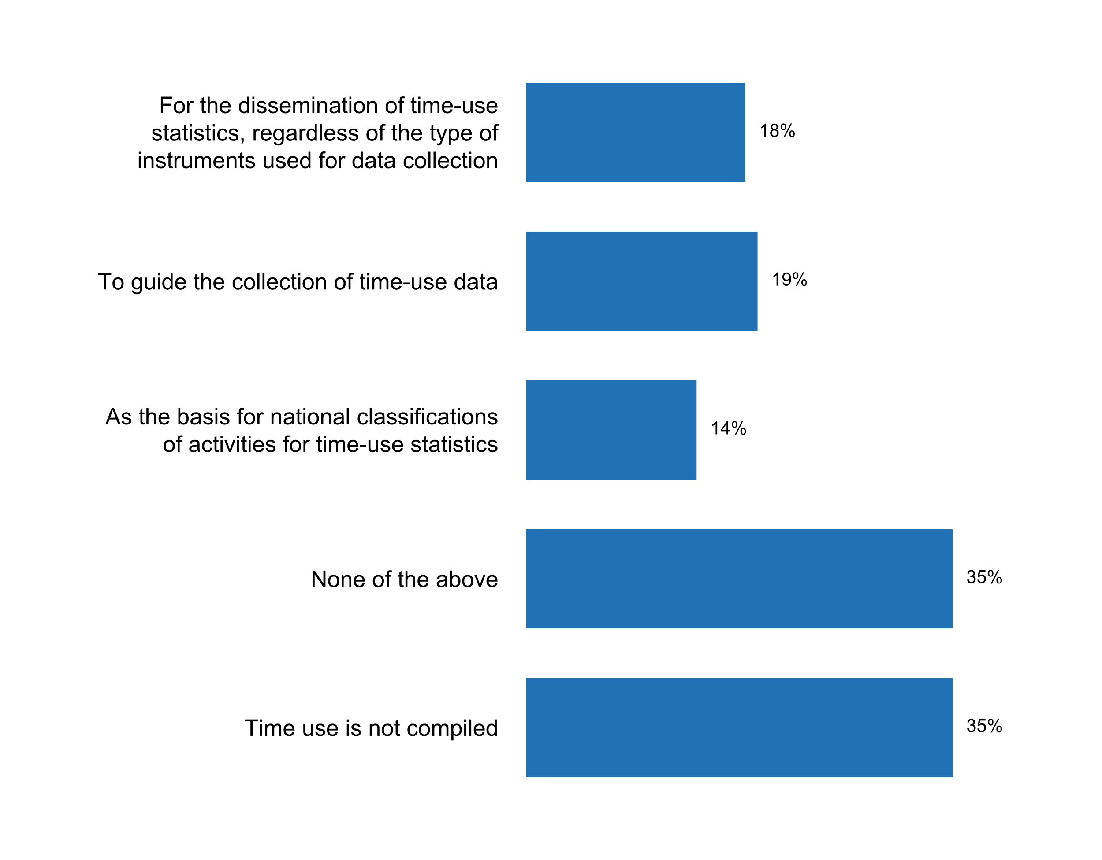

**Plot_64_Q09.4.svg**

**Existence of a programme on EEA\***

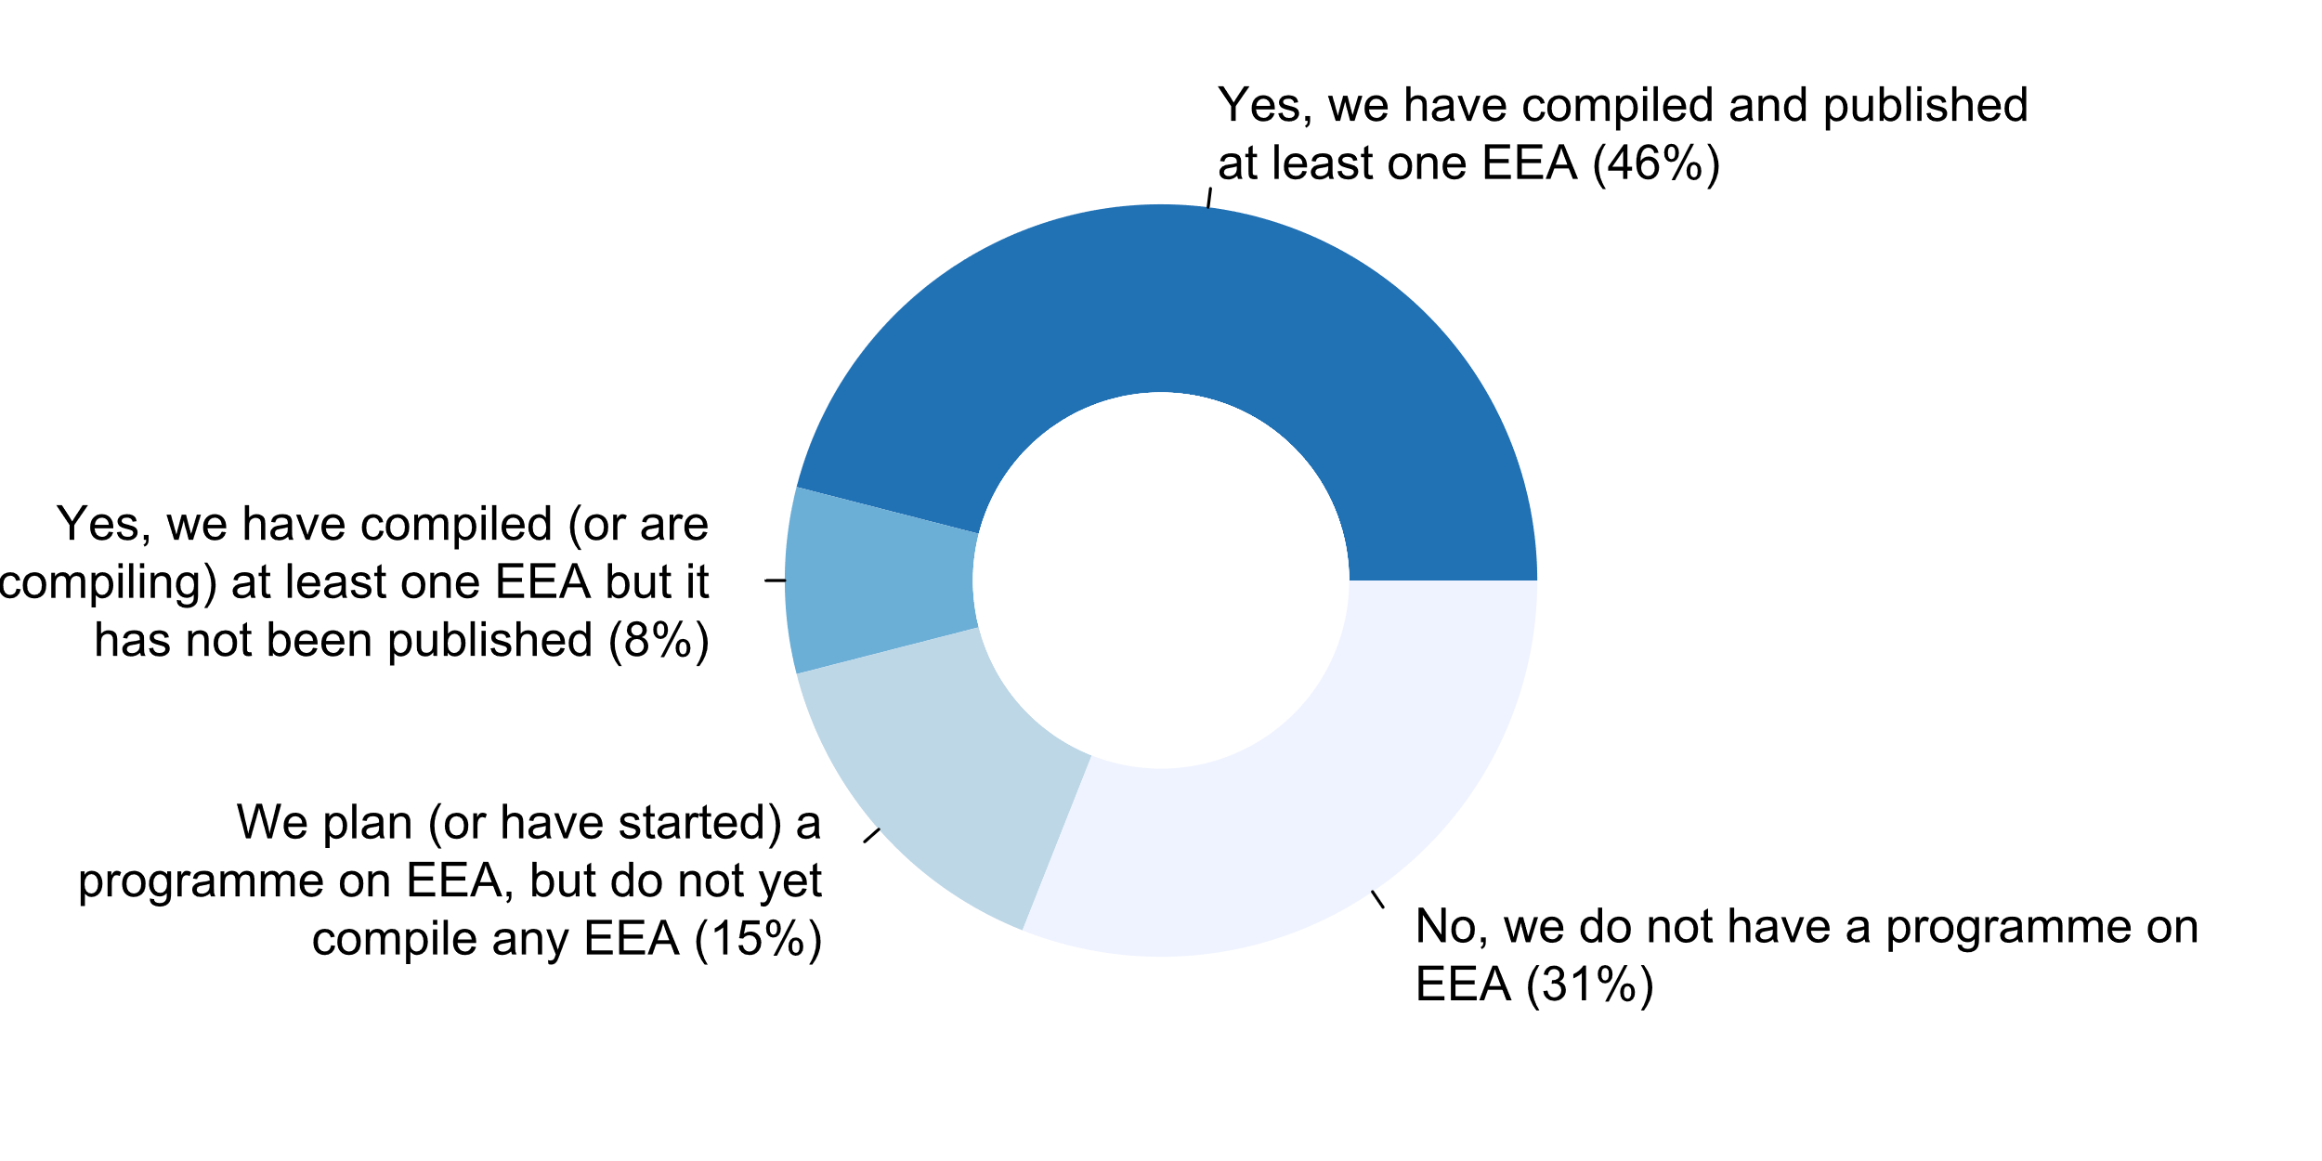

**Plot_65_Q09.5.svg**

**SDMX currently in use**

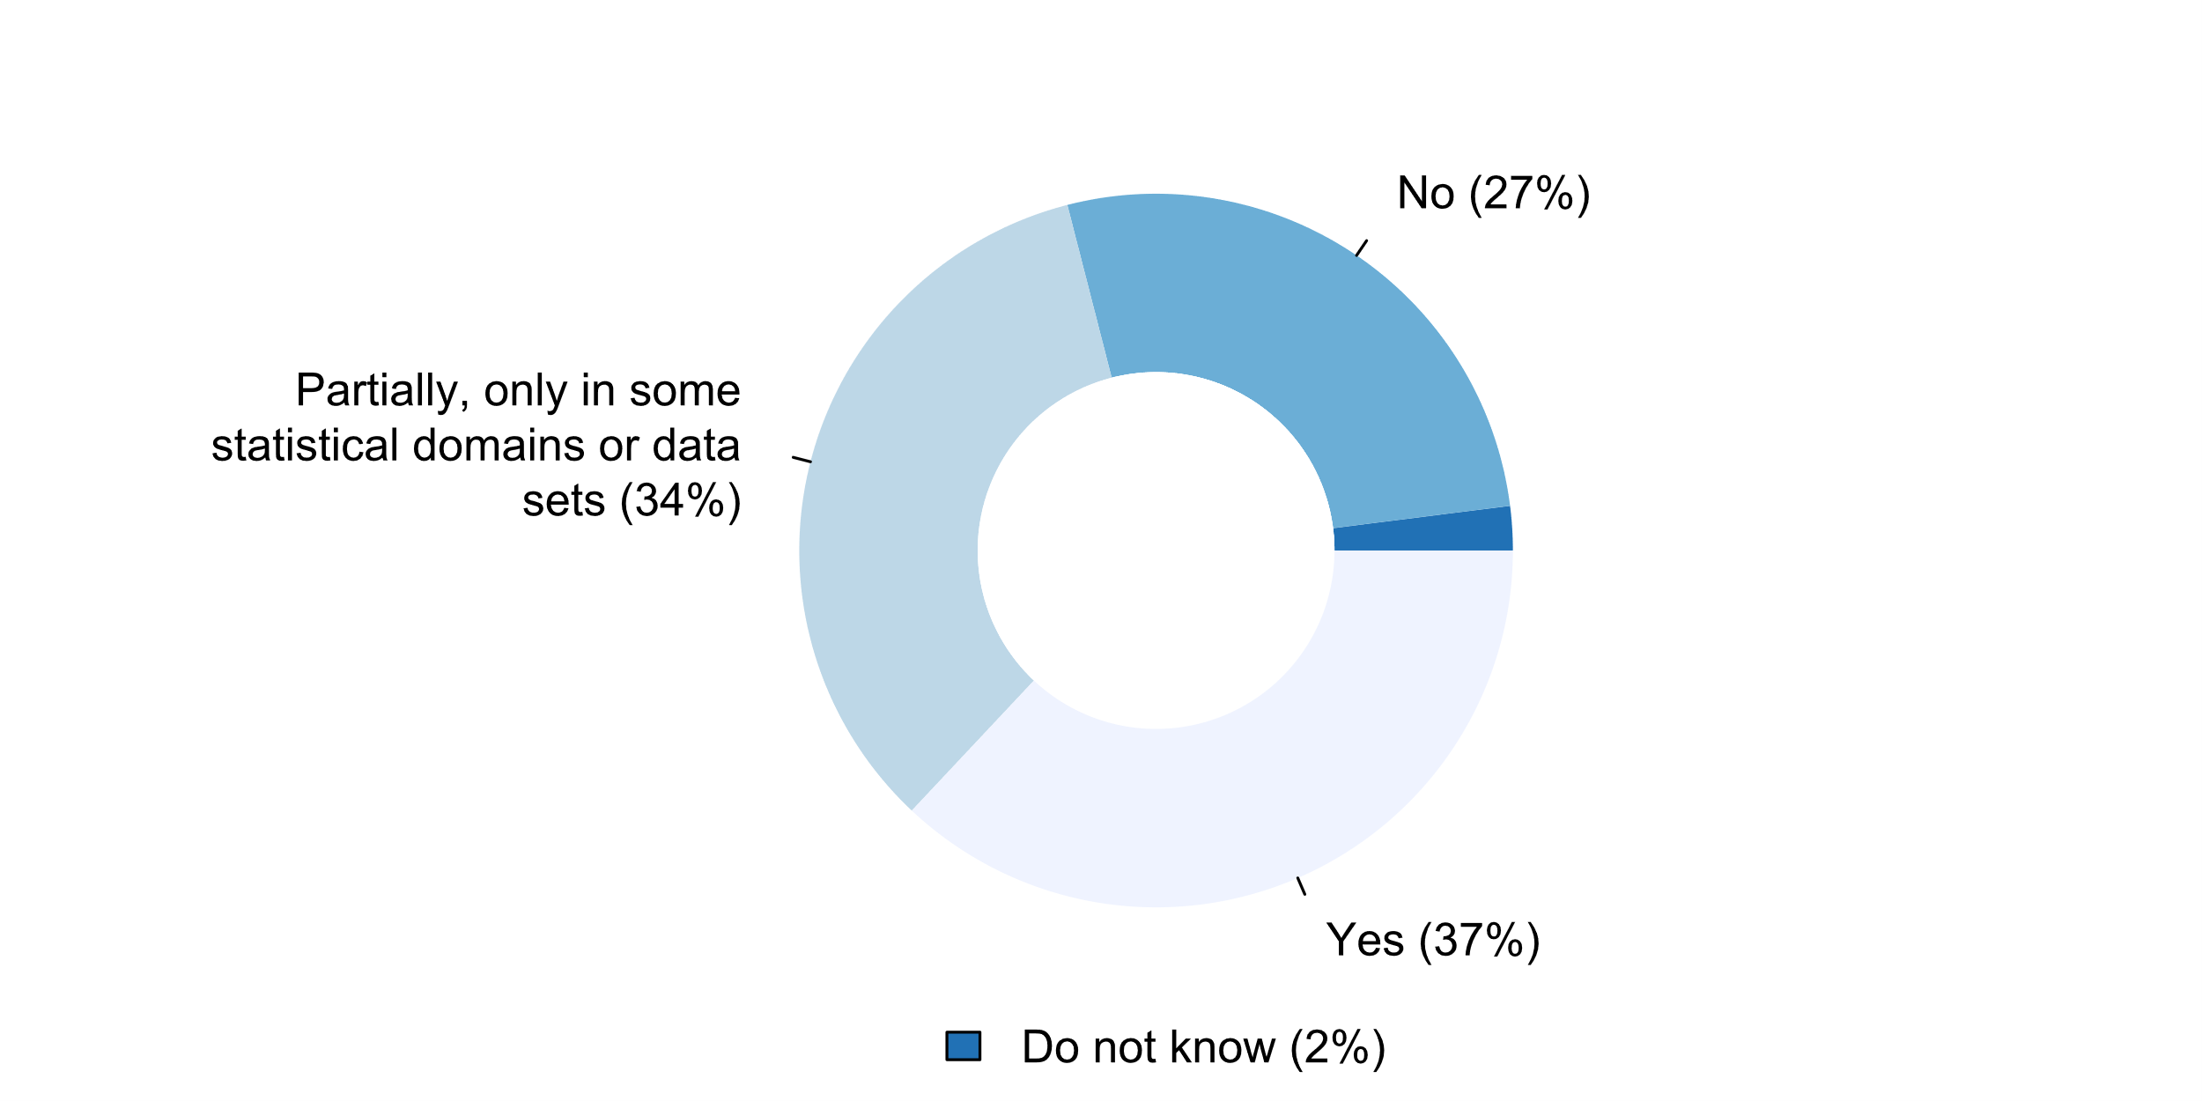

**Plot_66_Q10.1.svg**

**Types of international cooperation activities the NSS engages in**

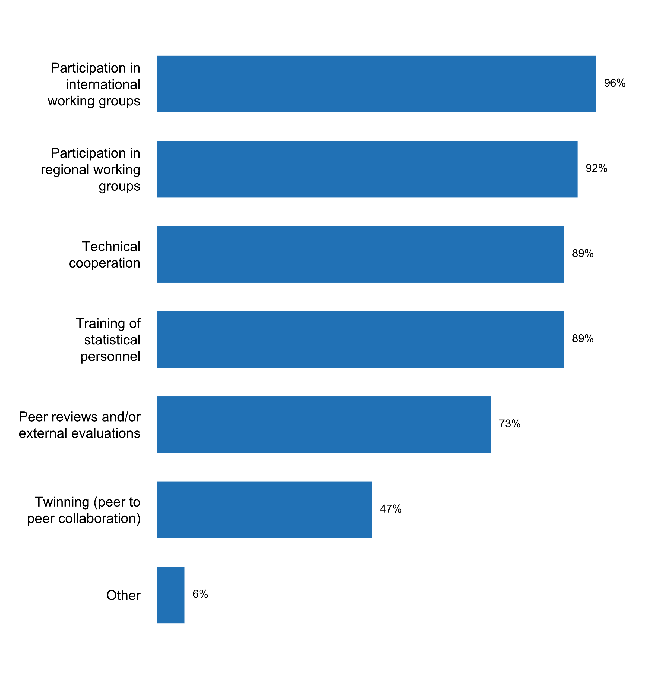

**Plot_67_Q10.3.svg**

**Existence of donor coordination mechanism or basket fund for statistics (if country receives support from donors)**

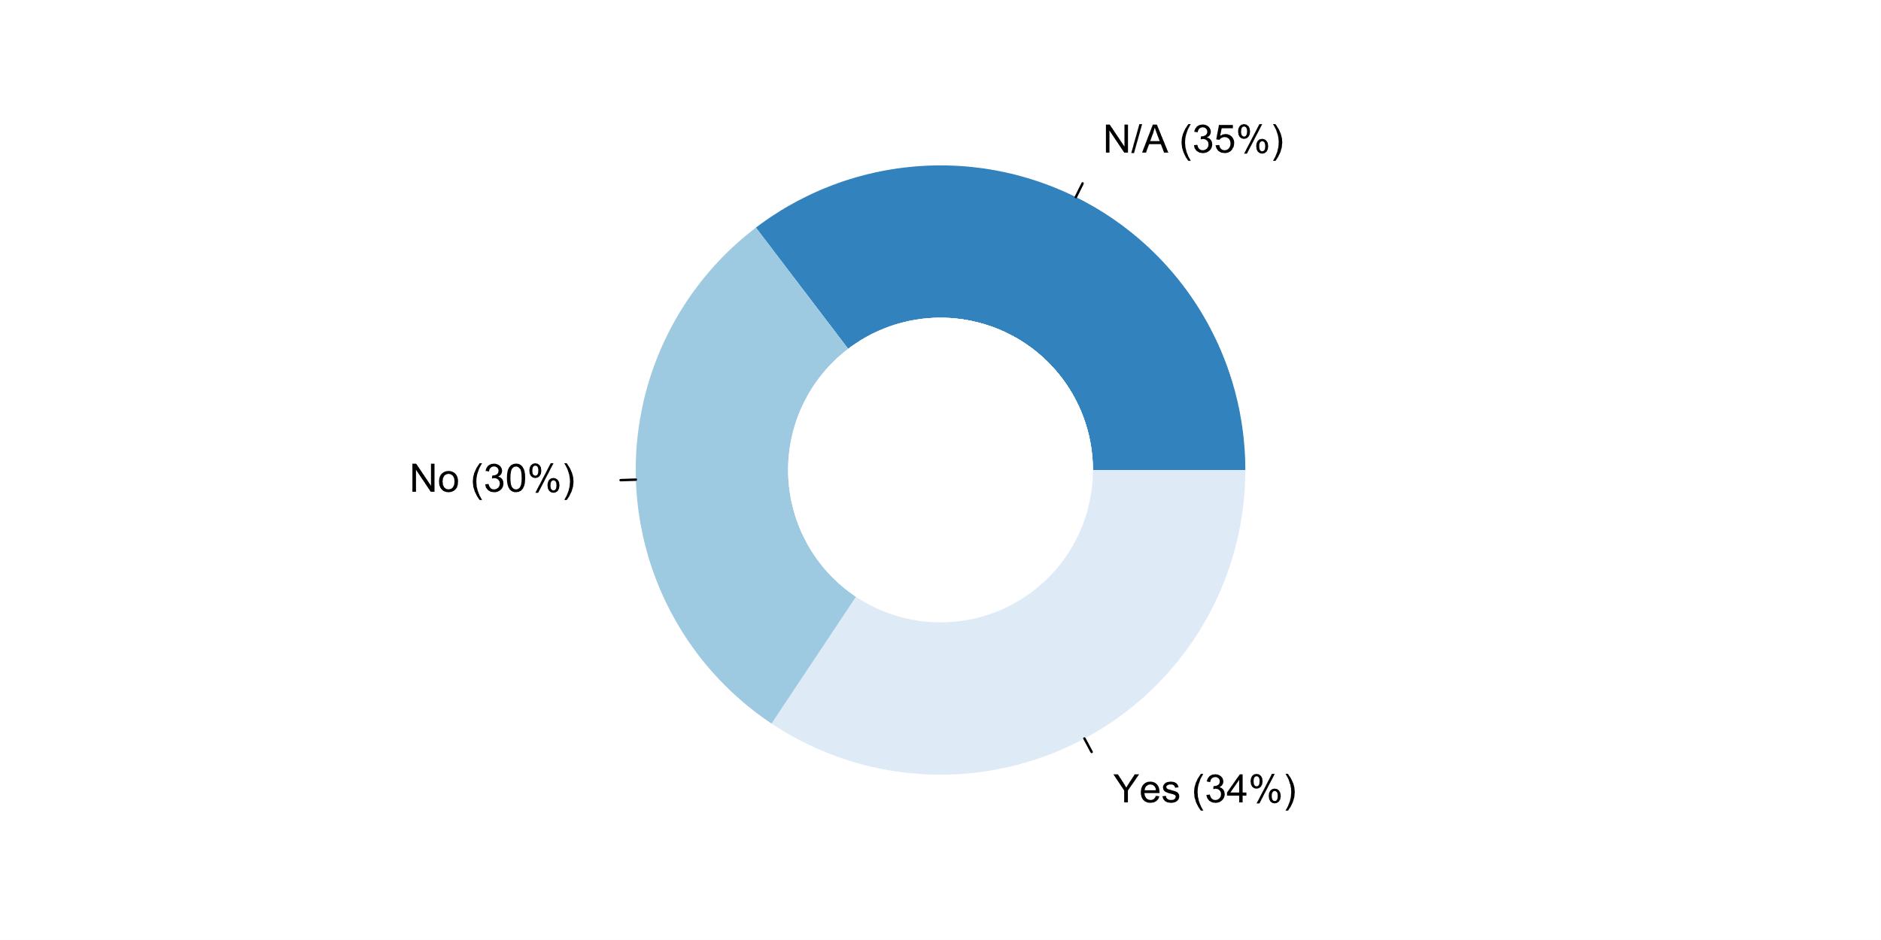

**Plot_68_Q10.4.svg**

**The NSO participates in or contributes to organizations or partnerships whose purpose is to promote open data**

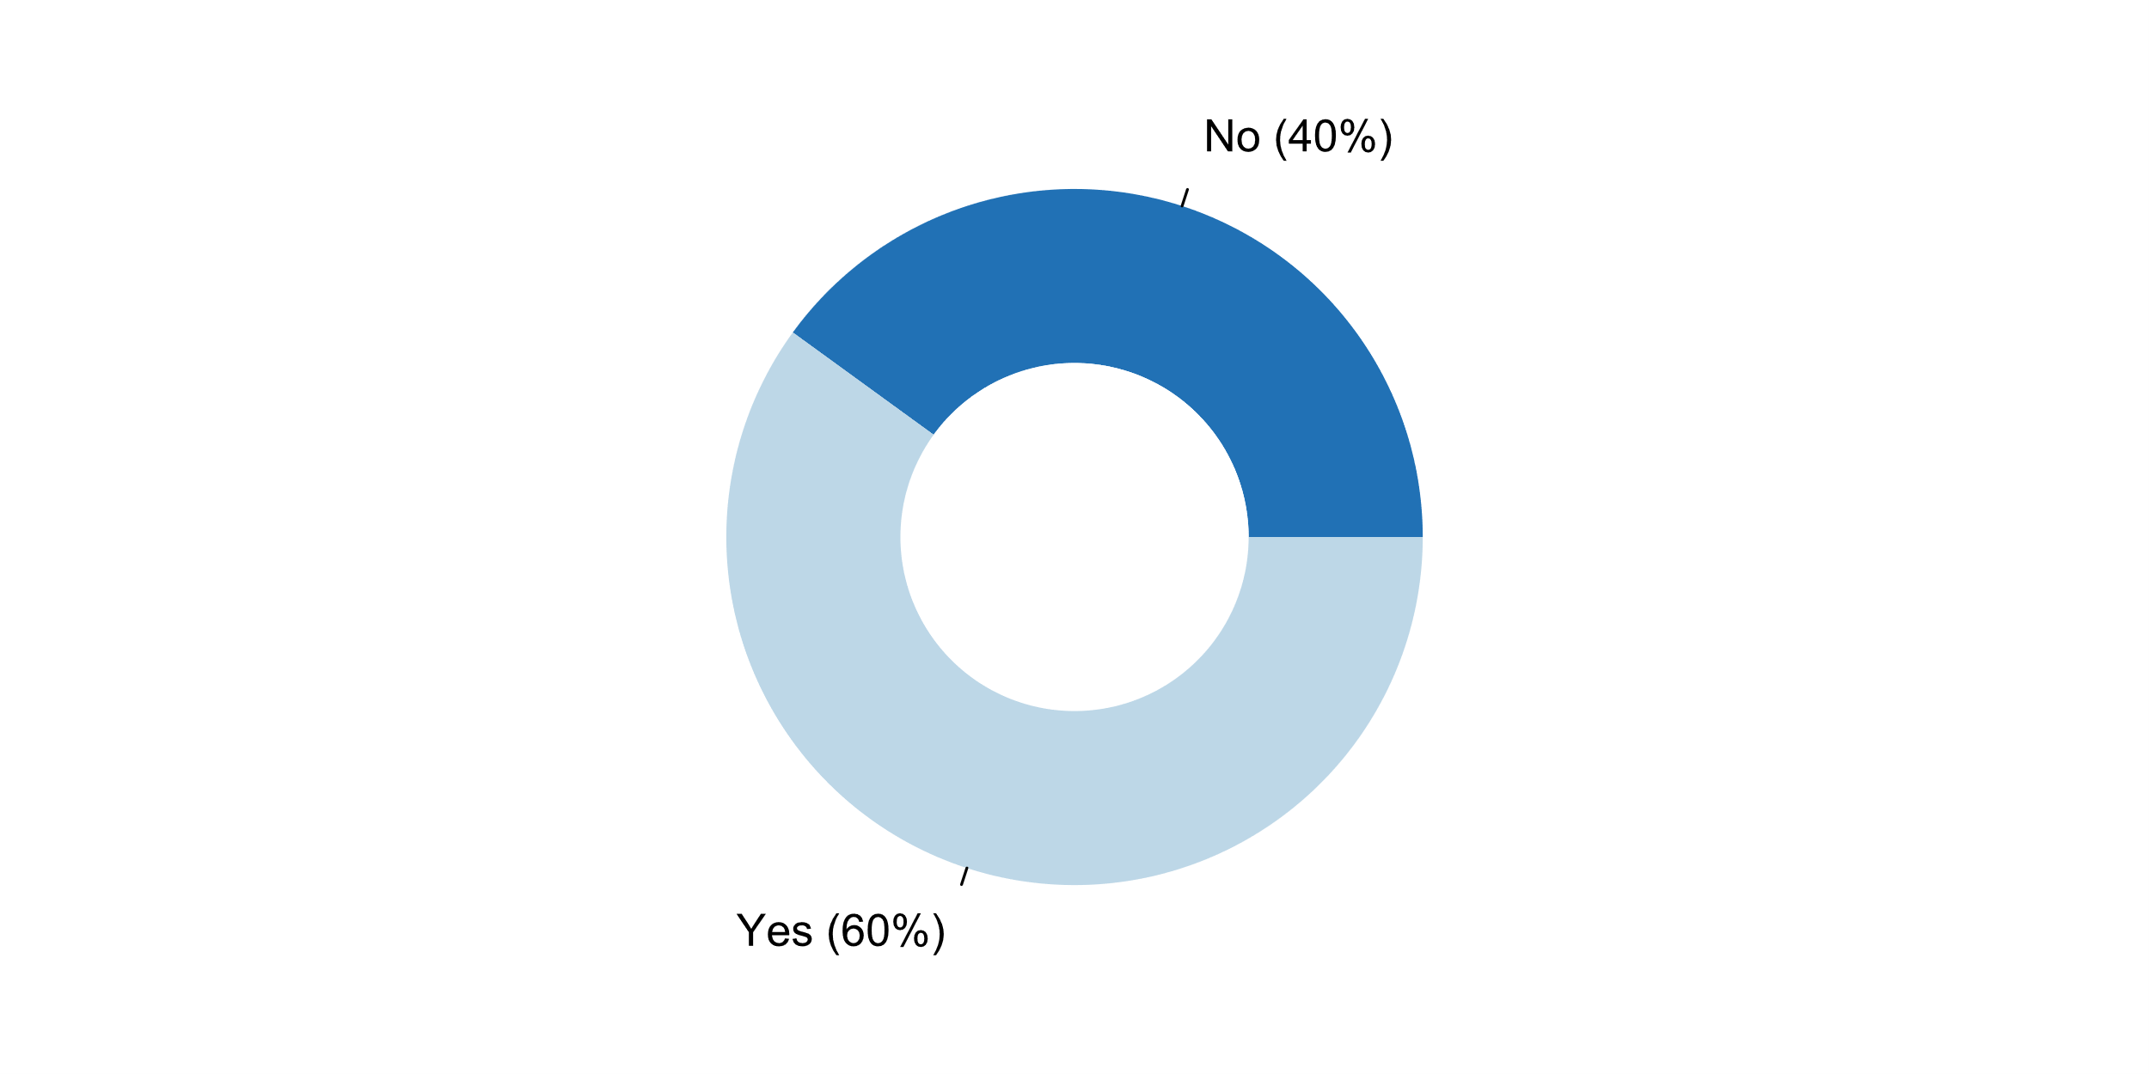

**Plot_69_Q11.5_rev.svg**

**How long did it take to fill out this questionnaire (in hours)?**

